|  |  |  |  |  |  |
| --- | --- | --- | --- | --- | --- |
|  | | | | | |
| Peoples Gas and North Shore Gas Evaluation Plans – 2022 to 2025 Compendium | | | | | |
| 2025 Update - DRAFT  Presented to:  Peoples Gas and North Shore Gas  December 14, 2024 | | | | | |
|  | | |  | | |
|  |  |  | | |  |
| **guidehouse.com** |  | |  |  | |

**Submitted to:**

Peoples Gas

North Shore Gas

200 East Randolph Street

Chicago, IL 60601

**Submitted by:**

Guidehouse Inc.

150 N. Riverside, Suite 2100

Chicago, IL 60606

Phone 312.583.5700

Fax 312.583.5701

**Contact:**

|  |  |
| --- | --- |
| Ed Balbis, Partner  561.644.9407  ebalbis@guidehouse.com | Laura Agapay-Read, Associate Director  312.583.4178  laura.agapay.read@guidehouse.com |
| Jeff Erickson, Director  608.616.4962  jeff.erickson@guidehouse.com | Charles Ampong, Associate Director  608.514.8203  charles.ampong@guidehouse.com |

Disclaimer: This document was prepared by Guidehouse Inc. (“Guidehouse”) for Peoples Gas Light and Coke Company (“PGL”) and North Shore Gas Company (“NSG”) based upon information provided by PGL and NSG and from other sources. Use of this document by any other party for whatever purpose should not, and does not, absolve such party from using due diligence in verifying the document’s contents. Neither Guidehouse nor any of its subsidiaries or affiliates assumes any liability or duty of care to such parties, and hereby disclaims any such liability.

Table of Contents

1. Introduction 1

2. Core Evaluation Tasks 2

2.1 Impact Evaluation 2

2.1.1 Guiding Principles 2

2.1.2 Approach 2

2.1.3 Deliverables and Timing 4

2.2 NTG Research and Framework Application 7

2.2.1 Guiding Principles 7

2.2.2 Approach 8

2.2.3 Deliverables and Timing 9

2.3 Market Transformation Evaluation 12

2.4 Portfolio Research 13

2.4.1 Guiding Principles 13

2.4.2 Support for TRM Updates 14

2.4.3 Process Evaluation Research 14

2.4.4 Other Cross-Cutting Research 15

2.4.5 Evaluation Research Activities 16

2.5 Evaluation Portfolio Support and Reporting 17

2.5.1 Annual Review of the Companies’ Adjustable Savings Goals 17

2.5.2 Ad-Hoc Evaluation Support Requests 18

2.5.3 Cost-Effectiveness Review and Summary Reporting 18

2.5.4 Job and Macroeconomic Impact Reporting 19

2.6 Evaluation Budget 21

Appendix A. Program Evaluation Plans 22

A.1 Residential Programs 23

A.1.1 OUTREACH AND EDUCATION 23

A.1.2 SINGLE FAMILY HOME ENERGY JUMPSTART 23

A.1.3 HOME ENERGY REBATE 24

A.1.4 MULTI-FAMILY ASSESSMENTS & REBATES/GRANTS 25

A.1.5 Epic Savers Kit Program 27

A.2 Income Eligible Programs 28

A.2.1 INCOME ELIGIBLE SINGLE FAMILY 28

A.2.2 INCOME ELIGIBLE MULTI-FAMILY 29

A.3 Business and Public Sector Programs 31

A.3.1 PRESCRIPTIVE REBATES 31

A.3.2 CUSTOM REBATES 31

A.3.3 GAS OPTIMIZATION 32

A.3.4 STRATEGIC ENERGY MANAGEMENT 33

A.3.5 COORDINATED RETRO-COMMISSIONING 33

A.3.6 COORDINATED NON-RESIDENTIAL NEW CONSTRUCTION 34

A.3.7 SMALL/MID-SIZE BUSINESS ASSESSMENTS & REBATES 35

A.3.8 COMMERCIAL FOOD SERVICE PROGRAM 36

A.4 Market Transformation Initiatives 38

**List of Tables**

Table 2‑1. Income Eligible and Residential Programs 6

Table 2‑2. Business and Public Sector Programs 7

Table 2‑3. Residential NTG Research Approach and Timing 10

Table 2‑4. Business & Public Sector NTG Research Approach and Timing 11

Table 2‑5. NTG Research Schedule by Year 12

Table 2‑6. Portfolio Evaluation Research 17

Table 2‑7. Evaluation Budget 21

# Introduction

This document presents evaluation, measurement, and verification (EM&V) plans for evaluating Peoples Gas (PGL) and North Shore Gas (NSG) (“the Companies”) portfolio of energy efficiency programs in 2022 through 2025, which is Energy Efficiency Plan (EEP) 2022-2025 (Plan 4). The next sections include an overview of evaluation approaches and a proposed high-level schedule for program-year evaluation tasks. The Appendix includes program-level evaluation plans.

When developing and implementing this plan, Guidehouse will coordinate with and/or seek input from other Illinois utilities (ComEd, Nicor Gas, Ameren Illinois) and their evaluators, the SAG, ICC staff, and the TRM administrator:

* + When planning evaluation research and survey activities
  + When conducting evaluation research where collaboration to achieve broader coverage and larger sample sizes may improve the research results

This portfolio EM&V plan will be updated annually to reflect updated research priorities. Specifically, Guidehouse will submit proposed updates to the portfolio EM&V plan annually by December 15. This updated draft portfolio EM&V plan shall be submitted to Program Administrators, the SAG Facilitator, and ICC Staff concurrently for review and comment, including a summary outline of actual evaluation activities that have occurred already, as well as tentatively planned and proposed evaluation activities for the four-year portfolio EM&V plan.

# Core Evaluation Tasks

The next sections present an overview of the core evaluation tasks with summary tables. The Appendix provides detailed, program-level evaluation plans. The core evaluation tasks are:

* Impact Evaluation
* NTG Research and Framework Application
* Market Transformation Evaluation
* Portfolio Research
* Evaluation Portfolio Support and Reporting

## Impact Evaluation

The primary goal of impact evaluation is to verify the gross and net savings claimed by PGL and NSG to be applied toward statutory goals. The effort has secondary goals of improving the accuracy of ex ante impact estimates, improving the accuracy and relevance of the TRM, and improving the accuracy and usefulness of the program tracking systems.

### Guiding Principles

1. Verify the gross and net savings to be applied toward statutory goals for all programs in each PGL and NSG program year. Use gross savings calculated from the Illinois Technical Reference Manual (TRM) or custom impact evaluation research and calculate net savings by applying the Illinois Energy Efficiency Stakeholder Advisory Group (SAG) deemed net-to-gross (NTG) value. When programs are delivered jointly with electric utilities, calculate verified gross natural gas savings without interactive effects from the reduction of electricity usage.
2. Where practical, conduct impact evaluations and measure research using randomized controlled trials (RCT) or quasi-experimental design (QED) and energy consumption data. When Guidehouse believes that RCTs or QEDs are not practical, as part of its evaluation plan, we will provide an explanation and support for its decision.
3. Coordinate impact evaluation of jointly delivered programs with the ComEd evaluation team to reduce duplication of work, customer disruption, and evaluation spending.
4. Conduct technical reviews and gather Illinois-specific data to update the TRM and recommend updated verification approaches for applicable measures.

### Approach

The impact analysis of a program portfolio will typically include the following components:

* **Program Tracking Data Review**. Verify the type of measures installed and the quantities claimed for accuracy as reported in the program tracking database and supplemental data provided by implementation contractors.
* **Savings Verification for TRM-Based Measures**. For TRM-based measures, Guidehouse will verify ex ante gross measure savings against the allowable input values and algorithms provided in the relevant ICC-approved version of the TRM.
* **Savings Verification for Custom Measures.** For non-TRM “custom” measures, Guidehouse will conduct evaluation research to verify gross impacts. For each project selected for the participant research sample, an in-depth application review is performed to assess the engineering methods, parameters, and assumptions used to generate all ex ante impact estimates. For each measure in the sampled project, engineers estimate verified gross savings based on their review of documentation and engineering analysis. Validation of savings through gas consumption (billing) data analysis may be used in combination with the engineering review for individual sites. Site-specific data will be collected for a subset of sampled projects, either through telephone interviews with site contacts, or an onsite visit that follows required safety protocols. For most projects, onsite data collection includes interviews completed at the time of the onsite visit, visual inspection of the systems and equipment, recording EMS settings, and collecting energy management system (EMS) trend data or production records when available and necessary. To support this review, Guidehouse requests project documentation in electronic format for each sampled project.
* **Gross Realization Rates**. The evaluation team will calculate gross savings realization rates to adjust ex ante savings based on verified gross savings estimates. The realization rate is defined as the percentage of ex ante gross savings achieved as determined through the independent evaluation review. A realization rate of 1.0, or 100%, indicates no difference between the ex ante gross and verified gross savings for a particular measure. For 2025, the evaluation team will consider applying the 2024 realization rate to reported savings for select programs.[1] In such instances, the evaluation team will confirm the program tracking data is consistent with the previous year and calculate verified net savings by applying the previous year’s realization rate to the program tracking data review results. If the program tracking data is inconsistent (for example, due to a substantial savings calculation change or new measure added to the program), the evaluation team may adjust the plan to re-evaluate the identified discrepancy (at the measure, end use, or program level, as appropriate, based on the program and portfolio savings impact).
* **Parallel Path / Large Project Review**. Guidehouse will conduct project file reviews that fall under a “Parallel Path” designation. These are projects that the implementation contractor has identified early in the project application cycle that may pose a risk to realization of verified gross impacts, either due to size of the project, the complex technical nature, or difficulty in baseline determination. As budget allows, Guidehouse conducts a review of project documentation and energy saving estimates and prepares a brief response that identifies further questions or revisions to the gross savings estimates. The findings are discussed with the implementation contractor who then adopts the findings going forward or proceeds as originally intended with a better knowledge of evaluation risk for the project.
* **Impact Sampling.** For custom measures, impact-related sampling will be designed to achieve a 90%/±10% level of confidence and precision at the program level and may also include selected high priority measures at the 90/10 level. Savings verification of TRM-based measures is performed on a census of claimed installations (not sampled).
* **Consumption Data (Billing) Analysis with** **Statistical Validation Check**. A standard regression approach for estimating program natural gas energy savings is a preferred method for evaluating the energy use impacts of certain programs and measures. Guidehouse will perform billing analysis to evaluate programs, projects, and measures when appropriate. Where practical, program evaluations will be conducted using RCTs or QEDs. When Guidehouse believes that RCTs or QEDs are not practical, we will provide an explanation and support for this decision as part of the program’s evaluation plan.
* **Net Savings Verification**. The net savings impact evaluation for each measure will apply the NTG ratio deemed through the Illinois SAG consensus process.
* **Jointly Implemented or Coordinated Programs.** Evaluations of joint or coordinated programs will be designed to meet the needs of PGL, NSG, and ComEd, as well as other Illinois utilities, when appropriate. When programs are delivered jointly with electric utilities, Guidehouse calculates verified gross natural gas savings without applying an interactive effects penalty from the reduction of electricity usage.

### Deliverables and Timing

* **Interim Impact Evaluation.** Guidehouse will conduct mid-year impact evaluation for most programs[2] if data are available prior to the end of the year. Guidehouse will conduct an engineering review of the Master Measure Database at mid-year, checking for correct adoption of the latest impact evaluation findings, updated TRM algorithms, and NTG values. Guidehouse will conduct a review of the adjustable savings goal calculations in December (if available) and January, checking for correct adoption of updated TRM algorithms and inputs. For programs with TRM-based measures, Guidehouse will conduct an interim review of per-unit savings from tracking data during the third quarter (results by August 31 if data is available by June 15). For programs with non-TRM custom measures, Guidehouse will draw savings verification samples one to three times during the program-year, depending on the number of completed projects, with the first sample drawn about July 1. Guidehouse will review implementer developed ex ante savings calculations if requested or when a new delivery channel is added to the portfolio.
* **End of Year Impact Evaluation.** Final program year impact evaluation will take place after the program-year ends when we receive final tracking data, expected by January 30. For PGL and NSG programs jointly implemented with ComEd, Guidehouse will make best efforts to deliver a draft report by March 15 and a final report by April 30.[3] However, this schedule is dependent on delivery of final tracking data by January 30 of each year and adherence to review schedules. For PGL- and NSG-only programs with only TRM-based measures, we expect draft delivery not later than April 15, with final reports by June 3. For PGL- and NSG-only programs with custom measures, we expect draft delivery not later than May 6, with final reports by June 24. We expect billing usage analyses will occur after the end of the program year when final billing data is available (which may be several weeks after January 30) and may include multiple program years to accommodate a full heating season.
* **End of Year Summary Report, Cost Effectiveness, and Economic Impacts**. Work on the annual summary report and cost-effectiveness spreadsheet reports will begin May 1, with draft results available thirty days after all annual impact evaluation reports are final and receiving final program cost data from PGL/NSG. Assuming all final reports and cost data are received by July 15, the first draft of the Cost Effectiveness test, and Job and Macroeconomic Impact Reporting will be delivered August 31, and the final report by October 31, or best efforts.
* **IQ Reporting Metrics**. Income Qualified Multi-Family[4] and Single-Family Equity and Affordability[5] Reporting Metrics per SAG approved utility reporting metrics, finalized in 2024.

Table 2‑1 and Table 2‑2 summarize the impact evaluation approach by program and market offering.

Table 2‑1. Income Eligible and Residential Programs

Impact Evaluation Approach for 2025

| Program / Market Offering | Gross Impact Evaluation Approach | Custom Project Parallel Path Review | Interim Review Type |
| --- | --- | --- | --- |
| **Income Eligible Programs** |  |  |  |
| **Single Family** |  |  |  |
| Retrofits | TRM |  | TRM |
| Elementary Energy Education | TRM |  | TRM |
| Home Energy Assessment | TRM |  | TRM |
| Income Eligible Kits* | 2024 RR |  | TRM |
| **Multi-Family** |  |  |  |
| Retrofits and New Construction | TRM & Custom | If Requested | TRM |
| Partner Trade Ally (PTA) | TRM |  | TRM |
| Income Eligible Kits* | 2024 RR |  | TRM |
| Public Housing Authority* | 2024 RR |  | TRM |
| **Residential Programs** |  |  |  |
| **Outreach & Education\*** |  |  |  |
| Energy Efficiency Education | 2024 RR |  | TRM |
| **Home Energy Jumpstart\*** |  |  |  |
| Assessments and DI | 2024 RR |  | TRM |
| Advanced Thermostats | 2024 RR |  | TRM |
| **Home Energy Rebate** |  |  |  |
| Space & Water Heating | TRM |  | TRM |
| Weatherization | TRM |  | TRM |
| Advanced Thermostats | TRM |  | TRM |
| **Multi-Family Program** |  |  |  |
| Assessments and DI | TRM |  | TRM |
| Rebates: Prescriptive/PTA | TRM |  | TRM |
| Rebates: Custom | Custom | If Requested | Q3, Q4 Samples |
| Gas Optimization | Custom | If Requested | Q3, Q4 Samples |
| Epic Savers Kit Program |  |  |  |
| Market Rate Kits | TRM |  | TRM |

* Programs that evaluation may use previous year’s realization rate.

Source: Guidehouse.

Table 2‑2. Business and Public Sector Programs

Impact Evaluation Approach for 2025

|  |  |  |  |
| --- | --- | --- | --- |
| Program / Market Offering | Gross Impact Evaluation Approach | Custom Project Parallel Path Review | Interim Review Type |
| **Business and Public Sector Programs** | |  |  |
| **Small/Mid-Size Business** |  |  |  |
| Assessments and DI | TRM |  | TRM |
| Rebates: Prescriptive/PTA | TRM |  | TRM |
| Rebates: Custom | Custom |  | Q3, Q4 Samples |
| Commercial Food Service | TRM |  | TRM |
| **C&I Programs** |  |  |  |
| Prescriptive Rebates | TRM |  | TRM |
| Custom Rebates | Custom | If Requested | Q3, Q4 Samples |
| Gas Optimization | Custom | If Requested | Q3, Q4 Samples |
| Strategic Energy Management | Custom | If Requested |  |
| Coordinated Retro-Commissioning | Custom |  | Quarterly Sample |
| Coordinated New Construction | Custom |  | Q3 Sample |
| **Public Sector Programs** |  |  |  |
| Prescriptive Rebates | TRM |  | TRM |
| Custom Rebates | Custom | If Requested | Q3, Q4 Samples |
| Gas Optimization | Custom | If Requested | Q3, Q4 Samples |
| Strategic Energy Management | Custom | If Requested |  |
| Coordinated Retro-Commissioning | Custom |  | Quarterly Sample |
| Coordinated New Construction | Custom |  | Q3 Sample |

Source: Guidehouse.

## NTG Research and Framework Application

The primary goal of NTG research is to estimate the change in energy consumption that is attributable to a particular energy efficiency program or to the combined influence of the energy efficiency portfolio. The net savings analysis requires the evaluator to assess the influence of PGL and NSG programs versus other factors on the customer’s decision to install energy efficiency measures, either through the programs or outside of these. This change in energy use may include consideration of factors such as free-ridership, participant and non-participant spillover, and induced market effects. The NTG research efforts have secondary goals of identifying strategies for improving net savings and gathering additional feedback from participants to improve the program.

### Guiding Principles

1. Estimate the NTG ratio for each program, including adjustments for free-ridership and spillover, to support annual prospective deeming of NTG ratios consistent with the Illinois NTG Policy. Conduct NTG research at least once during the four-year program cycle for each program following the NTG protocols in the TRM and when the program or market changes substantially. Some programs do not require primary NTG research when NTG values are deemed by consensus without primary research.
2. Where budget and schedule can accommodate, target a larger number of completions for NTG surveys than the minimum required for a 90%+/-10% level of confidence and precision program-level result.
3. Wherever possible, consider performing free-ridership research online in real time (soon after the participant decision is made), following TRM protocols, and collect spillover information after participants have had ample opportunity to take additional actions.
4. A sector or Portfolio-level Spillover analysis should be considered by each utility at least once every Plan period when it is feasible and considered viable by evaluation.[6]

### Approach

Evaluation efforts will measure net savings considering free-ridership and participant spillover in all programs (except those where consensus values are deemed statewide without further research), and, where supported by the program delivery model, non-participant spillover and market transformation effects. The NTG surveys may include process questions as an optional research task, decided on a case-by-case basis in consultation with the Companies.

The NTG analysis will apply, follow, and incorporate the Illinois Statewide NTG Methodologies Framework (NTG Framework or Framework) agreed to among the Illinois SAG participants, approved by the Illinois Commerce Commission and documented in the effective Illinois TRM Version and any subsequent updates to the Illinois NTG Methodologies Framework.

Guidehouse expects that most NTG research can be conducted through online surveys, supplemented by telephone interviews in some studies. Using program tracking data with participants’ email addresses, telephone numbers, and mailing addresses, we will conduct research on participant free ridership through a survey via online (preferred) and/or telephone (if needed). The surveys will target customers and include trade allies if they are important to the program delivery approach. If the program supports it and the Companies are willing, we can survey participants who submit their program applications online to be able to click through the application confirmation page to take the survey. Otherwise, shortly after completing their project, participants with email addresses will receive an email invitation to the online survey. Participants without email addresses may be solicited through the postal service to take an online survey or will be sampled for a telephone survey if they are a significant proportion of the population.

Spillover surveys may be conducted online or through telephone interview, but timing must allow ample time for spillover actions to take place, usually 12 to 18 months after project completion. Guidehouse will target participating customers for participant spillover research and, if indicated by the program theory, the trade ally perspective on participant and non-participant spillover. Non-participating customers are the target for sector-level non-participant spillover.

### Deliverables and Timing

Deliverables include:

* Draft and final survey research instruments
* Non-confidential data from survey respondents, upon request
* Draft and final NTG research findings memos
* NTG recommendations for SAG consensus

The timing for NTG research is driven by an Illinois energy efficiency policy requirement for the evaluators to send initial NTG recommendations to the SAG for the upcoming program year by September 1.

* **October 1 to January 15**: Initiate the next round of NTG research with interviews with program staff on program design, delivery, and marketing and customer targets to inform survey development. Produce a draft survey instrument during Q4, allow the Companies 15 days for initial review, revise, and reach a final version by January 15. Sampling approach will accompany the development of the draft survey instrument.
* **January 15 to April 30**: Prepare survey for fielding and launch and process sample for release during data collection. Survey field data collection occurs over a 2-3 week period for online-based survey efforts recruited by email invitations and over a longer period for efforts recruited by a link to the survey from the program’s rebate application website. If telephone surveys are required, they will slightly lengthen the timeframe. The survey ends when sample quotas are reached.
* **May 1 to July 15**: Analyze NTG data and report results. When NTG research is conducted on a program, the results will be summarized in a memo that is delivered in draft not later than July 15.
* **July 15 to August 31**: Finalize all NTG research memos.
* **September 1**: Evaluators send initial NTG recommendations to the SAG, as required by Illinois Policy.
* **September 1 to September 30**: Evaluators present initial recommended NTG ratios for each energy efficiency program, subprogram, and/or measure group (where applicable) to the SAG, intended to represent the best estimates of future actual NTG values likely to occur for the upcoming program year. SAG participants, the Companies, and Guidehouse will make best efforts to reach consensus by October 1 regarding NTG ratios appropriate for deeming for the upcoming program year.
* **October 1**: Final consensus NTG ratios for deeming for the upcoming program year beginning January 1.
* **January 1**: New consensus NTG ratios in effect.

Table 2‑3 and Table 2‑4 summarize the NTG research approach by program and market offering. Table 2‑5 provides the NTG survey schedule by year.

Table 2‑3. Residential NTG Research Approach and Timing

|  |  |  |  |  |  |
| --- | --- | --- | --- | --- | --- |
| Program / Market Offering | Previous NTG Research† | Free-ridership Approach | Spillover Approach | Timing | New NTG Effective |
| **Residential Programs** | | | | | |
| **Outreach & Education** |  |  |  |  |  |
| Energy Efficiency Education |  | Deemed | Deemed |  |  |
| **Home Energy Jumpstart** |  |  |  |  |  |
| Assessments and DI | 2018 | Online / Real-Time Post-Participation | Online | Completed  Q3 2023 | 2024 |
| Advanced Thermostats | Secondary1 | Online / Real-Time Post-Participation | Online | Completed  Q3 2023 | 2024 |
| **Home Energy Rebate** |  |  |  |  |  |
| Space & Water Heating | 2020 | Online / Real-Time Post-Participation | Online | Continue in Q4 20242 | 2026 |
| Weatherization | 2019 | Online / Real-Time Post-Participation | Online | Continue in Q4 20242 | 2026 |
| Advanced Thermostats | Secondary | Online / Real-Time Post-Participation | Online | Completed  Q3 2023 | 2024 |
| **Multi-Family Program** |  |  |  |  |  |
| Assessments and DI | 2019 | Secondary Research | Secondary Research | Start Q4 2024 | 2026 |
| Rebates: PTA | 2019 | Online + Telephone | Online + Telephone | Continue in Q4 20243 | 2026 |
| Rebates: Standard / Custom | 2019 | Online + Telephone | Online + Telephone | Continue in Q4 20243 | 2026 |
| Gas Optimization | 2021 | Online + Telephone | Online + Telephone | Start Q4 2024 | 2026 |

Source: Guidehouse.

1 Secondary denotes that previous research was secondary only; new research will be primary research conducted in Illinois.

2 Guidehouse is continuing the NTG research that was started in 2023 Q4 into 2024 Q4 due to low response rates among trade allies.

3 Research on property managers was started in Q3 2023 but, due to low response rates, has been extended before continued fielding in 2024 Q4 with NTG effective in January 2026. Property manager survey results will be reported with results from the multi-family trade ally survey, completed in 2023.

Table 2‑4. Business & Public Sector NTG Research Approach and Timing

|  |  |  |  |  |  |
| --- | --- | --- | --- | --- | --- |
| Program/Market Offering | Previous NTG Research | Free-ridership Approach | Spillover Approach | Timing | New NTG Effective |
| **Business and Public Sector Programs** | | | | | |
| **Small/Mid-Size Business** |  |  |  |  |  |
| Assessments and DI1 | 2021 | (Online + Telephone) / Real-Time Post-Participation | Online + Telephone | Discontinued 2022 | N/A |
| Rebates: Prescriptive/PTA | 2021 | (Online + Telephone) / Real-Time Post-Participation | Online + Telephone | Start Q4 2024 | 2026 |
| Rebates: Custom | 2021 | (Online + Telephone) / Real-Time Post-Participation | Online + Telephone | Start Q4 2024 | 2026 |
| **C&I Programs** |  |  |  |  |  |
| Prescriptive Rebates | 2020 | (Online + Telephone) / Real-Time Post-Participation | Online + Telephone | Start Q4 2024 | 2026 |
| Custom Rebates | 2019 | (Online + Telephone) / Real-Time Post-Participation | Online + Telephone | Completed in Q3 2024 | 2025 |
| Gas Optimization | 2021 | (Online + Telephone) / Real-Time Post-Participation | Online + Telephone | Start Q4 2024 | 2026 |
| Coord. Retro-Commissioning | 2021 | Online + Telephone | Online + Telephone | Completed in Q3 2024 | 2025 |
| Coord. New Construction2 | 2021 | Telephone / Real-Time Post-Participation | Telephone | Completed in  Q3 2023 | 2024 |
| **Public Sector Programs** |  |  |  |  |  |
| Prescriptive Rebates | 2021 | (Online + Telephone) / Real-Time Post-Participation. | Online + Telephone | Start Q4 2024 | 2026 |
| Custom Rebates | 2021 | (Online + Telephone) / Real-Time Post-Participation. | Online + Telephone | Start Q4 2024 | 2026 |
| Gas Optimization | 2021 | (Online + Telephone) / Real-Time Post-Participation. | Online + Telephone | Start Q4 2024 | 2026 |
| Coord. Retro-Commissioning | 2021 | Online + Telephone | Online + Telephone | Completed in Q3 2024 | 2025 |
| Coord. New Construction2 | 2021 | Telephone Real-Time Post-Participation | Telephone | Completed  Q3 2023 | 2024 |
| **Commercial Food Service** | Secondary | (Online + Telephone) / Real-Time Post-Participation. | Online + Telephone | Start Q4 2024 | 2026 |

Source: Guidehouse.

1 Measures discontinued in 2022.

2 The Coordinated New Construction program will be sunset at the end of 2025; therefore, no NTG research is planned for 2024-2025.

Table 2‑5. NTG Research Schedule by Year

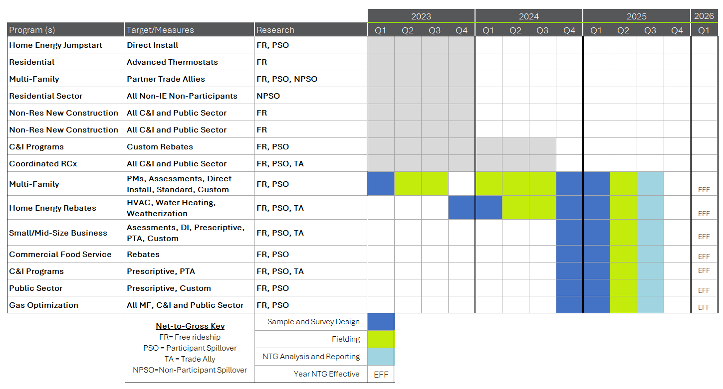

Source: Guidehouse.

## Market Transformation Evaluation

Market Transformation (MT) programs will be more prominent in Plan 4. Guidehouse will support MT efforts with two types of activities: 1) provide advice and insight to support the Companies activities to develop, deliver, and improve each MT initiative, and 2) apply theory-based evaluation to estimate savings attributable to the MT initiative.

1. **Advise:** Guidehouse will advise the Companies and their implementation partners as elements of the market transformation initiative are established following protocols in the TRM, including Logic Model (LM), Market Progress Indicators (MPIs), Energy Savings Framework (ESF), Natural Market Baseline (NMB), MT savings work papers, and methodologies for savings attribution in relation to the Natural Market Baseline. As part of the annual evaluation planning process, Guidehouse will work with the Companies to identify research that could be conducted to improve MT initiative performance during implementation.
2. **Prepare or Verify:** Savings verification for the Market Transformation evaluation will follow the IL Statewide TRM – Volume 4: Cross-Cutting Measures and Attachments, Attachment C: Framework for Counting Market Transformation Savings in Illinois.[7] The TRM protocols provide the framework for measuring interim and long-term indicators of market progress and structural changes, attribution to the program, and cumulative energy impacts. Guidehouse will participate in the SAG MT Working group, communicating methodologies to the Working Group and documenting refinements in the TRM. This may include developing and verifying a Natural Market Baseline, Energy Savings Framework and Market Progress Indicators.

Evaluation research plans for specific market transformation initiatives will be provided in Appendix A.4 as they are developed.

## Portfolio Research

Guidehouse conducts additional research above and beyond annual impact and process evaluation activities as requested, keeping budget priorities in consideration. Guidehouse will work with the Companies and other Illinois parties to identify the programs and measures that could most benefit from these supplemental research activities, being mindful of overall budget availability. Additional research may be requested as needed and considered as a part of the annual evaluation planning process. Guidehouse will leverage research opportunities through jointly funded studies with ComEd, Nicor Gas, and Ameren Illinois when possible.

Guidehouse will work with the Companies to identify research priorities and document these in the annual evaluation plans. Areas for portfolio research include:

* Support for TRM Updates
* Process Evaluation Research
* Other Cross-cutting Research

### Guiding Principles

1. There are limited evaluation resources and Guidehouse will work with the Companies to identify priorities and document these in the annual evaluation plans. Activities will focus first on programs that have not been evaluated, have been significantly modified, provide the most savings, or have activities that were not fully evaluated in an earlier round of evaluations.
2. Gather participant data, perform analysis, and produce recommendations to help improve the functioning and effectiveness of the Companies programs.
3. Within budget constraints, collaborate with Nicor Gas, ComEd, and other Illinois utilities to identify, prioritize, and conduct research, including process evaluation of joint programs and studies of energy efficiency technologies, industry best practices, non-participant characteristics, market characterizations, or other topics of interest.
4. When available to evaluators and appropriate, use gas consumption data when analyzing impacts and customer usage patterns.

### Support for TRM Updates

Activities

The evaluation team will provide support to improve the TRM by participating in the Technical Advisory Committee (TAC) meetings and update process. Guidehouse will work with the Companies to identify priorities and research needs for new measures or updates.

Activities may include reviewing TRM draft versions; developing workpapers for new measures or to update existing measures; and analyzing data from completed evaluation activities to support new measures or update TRM assumptions. Guidehouse will provide technical review for workpapers developed by PGL and NSG and their implementation contractors if requested.

Deliverables

* When identified, submit TRM update or new measure requests to the TRM Administrator
* If a TRM new measure or update request is accepted, produce the corresponding TRM update workpaper

Timing

The TRM is updated annually based on input from Program Administrators, evaluators, and other interested stakeholders through a consensus-based decision-making process. The following TRM schedule will be followed, unless changes are accepted by the TRM TAC:

* **February 26**: Submit TRM update requests to the TRM administrator.
* **April 1:** TRM TAC informs Program Administrators, evaluators, and SAG which measures are high priority measures, for which work papers need to be prepared.
* **May 15:** Proposed updates to existing measure work papers to clarify terms or approaches, as well as proposed work papers for new measures, are submitted to the TRM Administrator.
* **May 15 – September 24**: Ongoing TAC meetings and review/comment on submitted workpapers to reach consensus on TRM updates.
* **October 1:** Final TRM values effective January 1 for the following program year.
* **October/November:** Discussions on evaluation priorities for TRM updates.

### Process Evaluation Research

Activities

We will work closely with the Companies to select which programs and issues would benefit most from process evaluation. The procedure for selecting process evaluation work will be informed by the latest information on program performance, market status, joint-program collaboration opportunities, budget, and Company priorities. We will develop study-specific plans, conduct the evaluation, and deliver insights and recommendations in time for the Companies to incorporate these into the next program year. We will work with the Companies throughout the year to identify emerging issues that could be illuminated by new research (not anticipated in the evaluation plan process) and schedule and implement that research (budget allowing). As appropriate, Guidehouse will coordinate process activities across programs and across utilities for joint programs to address the whole of the Companies approach to the market.

The process evaluation for each program, when conducted, will include in-depth qualitative interviews with Program Administration staff and Program Implementers. These interviews will be used to develop a complete understanding of the final design, procedures, and implementation strategies for each program. Through these interviews, available program materials, including marketing and outreach materials such as web-based promotional content, point of purchase (POP) materials, print and radio advertising copy, and any cooperative marketing materials developed, will be collected.

While the process evaluation methods for each individual program will vary depending on the program’s needs and stage of development, key tasks in conducting process evaluations using interview techniques and documentation review include:

* Develop interview and/or online survey guides.
* Identify appropriate parties to interview or survey. Frequently, the evaluation will include in-depth qualitative interviews with those directly involved in each program, including program managers and implementation contractors, and conduct interviews or online surveys with participating trade allies and participating customers.
* Conduct interviews or online surveys and other research data collection tasks.
* Analysis and reporting of findings and recommendations.

Depending upon the circumstances, Guidehouse will use either a survey house to conduct structured surveys, online survey tools, or senior staff members to complete interviews. Process evaluation surveys will be conducted concurrently with NTG surveys, when appropriate, to minimize the burden on the customer and/or trade ally. Process evaluation findings and recommendations may be summarized in a report separate from the impact evaluation report.

Deliverables

* Presentation of process evaluation research findings and recommendations in memo format or PowerPoint presentation

Timing

* A schedule will be established for each process evaluation deliverable. To support the Companies’ annual planning process for program implementation, initial draft process findings and recommendations will be delivered prior to September 15.

### Other Cross-Cutting Research

In addition to TRM support and process research, cross-cutting evaluation research includes initiatives that contribute toward energy savings and other portfolio goals, such as EUL and new measure research, NTG research, and non-energy impacts (NEIs) research. Evaluation research is coordinated statewide with the evaluators for ComEd, Ameren Illinois, and Nicor Gas and jointly funded and implemented when possible.

### Evaluation Research Activities

Table 2‑6 summarizes evaluation research tasks underway or in the planning stages. The evaluation team will revisit this list on an ongoing basis as, for example, the SAG releases new updates on TRM research priorities and the PGL and NSG portfolio measure mix shifts over time. This regular review will enable Guidehouse’s research to focus on the most important topics for the Companies’ evaluation and SAG stakeholders. Guidehouse will develop research plans over the course of 2025 and as new needs arise and include those in the appendices.

Table 2‑6. Portfolio Evaluation Research

|  |  |  |  |  |  |  |
| --- | --- | --- | --- | --- | --- | --- |
| Research Task | Description | Joint | 2022 | 2023 | 2024 | 2025 |
| NTG Research: Non-Res New Construction Mock NTG Interviews | Conduct “mock” NTG interviews with non-residential new construction implementers to improve free ridership survey questions. Completed 2022. | ✓ | ✓ |  |  |  |
| NTG Research: Residential Non-Participant Spillover Study | Residential Non-Participant Spillover Study, non-joint. This would be an online survey of PGL and NSG residential customers in Q1 or Q2 2023 that have not participated in a PGL or NSG program within the prior three years (2020-2022). Completed 2023. | None |  | ✓ |  |  |
| TRM Support: Water Heater Temperature Setback | Compile Water Heater Temperature Setback default values from historical Elementary Energy Education (EEE) program survey data. Study cost assumes joint funding. October 2021 TRM TAC request. Completed 2023. | ✓ |  | ✓ |  |  |
| TRM Support: Income Eligible Measures | Compile Income Eligible Building and Equipment Baseline Efficiency Characteristics from Historical Program Tracking Data – There currently is very limited distinction made in the TRM for Income Eligible (IE) populations. The TRM Administrator would like to see data routinely collected and analyzed across all applicable studies that would allow distinctions to be made between income qualified versus non-income qualified populations, to allow the TRM to appropriately account for differences where these appear. Examples where differences are thought to exist include kit measure ISRs, appliance efficiencies, central HVAC, insulation levels, secondary market purchases, and electric versus gas heating. October 2021 TRM TAC request. Completed 2023. | ✓ |  | ✓ |  |  |
| Various Joint Research Activities, Including Process Research | ComEd, Ameren, and Nicor Gas are developing evaluation research plans for 2022-2025 across an array of topics. As scope, budget, and timing are firmed up for their research, we will present the opportunities and merits for joint-participation or coordination. This may include updating TRM defaults for non-residential condensing furnaces using tracking data as well as updating residential HVAC incremental measure costs. | ✓ | ✓ | ✓ | ✓ | ✓ |

Source: Guidehouse.

## Evaluation Portfolio Support and Reporting

### Annual Review of the Companies’ Adjustable Savings Goals

Each year, the Companies request that Guidehouse, as its Independent Evaluator, verify the accuracy in the TRM calculations used to derive the measure savings that form the savings goals in the adjustable savings goal spreadsheet in advance of filing the completed adjustable savings goal spreadsheet.

Guidehouse will work with the Program Administrator to review the Adjustable Savings Goals Spreadsheet each year for 2022 through 2025. This review will occur January and February every year. After our review, if we find instances of measures that do not accurately match the effective Illinois TRM Version, Guidehouse will recommend the Companies make updates. Guidehouse will review a revised version of the Adjustable Savings Goals Spreadsheet provided by the Companies to confirm they implemented our recommended measure updates correctly.

Deliverables

* Findings and recommendations from review of draft annual Adjustable Savings Goals templates for the Companies.

### Ad-Hoc Evaluation Support Requests

Guidehouse will produce periodic ad-hoc memos and presentations to assist the Companies and Program Implementer with guidance and program development assistance through the lens of the evaluation contractor perspective, when requested.

### Cost-Effectiveness Review and Summary Reporting

Guidehouse will conduct a TRC cost-effectiveness analysis at the conclusion of the four-year program plan pursuant to Section 8-104(f)(8). Guidehouse will provide a brief annual portfolio summary report for each program year, 2022 through 2025, and will produce a final report summarizing the combined results for the four program years after the conclusion of 2025. The annual portfolio summary reporting will be presented in three spreadsheet documents, using templates recommended by the SAG, accompanied by a memo describing Guidehouse’s approach and source of assumptions. The tables included are:

1. TRC and Program Administrator Cost Test (PACT) Cost-Effectiveness Results Tables
2. Verified Energy Savings and Program Cost Summary Tables
3. High-Impact Measures Tables

Results will include benefit-cost ratios as well as the net present value (NPV) of benefits, costs, and net benefits for the following scenarios:

* with and without non-energy impacts (NEIs) (if available at the time of evaluation), as well as,
* at the portfolio-level TRC, with and without income qualified programs.

The final summary for the four years will include the annual and four-year results in a standard report format. The annual and four-year cost-effectiveness reporting will include a separate joint-utility memo providing the gas and electric costs, benefits, and TRCs for the joint energy efficiency programs that the gas companies offer in conjunction with electric program administrators.

### Job and Macroeconomic Impact Reporting

Guidehouse will produce a draft and final report annually encompassing economic and employment impacts analysis for the Companies energy efficiency portfolio. This analysis will be in alignment with the Illinois Energy Efficiency Policy Manual (the Policy Manual) requirement that each program administrator in Illinois must annually report estimates of the economic development and employment impacts of its energy efficiency programs. The reports may also include estimated impacts for individual Programs. Estimates will include direct, indirect, and induced effects on employment, industry output, and labor income.

Direct effects may include, but are not limited to, the initial changes in employment and demand for regional production triggered by the implementation and management of utility Energy Efficiency Programs. These effects include jobs managing and implementing Programs, Program Implementation Contractor incentives, participant rebates, and bill savings.

Indirect effects may include, but are not limited to, secondary impacts generated from business-to-business spending as firms and households directly impacted by the Energy Efficiency Programs increase purchases from their suppliers who must in turn increase purchases from their suppliers and so forth as the initial expenditure ripples through interconnected industries. These effects include the impact of contractors purchasing equipment from distributors or manufacturers that is needed to implement programs.

Induced effects may include, but are not limited to, secondary impacts generated from household to business spending as labor income changes that result from both direct and indirect activity affect the local economy. This is the effect of additional household income resulting from jobs that are created.

Deliverables

* Annual program summary reporting of verified impacts, cost-effectiveness results and job and macroeconomic reporting.
* A four-year summary report of verified impacts and cost-effectiveness results and job and macroeconomic reporting produced after the end of 2025.

Timing

* Work on the annual cost-effectiveness spreadsheet reports will begin May 1, with draft results available thirty days after all annual impact evaluation reports are final and receiving final program cost data from the Companies. Assuming all final reports and cost data are received by July 15, the first draft will be delivered August 15, and the final report by October 15.
* Assuming all final reports and cost data are received by July 15, the first draft of the Job and Macroeconomic Impact Reporting will be delivered August 31, and the final report by October 31 or best efforts.

## Evaluation Budget

The evaluation budget for work represented in this evaluation plan is presented in Table 2‑7.

Table 2‑7. Evaluation Budget

 Source: Guidehouse.

##### Program Evaluation Plans

Guidehouse has developed program-specific plans to evaluate the entire portfolio of PGL and NSG energy efficiency programs. The following programs are covered in this plan:

* **Residential Programs**
  + Outreach and Education
  + Single Family Home Energy Jumpstart (Self-Assessment)
  + Home Energy Rebate
  + Multi-Family Assessment & Rebates/Grants
  + Epic Savers Kit Program
* **Income Eligible Programs**
  + Income Eligible Single Family
  + Income Eligible Multi-Family
* **Business and Public Sector Programs**
  + Prescriptive Rebates
  + Custom Rebates
  + Gas Optimization
  + Strategic Energy Management
  + Coordinated Retro-Commissioning
  + Coordinated Non-Residential New Construction
  + Small and Mid-Size Business
  + Commercial Food Service
* **Market Transformation Initiatives**

###### Residential Programs

OUTREACH AND EDUCATION

Outreach and Education is designed to provide awareness and education that motivates customers to change behavior and implement small but meaningful efficiency measures through education and provision of low-cost measures. It will also provide information on rebate programs and incentives available for long-term savings measures.

***Energy Efficiency Education***. Fifth-grade teachers are provided lesson plans and activities aligned with state curriculum standards that are designed to teach students about energy production and conservation. Each student will receive a take-home kit containing energy efficient products to install at home with their families.

The evaluation of this program will include the activities shown in Table 1.

Table 1. Evaluation Activities

 Source: Guidehouse.

SINGLE FAMILY HOME ENERGY JUMPSTART

The Single Family Home Energy Jumpstart path is designed to help customers save energy via energy assessments with direct install of low-cost measures and provide recommendations for incentives for efficient measures. The 2024-2025 program will be limited to a Self-Assessment program where a customer completes an online survey and has a kit of products shipped to their home for direct installation. Measures will include low flow showerheads, kitchen and bathroom faucet aerators, programmable/smart thermostats, and pipe insulation at no cost.

The evaluation of this program will include the activities shown in Table 1.

Table 1. Evaluation Activities



For NTG and Process research “X” indicates reporting year

Source: Guidehouse.

The Advanced Thermostat NTG research in 2022 will include thermostats distributed through rebated purchase (Home Energy Rebate Program) or part of an assessment and direct installation program (Home Energy Jumpstart and Multi-Family programs).

HOME ENERGY REBATE

The Home Energy Rebates path is designed to help customers save energy incentives for efficient equipment. Customers may receive incentives for the purchase and installation of higher efficiency furnaces, boilers, thermostats, and insulation/air sealing. The incentives offset the incremental cost of high efficiency equipment and the cost of installation. Trade allies install measures and engage customers.

The evaluation of this program will include the activities shown in Table 1.

Table 1. Evaluation Activities

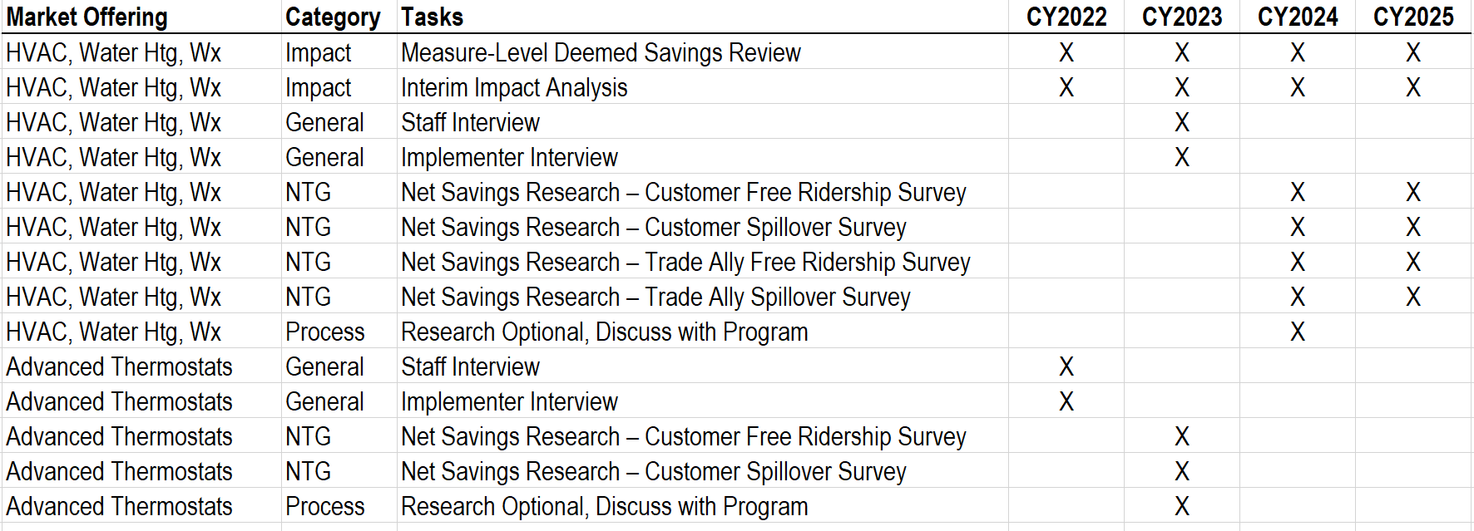

For NTG and Process research “X” indicates reporting year

Source: Guidehouse.

The Advanced Thermostat NTG research in 2022 will include thermostats distributed through rebated purchase (Home Energy Rebate Program) or part of an assessment and direct installation program (Home Energy Jumpstart and Multi-Family programs).

MULTI-FAMILY ASSESSMENTS & REBATES/GRANTS

Multi-Family Assessments and Rebates/Grants target customers who live in multi-family buildings and multi-family building owners/property managers. The path is designed as a one-stop-shop, meaning that the target audience will be able to access all offerings through one point of contact with assistance as needed and requested. Peoples Gas and North Shore Gas intend to work with local organizations with expertise in the multi-family market such as Elevate and Community Investment Corporation.

***Energy Assessment and Direct Install (DI)*** An energy advisor performs a comprehensive energy audit of the building and makes recommendations for direct install and rebate opportunities. A report is provided to building owners/managers on the energy and water saving opportunities present within their facility. Residents receive direct installation of low-cost energy and water saving measures including low flow showerheads, kitchen and bathroom faucet aerators, programmable/smart thermostats, and pipe insulation (at no cost).

***Rebates – Standard and Partner Trade Ally (PTA)*** Pre-qualified, standardized rebates are available for measures such as heating systems, steam traps, and pipe insulation. Incentives are based on the size and efficiency of the equipment installed. A network of selected trade allies, screened and registered, offers measures with higher incentives (20%‐30% higher on average).

***Rebates – Custom*** Customers may receive incentives for non-standard measures, including new construction projects. Incentives are calculated on a $/first year therm savings basis.

***Gas Optimization***. An energy advisor/engineer performs an advanced gas usage study to identify operation and maintenance issues as well as energy conservation measures related to the building heat system.

The evaluation of this program will include the activities shown in Table 1.

Table 1. Evaluation Activities

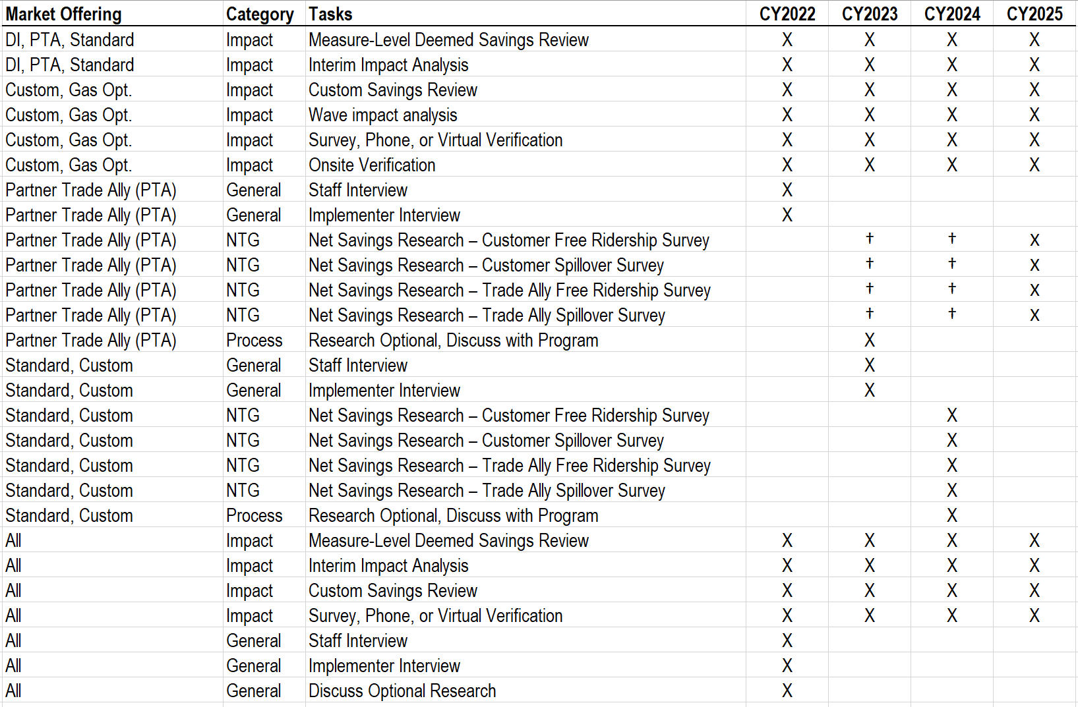

For NTG and Process research “X” indicates reporting year; † Denotes extension of Property Manager NTG research as indicated in Table 2‑3.

Source: Guidehouse.

The Advanced Thermostat NTG research in 2022 will include thermostats distributed through rebated purchase (Home Energy Rebate Program) or part of an assessment and direct installation program (Home Energy Jumpstart and Multi-Family programs).

Epic Savers Kit Program

Epic Savers Kit Program targets the highest energy usage single family homes through a targeted marketing campaign. The program focuses efforts on making these homes more energy efficient and lowering customers’ bills. The program started as a pilot in 2024 as a lever to drive market rate residential savings in 2025 and beyond. The program delivers kits to customers within the North Shore Gas territory. Kits contain energy efficiency measures, program promotions, and information to redeem additional items from an online store (option to use a coupon in the kit to redeem a smart thermostat). Measures included in the kit are showerhead and aerators, door sweep, and hot water temperature setback card.

The evaluation of this program will include the activities shown in Table 1.

**Table 1. Evaluation Activities**



*Source: Guidehouse.*

###### Income Eligible Programs

INCOME ELIGIBLE SINGLE FAMILY

Income Eligible Single Family is designed to help income eligible customers save energy and reduce their utility bills.

***Retrofit*** A comprehensive retrofit is an energy efficiency project that applies a whole building approach and touches multiple systems and components of a customer’s residence. Qualifying customers in existing homes will receive an energy assessment and a comprehensive retrofit that focuses on a whole building approach to improving energy efficiency in the customer’s home. Customers may receive free installation of insulation and air sealing based upon the results of the energy assessments, mechanicals, and electric measures. As needed, customers will receive emergency replacement of heating and water heating systems or a heating system tune-up, and health and safety measures.

***Elementary Energy Education*** Fifth‐grade teachers are provided lesson plans and activities aligned with state curriculum standards that are designed to teach students about energy production and conservation. Each student will receive a take‐home kit containing energy efficient products to install at home with their families. The program will target schools in neighborhoods that quality as income eligible.

***Home Energy Assessments*** Offers energy-saving products installed in homes at no cost to the customer. Option for virtual assessment: the goal of this pathway will be used as another touch point with income eligible customers and an opportunity to drive them toward the more comprehensive retrofit paths.

***Income Eligible Kits*** Provides income-qualified customers with a kit of energy efficiency measures to self-install. The Income Eligible Gas Kits are distributed by ground mail to qualified customers vetted by the Low-Income Eligible Home Energy Assistance Program (LIHEAP).

The evaluation of this program will include the activities shown in Table 1.

Table 1. Evaluation Activities



Source: Guidehouse.

INCOME ELIGIBLE MULTI-FAMILY

Income Eligible Multi-Family is designed to offer a comprehensive, one-stop-shop to multi-family building owners whose buildings are targeted to income eligible residents. Participating multi-family building owners and managers will benefit directly from free energy assessments, financial guidance and enhanced rebates, installation support, project oversight and continuing engagement.

***Retrofit*** A comprehensive retrofit is an energy efficiency project that applies a whole building approach and touches multiple systems and components of a customer’s residence. A technician will conduct a comprehensive energy assessment to identify energy savings opportunities. This will include a site visit with a visual and diagnostic inspection as well as an analysis of utility bills. The assessment will report on opportunities for direct installation of low-cost measures both in-unit and common areas, plus comprehensive retrofit opportunities that focus on a whole building approach to improving energy efficiency. Building owners will receive a report detailing estimated costs and savings for the efficiency improvements. They will receive enhanced incentives and possibly financing for the purchase and installation of efficient equipment. The incentives help offset the incremental cost of high efficiency equipment and the cost of installation. As needed, buildings will receive health and safety measures as well as, direct installation of unit measures at no cost.

***Partner Trade Ally (PTA)*** Trade Allies are given higher rebate amounts to serve geographically income-eligible customers with retrofit measures.

***Income Eligible Kits*** Provides income-qualified customers with a kit of energy efficiency measures to self-install. The Income Eligible Gas Kits are distributed by ground mail to qualified customers vetted by the Low-Income Eligible Home Energy Assistance Program (LIHEAP).

The evaluation of this program will include the activities shown in Table 1.

Table 1. Evaluation Activities



Source: Guidehouse.

The ComEd evaluation team will conduct additional income eligible process evaluation research in 2023 and 2024 to support ComEd’s compliance with the Plan 6 Stipulation Agreement.[8] As the ComEd evaluation plan for this research develops further, we will discuss with PGL and NSG program staff the opportunities and merits for collaboration or coordination.

**PUBLIC HOUSING AUTHORITY**

The Income Eligible Public Housing Authority (PHA) program provides broad and impactful energy efficiency opportunities to Public Housing Authorities to help the income-qualified households they serve. The PHA program will be delivered jointly with other program administrators including ComEd, Ameren, and Nicor Gas.

The evaluation of this program will include the activities shown in Table 1.

**Table 1. Evaluation Activities**



*Source: Guidehouse.*

###### Business and Public Sector Programs

PRESCRIPTIVE REBATES

C&I and Public Sector customers may receive pre-qualified, standardized rebates available for the most common efficiency upgrades, such as heating systems, steam traps, and pipe insulation. The incentives are based on the size and efficiency of the equipment installed.

The evaluation of this program will include the activities shown in Table 1.

Table 1. Evaluation Activities



For NTG and Process research “X” indicates reporting year

Source: Guidehouse.

The NTG interviews in the Public Sector will cover Prescriptive and Custom project participants, due to the project type overlap and decision-making similarities within Public Sector customers and the trade allies that serve them.

CUSTOM REBATES

C&I and Public Sector Custom Rebate customers may receive incentives for non-standard measures, including new construction projects. Incentives are calculated on a $/first year therm savings basis. Staff will work with customers to identify and quantify savings opportunities for complex projects. New construction incentives are designed to push building efficiency beyond what is required through compliance with building codes, through an integrated, comprehensive, whole‐building analysis early in the design phase.

The evaluation of this program will include the activities shown in Table 1.

Table 1. Evaluation Activities



For NTG and Process research “X” indicates reporting year

Source: Guidehouse.

The Custom Rebate NTG interviews in the C&I sector will be conducted in 2023 and 2024 for reporting in 2024. Public Sector NTG research for Custom Rebates will occur one year later, for reporting in 2025, to cover Prescriptive and Custom project participants, due to the project type overlap and decision-making similarities within Public Sector customers and the trade allies that serve them.

GAS OPTIMIZATION

Gas Optimization Studies that focus on identifying low‐cost or no‐cost “actionable” measures for building heating, central steam plant and/or process heating energy optimization. The studies will incorporate limited monitoring and testing as necessary.

The evaluation of this program will include the activities shown in Table 1.

Table 1. Evaluation Activities

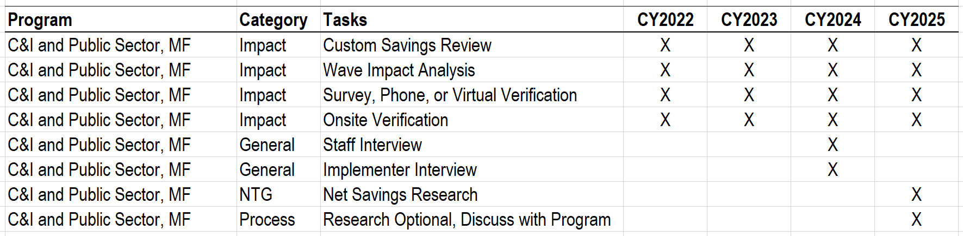

For NTG and Process research “X” indicates reporting year

Source: Guidehouse.

The NTG research will cover C&I, Public Sector, and Multi-Family participants. Sector-specific NTG values will be reported if the population and response count support them, otherwise a single NTG will cover all sectors.

STRATEGIC ENERGY MANAGEMENT

Strategic Energy Management engages customers in long-term continuous energy efficiency improvements at their facilities by involving site management, leveraging data, and promoting best practices at the site.

The evaluation of this program will include the activities shown in Table 1.

Table 1. Evaluation Activities



Source: Guidehouse.

COORDINATED RETRO-COMMISSIONING

The Retro-Commissioning (RCx) Program seeks to realize energy savings by restoring building HVAC systems and optimizing controls to meet the needs of the current building occupants. The program is managed by ComEd, and ComEd coordinates with Nicor Gas, Peoples Gas, and North Shore Gas to account for gas savings generated through the program.

The evaluation of this program will include the activities shown in Table 1.

Table 1. Evaluation Activities

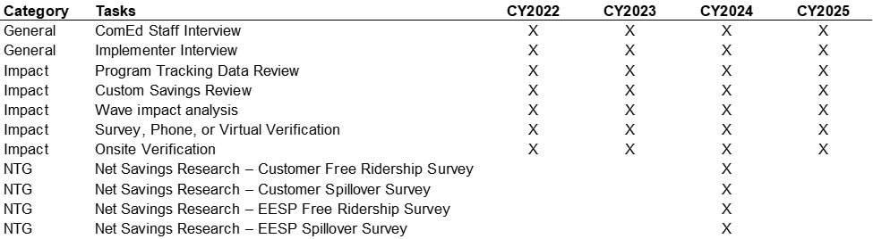

For NTG and Process research “X” indicates reporting year

Source: Guidehouse.

Guidehouse will perform program tracking data review and project reviews quarterly in 2025. Our overarching goal is to research savings impacts sufficiently to report program-level savings at ±10% precision and 90% confidence. The default strata will be defined by project size and offering type.

The impact research sample will be drawn quarterly based on the projects labeled “Ready for Evaluation” in the Ops Report provided by the implementation contractor. After program ex ante results are final, the progressive quarterly sample will be compared to the year-end program participation and savings, and we will adjust the sample to comply with sampling goals.

In 2024 the evaluation team will conduct a NTG study to research free ridership and spillover. We will survey participants and interview active EESPs to research free ridership and spillover. We will triangulate their results to inform the final recommended NTG value in 2024 using methods defined in the Illinois TRM.

COORDINATED NON-RESIDENTIAL NEW CONSTRUCTION

The New Construction Program is offered jointly to non-residential (including public sector) customers served by ComEd and Nicor Gas.[9] The program aims to capture immediate and long-term energy efficiency opportunities that are available during the design and construction of non-residential and multifamily buildings in ComEd’s service territory. The program covers new buildings, additions, and major renovations. Slipstream implements the program for ComEd and Nicor Gas.

The program offers two different program tracks to tailor program support to different types of participants and specific business segments.

* **Performance path:** Offers a custom, hands-on technical approach to new construction projects and targets projects that are early in the design phase to maximize opportunities to influence the incorporation of high performance design strategies. Technical staff use whole building energy simulations (including energy models and spreadsheet calculations) to optimize the building design for energy performance. Modeling results include incentive amounts and annual energy cost savings estimates. This allows the design team to identify design strategies and technologies that will take their building design further and have the greatest impact on the building’s energy use.
* **Best Practices path:** Offers a more prescriptive approach to new construction projects. This pathway was designed for fast-moving, developer-led projects or small projects. This includes predetermined lists of measures and incentives that are available for specific building types along with resources and guidelines for how to best implement those measures. This path provides an optimized and predictable incentive pathway with predefined, per-square foot incentives for achieving specific energy efficiency best practices, as well as optional advanced measures. The building types that are available through the Best Practices path are listed as follows:
  + Warehouse and industrial
  + Multifamily and assisted living
  + Office
  + Retail and grocery
  + Parking garage

The program is still serving projects that entered the program prior to program year 2020 under one of the legacy participation tracks.

The evaluation of this program will include the activities shown in Table 1.

Table 1. Evaluation Activities

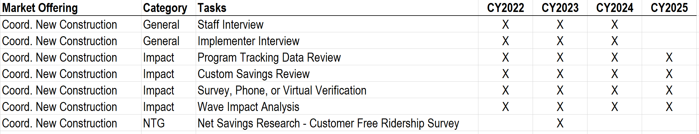

For NTG and Process research “X” indicates reporting year

Source: Guidehouse.

The gross impact evaluation will be based on a custom savings review. We will perform a program tracking data review and custom savings review in two waves. The first wave is expected to cover the first half of the calendar year (January 1-June 30) and the second wave is expected to cover the second half (July 1-December 31). Each wave will consist of a tracking data review, followed by stratified random sampling of all completed projects and a custom savings review of sampled projects.

The custom savings review will include desk reviews of all sampled projects, including reviewing and, if needed, revising building energy simulation models. On a project-by-project basis, the evaluation team will determine if survey, phone, or virtual verification activities are necessary to complement desk review activities. We will present realization rate results overall for the program by fuel type, inclusive and exclusive of interactive effects.

Per the program design, the baseline for all projects will typically be based on the applicable Illinois Energy Conservation Code (ICC) for Commercial Buildings. The ICC references the International Energy Conservation Code (IECC), which also allows for use of ASHRAE Standard 90.1 as an alternate compliance method. For each project, the applicable code version will be determined by the issuance date of the construction permit. We will also allow for a grace period (in years) with IECC code updates. Therefore, projects with permit issuance dates at or after January 1 of the year following an IECC code update will be assigned the newest IECC code version as a baseline.

In 2024, the evaluation team learned that this program would end with 2025. Therefore, we no longer plan to research NTG for this program.

SMALL/MID-SIZE BUSINESS ASSESSMENTS & REBATES

Small business owners are often time-constrained, unaware of energy efficiency opportunities, and lack dedicated staff who concentrate on the facility’s energy use. As such, they are a hard-to-reach target audience. While some business owners are also the property owner, many lease their space and consequently have little motivation to make major improvements to their tenant’s premises.

***Direct Install*** Customers receive direct installation of low-cost energy and water saving measures including low flow showerheads, kitchen and bathroom faucet aerators, pipe insulation and, if applicable, pre-rinse sprayers (at no cost). A high-level, no-cost assessment of the facility will be completed while at the site to identify additional energy efficiency improvements the small business owner/tenant can pursue.

***Prescriptive Rebates*** Pre-qualified, standardized rebates are available for the most common efficiency upgrades, such as heating systems, steam traps, and pipe insulation. Incentives are based on the size and efficiency of the equipment installed.

***Partner Trade Ally (PTA)*** A network of trade allies promotes measures and assists in engaging customers to participate in site assessments to identify savings opportunities. To serve as a PTA, participation, and customer satisfaction goals much be achieved. Customers using a PTA will be eligible for enhanced rebate levels.

***Custom Incentives*** Customers may receive incentives for non-standard measures, including new construction projects. Incentives are calculated on a $/first year therm savings basis. Staff will work with customers to identify and quantify savings opportunities for complex projects.

The evaluation of this program will include the activities shown in Table 1.

Table 1. Evaluation Activities



For NTG and Process research “X” indicates reporting year

Source: Guidehouse.

COMMERCIAL FOOD SERVICE PROGRAM

The upstream commercial food service (CFS) rebate program builds on the progress, analysis, and experience gained from a jointly funded pilot program that has been successfully running since 2018. The goal is to support and sustain a comprehensive list of measures for the food service industry to give operators a range of options for improving energy efficiency in their facilities. The CFS program is implemented and evaluated as a path under the Small/Mid-Size Business program.

The evaluation of this program will include the activities shown in Table 1.

Table 1. Evaluation Activities



For NTG and Process research “X” indicates reporting year

Source: Guidehouse.

The evaluation team will perform net-to-gross (NTG) savings research to update the pilot’s NTG ratio for reporting in 2025. This research will include process evaluation into the pilot’s market engagement and customer satisfaction.

###### Market Transformation Initiatives

Detailed plans will be added to this Compendium as these are developed.

1. A program that accounts for less than 3% of portfolio savings and has a history of consistent verified savings realization rates with values close to 100% at both the measure level and program level will be considered for applying the previous year’s realization rates. Candidate programs include Energy Education Outreach, Home Energy Assessment (Jumpstart), Community Joint Kits, and Public Housing Energy Savings programs.
2. A program that accounts for less than 3% of portfolio savings and has a history of realization rates at or near 100% may not receive interim impact review. If a program has completed an interim impact review and measures or program realization rates are consistent with historic values, the evaluation may use the interim realization rates for the end of year evaluation.
3. Utilizing “best efforts” is Illinois Energy Efficiency Policy Manual Version 3.0, draft impact evaluation reports.
4. https://www.ilsag.info/wp-content/uploads/IQ-Multi-Family-Reporting-Metrics_FINAL-Clean-6-20-2024_v2.pdf
5. https://www.ilsag.info/wp-content/uploads/Equity-and-Affordability-Reporting-Policy-Metrics_FINAL-Clean-6-20-2024.pdf
6. Illinois Energy Efficiency Policy Manual Version 3.0, Section 7.5, Free Ridership and Spillover.
7.
8. “Evaluation of Customer Engagement and Targeted Energy Efficiency Delivery Efforts: ComEd will direct its independent evaluator to perform one or more process evaluations of the Customer Engagement and Mapping of Assistance Needs and Targeting Delivery of Weatherization Services efforts described above during the Plan 6 Period and will share the results at a joint SAG and Committee meeting.” (Revised Stipulation Agreement, February 28, 2022, section IV.A.6.c)
9. Peoples Gas and North Shore Gas offered the program in the previous program cycle and continue to support legacy projects, although they are no longer accepting new applications.