|  |  |
| --- | --- |
| To: | ComEd, Nicor Gas, Peoples Gas, and North Shore Gas |
|  |  |
| CC: | Elizabeth Horne, ICC Staff; Jeff Erickson, Nishant Mehta, Charles Ampong, Laura Agapay-Read, Guidehouse |
|  |  |
| From: | Sagar Phalke, Christopher Frye, Guidehouse, Sharon Mullen, EcoMetric |
|  |  |
| Date: | August 21, 2024 |
|  |  |
| Re: | Net-to-Gross Research Results for the IL Coordinated Retro-Commissioning Program |

# Executive Summary

This memo presents the results from the net-to-gross (NTG) study of the IL Coordinated Retro-Commissioning (RCx) Program offered jointly to customers served by ComEd, Nicor Gas, Peoples Gas, and North Shore Gas. The NTG calculations rely on the NTG algorithms agreed to by the Illinois Stakeholder Advisory Group (SAG) Non-Residential Net-to-Gross Working Group and use the self-report approach for estimating free ridership (FR) and spillover (SO). These results will inform Guidehouse’s September 2024 draft recommendations to the Illinois SAG of NTG values to be used for this program in CY2025.

The findings are derived from telephone interviews and web surveys administered to two populations, including customers to assess the participant perspective and Energy Efficiency Service Providers (EESPs) to assess the trade ally (TA)[1] perspective. These interviews and surveys researched both FR and SO effects. The customer FR surveys were administered to participants of the RCx program who completed projects in CY2023, using a mixed mode of both online and phone-administered surveys. For SO surveys, Guidehouse administered these online to participants of the RCx program who completed projects in CY2022. Guidehouse administered both FR and SO batteries to EESPs who completed projects in CY2023, using a mixed mode of both online and phone-administered surveys. The NTG findings are based on the outcome of three phone interviews and nine web surveys with CY2023 participants for FR and eight web surveys with CY2022 participants for SO, supplemented by five interviews and eight web surveys with CY2023 EESPs for both FR and SO.

The response rate was moderate among participants but high among EESPs. As shown in Table 2, 21% of participants responded to the free ridership survey, responsible for 46% of kWh and 49% of Therms savings. The participant spillover survey achieved a 19% response rate among participants responsible for 24% of kWh savings and 14% of Therms savings (Table 3). Seventy-two percent of EESPs responded to one survey that combined free ridership and spillover. The respondents were responsible for 87% of kWh and 99% of Therms savings.

Table 1 summarizes the RCx Program FR and SO research findings based on the

participant and EESP research. Guidehouse expects to recommend to the Illinois SAG these values be used for this program in CY2025. This represents a decline from the current NTG value of 0.94 for electric (kWh) and 0.97 for gas (therms).

Table 1. NTG Research Results for RCx Program

|  |  |  |  |  |
| --- | --- | --- | --- | --- |
| Savings Type | Free Ridership | Participant Spillover | EESP Spillover | NTG Ratio |
| kWh | 0.16 | 0.00 | 0.00 | 0.84 |
| Therms | 0.16 | 0.00 | 0.00 | 0.84 |

Source: Evaluation team analysis

# Free Ridership and Spillover Survey Disposition

The evaluation team conducted a combination of telephone interviews and web surveys with key decision makers. The participant and EESP web surveys were fielded by Guidehouse using web survey software. The evaluation team targeted high-saving CY2023 participants[2] (both customer and EESPs) for a telephone interview and emailed survey invitations to the rest of the customers who participated in the program in CY2022 (SO only) and CY2023 (FR only). Similarly, links to web surveys were also emailed to all remaining program EESPs that completed projects in CY2023 (both FR and SO).

Out of a total census of 18 unique EESPs, we completed 13 surveys representing 72% of the population and 87% of EESP kWh savings (99% of Therm savings). Out of a total census of 101 unique participants, we completed 20 surveys representing 20% of the population and 38% of participant kWh savings (40% of therm savings). We combined the participant and EESP perspective of FR and SO using Section 5.1 of the IL TRM v12.0. Table 2 presents the representativeness of completes for each survey.

Table 2. Free Ridership Sample Disposition

|  |  |  |  |  |  |  |
| --- | --- | --- | --- | --- | --- | --- |
| Category | Population | Sample | Actual Completes | Response Rate | Respondent Share of Program Savings (kWh) | Respondent Share of Program Savings (Therms) |
| Participants | 58 | Census | 12 | 21% | 46% | 49% |
| EESPs | 18 | Census | 13 | 72% | 87% | 99% |

Source: Guidehouse Research

Table 3. Spillover Sample Disposition

|  |  |  |  |  |  |  |
| --- | --- | --- | --- | --- | --- | --- |
| Category | Population | Sample | Actual Completes | Number Qualified for SO | Respondent Share of Program Savings (kWh) | Respondent Share of Program Savings (Therms) |
| Participants | 43 | Census | 8 | 0 | 24% | 14% |
| EESPs | 18 | Census | 13 | 0 | 87% | 99% |

Source: Guidehouse Research

# Free Ridership and Spillover Protocols

This section discusses the free ridership and spillover approach used for the research.

## Participant Free Ridership Estimation

Based on TRM guidance, the proper algorithms for use with Retro-Commissioning Programs is the Study-Based Protocol (per Table 3-1, IL TRM v12, Volume 4 – Attachment A, page 42). This algorithm is based on the core non-residential free ridership algorithm with some exceptions. Figure 1 below illustrates the calculation of the program influence FR score, efficiency FR score, and the final FR value, while Figure 2 and Figure 3 illustrate the way the counterfactual scores are calculated.

Figure 1. Study-Based Free Ridership – Overview

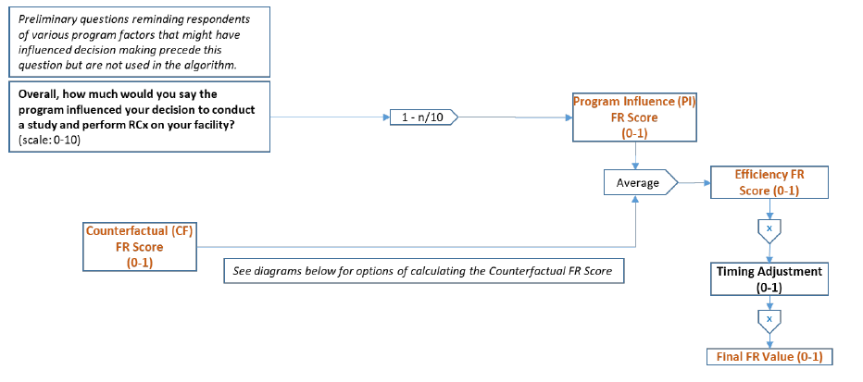

Source: 2024 Illinois TRM Version 12.0, Volume 4: Cross-Cutting Measures & Attachments, Page 56, Figure 3-2

Figure 2. Study-Based Free Ridership – No Program FR Score Option #1

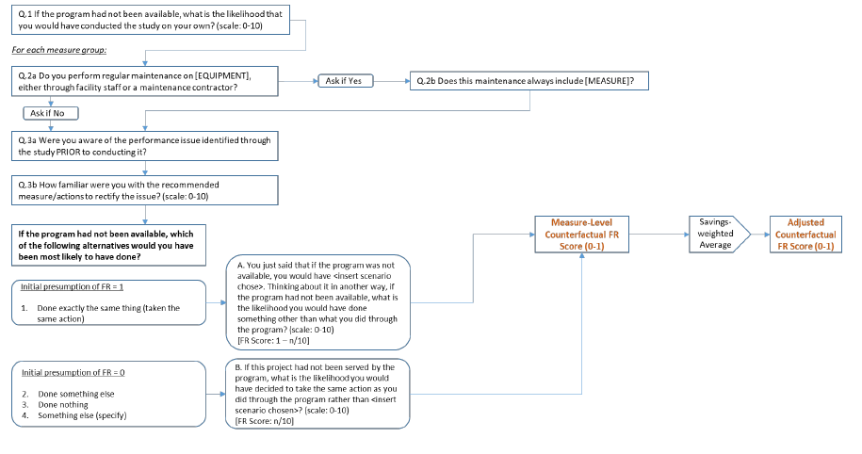

Source: 2024 Illinois TRM Version 12.0, Volume 4: Cross-Cutting Measures & Attachments, Page 57, Figure 3-3

Figure 3. Study-Based Free Ridership – No Program FR Score Option #2

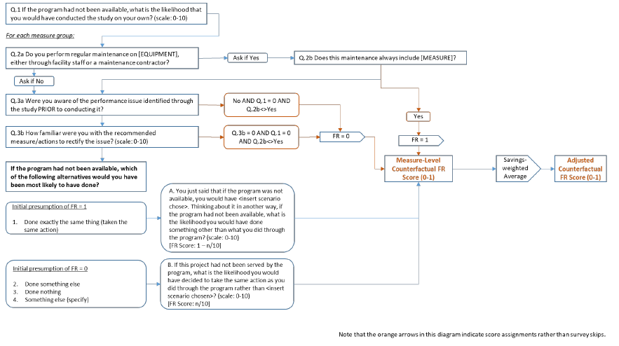

Source: 2024 Illinois TRM Version 12.0, Volume 4: Cross-Cutting Measures & Attachments, Page 58, Figure 3-4

## Participant Spillover Estimation

The illustration in Figure 5 is based on guidance in the IL TRM v12 under Volume 4, Section 3.1.2.2: Approach for Identifying and Quantifying Spillover.

Figure 5. Spillover Algorithm – Participant

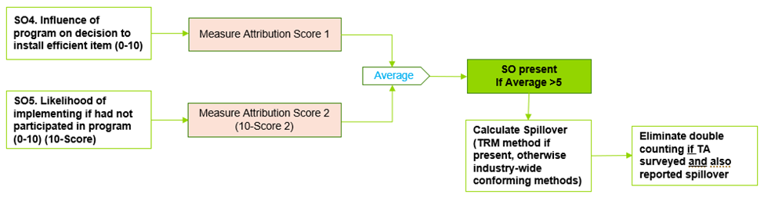

Source: 2024 Illinois TRM Version 12.0, Volume 4: Cross-Cutting Measures & Attachments, Page 48

## EESP Free Ridership Estimation (2024 & 2021)

Figure 6 describes the approach to assess free ridership from an EESP perspective. We have also included a diagram of the algorithm used in 2021 among the EESP population which appears in Figure 7. The one change we would note between these two algorithms is that the 2021 version asked about what percent of savings customers would have achieved in the absence of the program, while the 2024 version asked both percent and measure count, in addition to calculating their estimate of the counterfactual relative to actual incented measures installed.

Figure 6. 2024 Free Ridership Algorithm – EESP

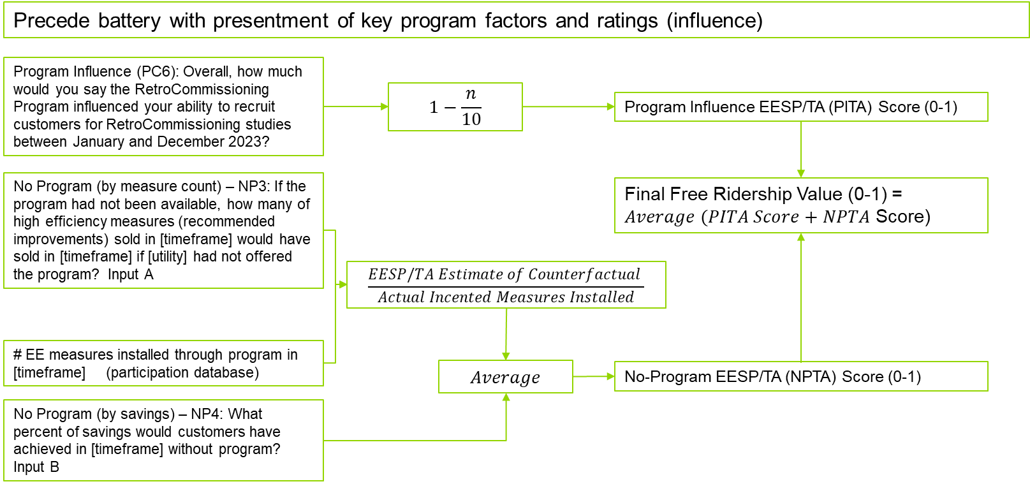

Source: Guidehouse

Figure 7. 2021 EESP Free Ridership Algorithm

## EESP Spillover Estimation

Figure 8 describes the approach to assess EESP spillover.

Figure 8. 2024 Spillover Algorithm – EESP

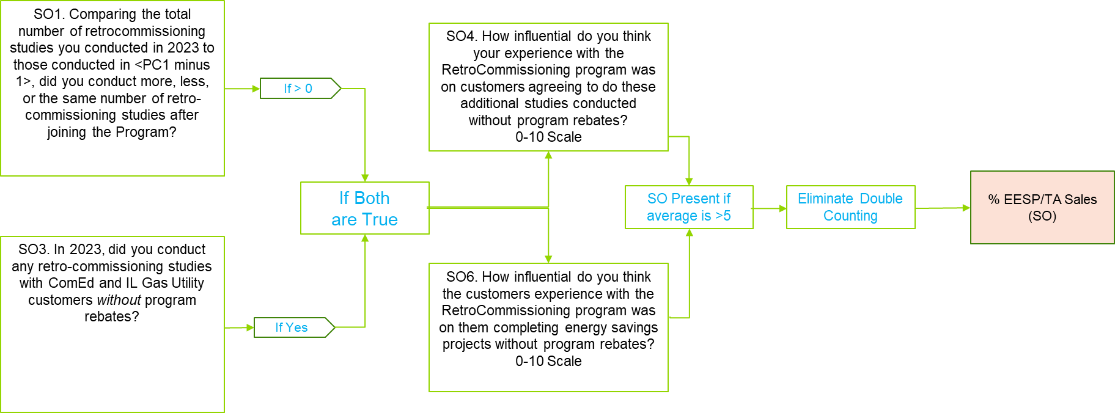

Source: Guidehouse

# Participant and EESP Free Ridership Results

Using the protocols detailed above and data collected during the participant and EESP interviews and surveys, FR estimates were calculated for the Retro-Commissioning Program participants and trade allies. Table 4 below presents the FR estimates and the relative precision of the estimates. As this table shows, participant-based FR estimates varied ranging from 0.000 to 0.400 with a weighted average of 0.104 for Electric and 0.146 for Gas. The trade ally-based FR estimates were relatively higher, ranging from 0.000 to 0.613 with a weighted average value of 0.203 for Electric and 0.167 for Gas. The difference between the participant and trade ally overall FR estimates was 0.10 for Electric and 0.02 for Gas. The average weighted FR value was 0.156 for Electric and 0.157 for Gas (see Page 8 for details of combined participant and trade ally FR estimate).

Table 4. Relative Precision and Free Rider Estimates

|  |  |  |  |  |  |  |
| --- | --- | --- | --- | --- | --- | --- |
| Category | Relative Precision | | Raw Free Ridership Range | | Weighted Free Ridership | |
| **Electric** | **Gas** | **Electric** | **Gas** | **Electric** | **Gas** |
| Participant | 5% | 6% | 0.000-0.400 | 0.000-0.181 | 0.104 | 0.146 |
| EESP | 1% | 3% | 0.000-0.613 | 0.000-0.613 | 0.203 | 0.167 |

Source: Guidehouse primary research

## Free Ridership Consistency Check Analysis

The evaluation team checked for consistency in free rider responses. Respondents were asked to describe in their own words any influence that the Retro commissioning Program had on their decision to implement the measures at their facilities.

According to the IL TRM v12.0, Volume 4, Section 3.1.1.1.5, a program’s influence and counterfactual consistency check is triggered when either of the following conditions are met:

1. The Program Influence FR Score is greater than 0.7 AND the Counterfactual FR Score is less than 0.3.

OR

1. The Program Influence FR Score is less than 0.3 AND the Counterfactual FR Score is greater than 0.7.

For respondents that failed the consistency checks, the evaluation team reviewed the verbatim responses to determine the weight of the program influence against the counterfactual responses and timing adjustments to arrive at a free ridership score.

The evaluation team determined that one of the thirteen EESP respondents failed the consistency check, which triggered a detailed review of the verbatim responses for that EESP. The team found that the respondent’s answer to the verbatim question was reasonably consistent with the influence and counterfactual scores. As a result, the evaluation team used the raw free ridership score, an average of the counterfactual and influence scores, to calculate that respondent’s free ridership.

The evaluation team found no inconsistencies in the verbatim responses for the participant free ridership and so did not adjust scores for that calculation.

## Participant Free Ridership Detailed Results

The TRM requires that evaluators analyze the participant data for a “no program free ridership score” following two different algorithms, labeled as Option 1 (Figure 2) and Option 2 (Figure 3). The algorithms are similar in that they both ask a counterfactual rating question to determine the likelihood of performing defined actions absent the program. Option 2 also calculates a free ridership value of zero (no free ridership) or one (full free rider) to average with the counterfactual rating question. The results of these approaches are offered in Table 5.

Table 5. TRM "No Program" Methodology Results

|  |  |  |
| --- | --- | --- |
| TRM “No Program” Methodologies | Average Raw Efficiency Score, Electric | Average Raw Efficiency Score, Gas |
| Option 1 | 0.117 | 0.106 |
| Option 2 | 0.150 | 0.226 |

Source: Guidehouse primary research and analysis

The evaluation team used the Option 1 “No Program” scores because we found that the raw free ridership calculated using Option 1 more closely adhered to the respondent verbatim in response to the question[3] that asked respondents to explain the program’s impact on their decision to take energy saving actions recommended through the program-incented facility study.

Examples of verbatim responses supporting the Team’s decision to favor Option 1 include: “Very impactful. Has saved the property a lot in energy usage.” (Option 1 free rider score of 0.083, Option 2 score of 0.150); and “The program gives us a lot of detail/info to know what to take action on. Partnership/teamwork with ComEd and vendor is very helpful.” (Option 1 free rider score of 0.125, Option 2 score of 0.157).

## Combining Participant and EESP Free Ridership

Guidehouse calculated a combined participant and trade ally FR estimate utilizing the triangulation approach outlined in IL TRM v12.0 (Volume 4, Section 5.1). This approach calculates a weighted average of the participant and EESP FR results using the weighting approach shown in Table 6 below.

This approach rates the participant and trade ally survey data on three aspects: accuracy, validity, and representativeness, Assigning a score to each respondent group for each aspect. The scores are then weighted to assign a percentage to the participant data and the EESP data that totals 100%.

1. **Accuracy**: How likely is the approach to provide an accurate estimate of FR?
   1. We assigned the participant response a value of 90% because we followed the TRM approach, which was considered the most appropriate approach at the time of development based on the IL NTG Working Group and SAG perspectives, and because the consistency check responses agreed with the raw free rider scores.
   2. We assigned the EESPs a value of 60% because, while the consistency check responses agreed with the raw free rider scores, the TRM does not currently contain a standardized approach for measuring FR from trade allies. Guidehouse has used this approach for several years now, and it should be refined and finalized in a future iteration of the TRM via the NTG Working Group process.
2. **Validity**: How valid are the data collected and analysis?
   1. We assigned the participant response a value of 70% because we followed the TRM approach. The 21% response rate may have produced some non-response bias, and earlier participants may have recall bias for a survey fielded in Q3 2024.
   2. We assigned the trade ally results a value of 80% since the response rate is high at 72%. Factors that lower this score are potential quantitative estimates from EESPs that rely on best estimates made at the time of the survey rather than historical record keeping.
3. **Representativeness**: How representative is the sample?
   1. We calculated the participant and EESP values using the percentage of program savings represented by respondents. Resulting scores were 46% (Electric) and 49% (Gas) for Participants and 87% (Electric) and 99% (Gas) for EESPs.

Table 6. Triangulation of Participant and EESP Free Ridership

| Free Ridership Triangulation Data and Analysis | Electric | | Gas | |
| --- | --- | --- | --- | --- |
| Participant | EESP | Participant | EESP |
| Free Ridership | 0.104 | 0.203 | 0.146 | 0.167 |
| How likely is this approach to provide an accurate estimate of free ridership? | 90% | 60% | 90% | 60% |
| How valid is the data collected/analysis? | 70% | 80% | 70% | 80% |
| How representative is the sample? | 46% | 87% | 49% | 99% |
| Average Score | 69% | 76% | 70% | 80% |
| Sum of Averages | 144% | | 149% | |
| Weights | 48% | 52% | 47% | 53% |
| Weighted FR Value | 0.050 | 0.107 | 0.068 | 0.089 |

Source: Guidehouse primary research

Applying these participant and EESP weights to the FR estimates yields the blended FR estimate shown in the equation below.

$$Free Ridership=\left(Participant FR*Participant Weight\right)+\left(EESP FR*EESP Weight\right)$$

$$Free Ridership_{ELECTRIC}=0.104*0.48+0.203*0.52=0.156$$

$$Free Ridership_{GAS}=0.146*0.47+0.167*0.53=0.157$$

The evaluation team used this formula to combine the participant free ridership with the EESP free ridership to produce the weighted average free ridership of 0.156 for Electric savings and 0.157 for Gas savings.

## Comparison of 2021 and 2024 Results

Table 7 and Table 8 provide a comparison between the previous results published in 2021[4] and the current results for 2024. Table 7 focuses on survey completes and representation.

Table 7 provides counts of the population (sample) for both participants and EESPs in both 2021 and 2024, along with actual completes, response rate, and the respondent share of program savings captured by respondents completing the survey, in both kWh and therms. Please note that we include all respondents from 2024, including those answering free ridership and spillover questions as the 2021 study asked both questions of all participant respondents. In both response rate and savings captured, the 2024 results are higher than that achieved in 2021. In the case of EESPs, this is substantially higher, particularly with regard to savings captured (both kWh and therms).

Table 7 Comparison of 2021 and 2024 Survey Completes and Representation

| Year / Population | | Number | Sample | Actual Completes | Response Rate | Respondent Share of Program Savings (kWh) | Respondent Share of Program Savings (Therms) |
| --- | --- | --- | --- | --- | --- | --- | --- |
| 2024 | Participants | 101 | Census | 20 | 20% | 38% | 40% |
| EESPs | 18 | Census | 13 | 72% | 87% | 99% |
| 2021 | Participants | 132 | Census | 17 | 14% | 12% | 11% |
| EESPs | 25 | Census | 10 | 42% | 33% | 15% |

Source: Guidehouse primary research; note that the 2021 participants answered both FR and SO batteries.

The relative precision was within the target range for both 2021 and 2024, as shown in Table 8. While the participant free ridership declined in 2024 by 0.086 for electric and 0.014 for gas, the EESP free ridership increased in 2024 by 0.153 for electric and 0.157 for gas.

Table 8 Comparison of 2021 and 2024 Relative Precision and Free Rider Estimates

|  |  |  |  |  |  |
| --- | --- | --- | --- | --- | --- |
| Category | | Relative Precision | | Weighted Free Ridership | |
| **Electric** | **Gas** | **Electric** | **Gas** |
| 2024 | Participant | 5% | 6% | 0.104 | 0.146 |
| EESP | 1% | 3% | 0.203 | 0.167 |
| 2021 | Participant | 7% | 10% | 0.19 | 0.16 |
| EESP | 8% | 8% | 0.05 | 0.01 |

Source: Guidehouse primary research

# Participant and EESP Spillover Results

Of the eight participant survey respondents included in the participant spillover analysis, four reported that they had installed additional energy efficient measures and of those, all indicated they had received program incentives. No respondents qualified for spillover.

Of the 13 EESPs included in the trade ally analysis, two reported performing additional non-program incented retro-commissioning studies. However, none of the EESPs passed all spillover screening criteria. Therefore, spillover is calculated at 0.00.

# Final NTG Results and Recommendations

Table 7 summarizes Guidehouse’s recommendations for the Retro-Commissioning Program to be used in CY2025.

Table 7. Summary of Free Ridership, Spillover, and NTG Research Results for Retro-Commissioning Program

|  |  |  |  |  |
| --- | --- | --- | --- | --- |
| Fuel Type | FR | PSO | ATSO | NTG |
| kWh | 0.16 | 0.00 | 0.00 | 0.84 |
| Therms | 0.16 | 0.00 | 0.00 | 0.84 |

FR = Free Ridership; PSO = Participant Spillover; ATSO = Active Trade Ally Spillover.

NTG = 1 – FR + PSO + ATSO

Source: Guidehouse primary research

##### Program NTG History

###### Retro-Commissioning Program NTG History – ComEd

|  | **ComEd Retro-Commissioning** |
| --- | --- |
| EPY1 | **NTG:** 0.8  **Free ridership:** 0%  **Spillover:** 0%  **Method:** Program *ex ante* assumption.  Customer self-report. Two completed surveys from a population of four participants bracketed the assumed NTG. Basic method. |
| EPY2 | **NTG:** 0.916  **Free ridership:** 8.4%  **Spillover:** 0%  **Method:** Customer self-report. Five surveys completed from an attempted census of a population of 13. Basic method. |
| EPY3 | **NTG:** 0.71  **Free ridership:** 28.7%  **Spillover:** 0%  **Method:** Customer self-report. Eight surveys completed from an attempted census of a population of 34 participants. Basic method. |
| EPY4 | **Deemed NTG from EPY2:** 0.916  **Research NTG:** 1.04  **Free ridership:** 0.097  **Spillover:** 0.136  **Method:** Program *ex ante* assumption and stipulated for EPY4. NTG based on EPY2 research. EPY3 research rejected due to small ratio of completed surveys. |
| EPY5 | **SAG Consensus:** 0.71 |
| EPY6 | **SAG Consensus:** 1.04 |
| EPY7 | **NTG:** 1.04  There was no new NTG research in EPY5. The most recent NTG research is from PY4.  **Free ridership:** 0.10.The PY4 free ridership ratio is an equally weighted average of savings-weighted participant and service provider free ridership scores.  **Participant spillover:** 0.14.Source: Participant and trade ally surveys.  (Includes spillover from trade allies that account for 94% of program participation)  **Nonparticipant spillover:** negligible.There is no evidence of nonparticipant spillover. Service providers are dropped from the program if they are not generating projects. If they are not generating projects in the program, they are probably not generating them outside of the program. |
| EPY8 | **Recommendation (based upon PY6 research):**  **NTG:** 0.95 (electric)  **Free ridership:** 0.09 (electric)  **Spillover:** 0.04 (electric)  Spillover and free ridership were calculated from self-report interviews with participants and service providers (n=18). The final EPY6 free ridership ratio is an equally weighted average of savings-weighted participant and RSP free ridership. Interviewed service providers account for 92% of electric savings.  NTG research was not conducted for the gas companies. |
| EPY9 | **NTG:** 0.95 (electric)  **Free ridership:** 0.09 (electric)  **Spillover:** 0.04 (electric)  **NTG Source:** Free ridership and Spillover: PY6 NTG Research |
| CY2018 | **NTG:** 0.95 (electric)  **Free ridership:** 0.09 (electric)  **Spillover:** 0.04 (electric)  **NTG Source:** Free ridership and Spillover: PY6 NTG Research  Due to the limited sample size of PY8 NTG research, EPY8 results will be included in EPY9 research and analysis. |
| CY2019 | **NTG:** 0.94 (electric)  **Free ridership:** 0.06 (electric)  **Spillover:** 0.00  **NTG Source:** Free ridership and Spillover: PY9 participating customer surveys and PY9 service provider surveys  Note: Applies to all program paths. |
| CY2020 | **Unchanged from CY 2019**  **NTG:** 0.94 (electric)  **Free ridership:** 0.06 (electric)  **Spillover:** 0.00  **NTG Source:** Free ridership and Spillover: PY9 participating customer surveys and PY9 service provider surveys  Note: Applies to all program paths. |
| CY2021 | **Unchanged from CY 2019**  **NTG:** 0.94 (electric)  **Free ridership:** 0.06 (electric)  **Spillover:** 0.00  **NTG Source:** Free ridership and Spillover: PY9 participating customer surveys and PY9 service provider surveys  Note: Applies to all program paths. |
| CY2022 | **NTG:** 0.94 (electric)  **Free ridership:** 0.11 (electric)  **Participant Spillover:** 0.02  **Active Trade Ally Spillover:** 0.03  **NTG Source:** CY2020 participating customer survey and service provider survey  Note: Applies to all program paths. |
| CY2023 | **Unchanged from CY 2022**  **NTG:** 0.94 (electric)  **Free ridership:** 0.11 (electric)  **Participant Spillover:** 0.02  **Active Trade Ally Spillover:** 0.03  **NTG Source:** CY2020 participating customer survey and service provider survey  Note: Applies to all program paths. |
| CY2024 | **Unchanged from CY 2022**  **NTG:** 0.94 (electric)  **Free ridership:** 0.11 (electric)  **Participant Spillover:** 0.02  **Active Trade Ally Spillover:** 0.03  **NTG Source:** CY2020 participating customer survey and service provider survey  Note: Applies to all program paths. |

Source: https://www.ilsag.info/wp-content/uploads/Illinois-Coordinated-RCx-NTG-Memo-2021-08-28.pdf

###### Retro-Commissioning Program NTG History – Nicor Gas

|  | **Nicor Gas Business and Public Sector Retro-Commissioning** |
| --- | --- |
| GPY1 | **NTG:** 1.02  **Free ridership:** 9%  **Spillover:** 11%  **Method:** Customer and service provider self-report.  NTG based on GPY1 research: 11 participants with gas savings and eight out of nine service providers surveyed. Enhanced method. Participant and Service Provider spillover researched. |
| GPY2 | **NTG:** 1.02  **Free ridership:** 9%  **Spillover:** 11%  **Method:** SAG deemed NTG ratio based on GPY1 evaluation research. |
| GPY3 | **NTG:** 1.02  **Free ridership:** 9%  **Spillover:** 11%  **Method:** SAG deemed NTG ratio based on GPY1 evaluation research. |
| GPY4 | **NTG:** 1.02  **Free ridership:** 9%  **Spillover:** 11%  **Method:** NTG values for GPY4 were deemed using values from GPY3 and reported in Table 14 of the Nicor Gas filed Energy Efficiency Plan for GPY4-GPY6. |
| GPY5 | **NTG:** 1.02  **Free ridership:** 9%  **Spillover:** 11%  **Method:** No new research. Values based on GPY1 evaluation research. |
| GPY6 | **NTG:** 1.02  **Free ridership:** 9%  **Spillover:** 11%  **Method:** No new research. Values based on GPY1 evaluation research. |
| 2018 (GPY7) | **NTG:** 1.02  **Method:** No new research. Retained GPY6 final value. |
| 2019 | **NTG:** 0.94  **Free ridership:** 0.06  **No spillover identified.**  **Method:** Evaluation research conducted in 2017 and 2018 with GPY6/EPY9 project participants resulted in a NTG of 0.94 for gas. Memo: *Net-to-Gross Research Results from EPY9/GPY6 for the Coordinated Utility Retro-Commissioning Program*, Navigant (now Guidehouse), 8/25/18, revised 9/14/18. FR results weighted 36% for participants (FR=0.13) and 64% for service providers (FR=0.025). No spillover identified. |
| 2020 | **NTG:** 0.94  **Free Ridership:** 0.06  **No spillover identified.**  **Method:** No new research. Evaluation research conducted 2017 and 2018 with GPY6/EPY9 project participants resulted in an NTG of 0.94 for gas. Memo: *Net-to-Gross Research Results from EPY9/GPY6 for the Coordinated Utility Retro-Commissioning Program*, Navigant, 8/25/18, revised 9/14/18. FR results weighted 36% for participants (FR=0.13) and 64% for service providers (FR=0.025). No spillover identified. |
| 2021 | **NTG:** 0.94  **Free Ridership:** 0.06  **No spillover identified.**  **Method:** No new research. Evaluation research conducted 2017 and 2018 with GPY6/EPY9 project participants resulted in an NTG of 0.94 for gas. Memo: *Net-to-Gross Research Results from EPY9/GPY6 for the Coordinated Utility Retro-Commissioning Program*, Navigant, 8/25/18, revised 9/14/18. FR results weighted 36% for participants (FR=0.13) and 64% for service providers (FR=0.025). No spillover identified. |
| 2022 | **NTG:** 0.98  **Free Ridership:** 0.07  **Participant Spillover:** 0.05  **Active Trade Ally Spillover:** 0.00  **Method:** FR (Guidehouse research conducted in 2021): Participant FR based on responses from year 2020 participants and EESPs. Participant free ridership reported by 10 (C/I: 90/10) responses from population of 132 participants. EESP FR reported by 10 EESPs (delivering 15% of program savings) from population of 25 EESPs. FR results weighted 37% participants and 63% EESP.  Spillover (Guidehouse research conducted in 2021): Spillover population and sample same as free ridership, results verified from two of six participant respondents passing spillover screen. EESP natural gas spillover was negligible from one respondent. No NPSO. |
| 2023 | **Unchanged from CY2022**  **NTG:** 0.98  **Free Ridership:** 0.07  **Participant Spillover:** 0.05  **Active Trade Ally Spillover:** 0.00  **Method:** FR (Guidehouse research conducted in 2021): Participant FR based on responses from year 2020 participants and EESPs. Participant free ridership reported by 10 (C/I: 90/10) responses from population of 132 participants. EESP FR reported by 10 EESPs (delivering 15% of program savings) from population of 25 EESPs. FR results weighted 37% participants and 63% EESP.  Spillover (Guidehouse research conducted in 2021): Spillover population and sample same as free ridership, results verified from two of six participant respondents passing spillover screen. EESP natural gas spillover was negligible from one respondent. No NPSO. |
| 2024 | **Unchanged from CY2022**  **NTG:** 0.98  **Free Ridership:** 0.07  **Participant Spillover:** 0.05  **Active Trade Ally Spillover:** 0.00  **Method:** FR (Guidehouse research conducted in 2021): Participant FR based on responses from year 2020 participants and EESPs. Participant free ridership reported by 10 (C/I: 90/10) responses from population of 132 participants. EESP FR reported by 10 EESPs (delivering 15% of program savings) from population of 25 EESPs. FR results weighted 37% participants and 63% EESP.  Spillover (Guidehouse research conducted in 2021): Spillover population and sample same as free ridership, results verified from two of six participant respondents passing spillover screen. EESP natural gas spillover was negligible from one respondent. No NPSO. |

Source: https://www.ilsag.info/wp-content/uploads/Illinois-Coordinated-RCx-NTG-Memo-2021-08-28.pdf

###### Retro-Commissioning Program NTG History – Peoples Gas and North Shore Gas

|  | **Peoples Gas and North Shore Gas Business and Public Sector Retro-Commissioning** |
| --- | --- |
| GPY1 | **NTG:** 1.02  **Free ridership:** 0.09  **Participant spillover:** 0.11  **Method and source:** Evaluation research consisting of GPY1 participating customer and Retro-Commissioning Service Provider self-reports. Interviews conducted with nine of 15 participants from Peoples Gas and North Shore Gas and eight of nine service providers. Participant and service provider spillover researched. |
| GPY2 | **Peoples Gas**  **Deemed NTG:** 1.02  **Free ridership:** 0.09  **Participant spillover:** 0.11  **North Shore Gas**  **Deemed NTG:** 1.02  **Free ridership:** 0.09  **Participant spillover:** 0.11  **Method and source:** Deemed by SAG consensus from GPY1 evaluation research. |
| GPY3 | **Peoples Gas**  **Deemed NTG:** 1.02  **Free ridership:** 0.09  **Participant spillover:** 0.11  **North Shore Gas**  **Deemed NTG:** 1.02  **Free ridership:** 0.09  **Participant spillover:** 0.11  **Method and source**: Deemed by SAG consensus from GPY1 evaluation research. |
| GPY4 | **NTG:** 1.02  **Free ridership:** 0.09  **Participant spillover:** 0.11  **Method and source:** Deemed by SAG consensus. Values based on GPY1 evaluation research. |
| GPY5 | **NTG:** 1.02  **Free ridership:** 0.09  **Participant spillover:** 0.11  **Method and source:** No new research. Values based on GPY1 evaluation research. |
| GPY6 | **NTG** 1.02  **Free ridership:** 0.09  **Participant spillover:** 0.11  **Method and source**: No new research. Values based on GPY1 evaluation research. |
| 2018 (GPY7) | **NTG:** 1.02  **Method:** No new research. Retained GPY6 final value. |
| 2019 | **NTG:** 0.94  **Free Ridership:** 0.06  **PSO and NPSO:** 0.00  **Method:** Evaluation research conducted 2017 and 2018 with GPY6/EPY9 project participants resulted in an NTG of 0.94 for gas. Memo: Net-to-Gross Research Results from EPY9/GPY6 for the Coordinated Utility Retro-Commissioning Program, Navigant, 8/25/18, revised 9/14/18. FR results weighted 36% for participants (FR=0.13) and 64% for service providers (FR=0.025). No spillover identified. |
| 2020 | **NTG:** 0.94  **Free ridership:** 0.06  **PSO and NPSO:** 0.00  **Method:** No new research. Evaluation research conducted 2017 and 2018 with GPY6/EPY9 project participants resulted in a NTG of 0.94 for gas. Memo: Net-to-Gross Research Results from EPY9/GPY6 for the Coordinated Utility Retro-Commissioning Program, Navigant, 8/25/18, revised 9/14/18. FR results weighted 36% for participants (FR=0.13) and 64% for service providers (FR=0.025). No spillover identified. |
| 2021 | **NTG:** 0.98  **Free Ridership:** 0.07  **Participant Spillover:** 0.05  **Active Trade Ally Spillover:** 0.00  **Method:** FR (Guidehouse research conducted in 2021): Participant FR based on responses from year 2020 participants and EESPs. Participant free ridership reported by 10 (C/I: 90/10) responses from population of 132 participants. EESP FR reported by 10 EESPs (delivering 15% of program savings) from population of 25 EESPs. FR results weighted 37% participants and 63% EESP.  Spillover (Guidehouse research conducted in 2021): Spillover population and sample same as free ridership, results verified from two of six participant respondents passing spillover screen. EESP natural gas spillover was negligible from one respondent. No NPSO |
| 2022 | **Unchanged from CY2022**  **NTG:** 0.98  **Free Ridership:** 0.07  **Participant Spillover:** 0.05  **Active Trade Ally Spillover:** 0.00  **Method:** FR (Guidehouse research conducted in 2021): Participant FR based on responses from year 2020 participants and EESPs. Participant free ridership reported by 10 (C/I: 90/10) responses from population of 132 participants. EESP FR reported by 10 EESPs (delivering 15% of program savings) from population of 25 EESPs. FR results weighted 37% participants and 63% EESP.  Spillover (Guidehouse research conducted in 2021): Spillover population and sample same as free ridership, results verified from two of six participant respondents passing spillover screen. EESP natural gas spillover was negligible from one respondent. No NPSO |
| 2023 | **Unchanged from CY2022**  **NTG:** 0.98  **Free Ridership:** 0.07  **Participant Spillover:** 0.05  **Active Trade Ally Spillover:** 0.00  **Method:** FR (Guidehouse research conducted in 2021): Participant FR based on responses from year 2020 participants and EESPs. Participant free ridership reported by 10 (C/I: 90/10) responses from population of 132 participants. EESP FR reported by 10 EESPs (delivering 15% of program savings) from population of 25 EESPs. FR results weighted 37% participants and 63% EESP.  Spillover (Guidehouse research conducted in 2021): Spillover population and sample same as free ridership, results verified from two of six participant respondents passing spillover screen. EESP natural gas spillover was negligible from one respondent. No NPSO |
| 2024 | **Unchanged from CY2022**  **NTG:** 0.98  **Free Ridership:** 0.07  **Participant Spillover:** 0.05  **Active Trade Ally Spillover:** 0.00  **Method:** FR (Guidehouse research conducted in 2021): Participant FR based on responses from year 2020 participants and EESPs. Participant free ridership reported by 10 (C/I: 90/10) responses from population of 132 participants. EESP FR reported by 10 EESPs (delivering 15% of program savings) from population of 25 EESPs. FR results weighted 37% participants and 63% EESP.  Spillover (Guidehouse research conducted in 2021): Spillover population and sample same as free ridership, results verified from two of six participant respondents passing spillover screen. EESP natural gas spillover was negligible from one respondent. No NPSO |

Source: https://www.ilsag.info/wp-content/uploads/Illinois-Coordinated-RCx-NTG-Memo-2021-08-28.pdf

1. The Illinois TRM refers to the EESPs as trade allies; we have used EESPs throughout this document to refer to trade allies.
2. The top ten participants and top five EESPs with the highest savings (electric and gas savings) were targeted for a phone interview.
3. Consistency Check question, CC1 “In your own words, what impact has the program had on your decision to take actions recommended through the program to save energy at your facility?”
4. See [Illinois-Coordinated-RCx-NTG-Memo-2021-08-28.pdf (ilsag.info)](https://www.ilsag.info/wp-content/uploads/Illinois-Coordinated-RCx-NTG-Memo-2021-08-28.pdf).