Memorandum
To: | Illinois SAG
From: | Christopher Frye, Laura Agapay-Read, Guidehouse
CC: | Elizabeth Horne, ICC; Nicor Gas, Peoples Gas, North Shore Gas
Date: | June 10, 2024
Re: | Residential Prescriptive Free Ridership Protocol Deviation from Illinois Statewide Technical Reference Manual, Version 12.0

This memorandum outlines the deviation to the residential free ridership protocol that Guidehouse, Inc. (Guidehouse) plans to use for its evaluation of residential prescriptive programs offered by Nicor Gas (NG), Peoples Gas (PGL), and North Shore Gas (NSG). The memo also provides Guidehouse’s protocol for testing the proposed algorithm with an algorithm that Guidehouse tested in Summer 2023 (documented in our memo to IL SAG).
The Illinois Net-to-Gross (NTG) Working Group met in early 2024 and proposed an algorithm to estimate free ridership for residential prescriptive rebate programs; this algorithm is based on the one Guidehouse tested in 2023 but includes modifications. The working group is currently in discussion regarding the proposed protocol and has come to an understanding that it likely will result in a more accurate assessment of free ridership for participants in residential prescriptive rebate programs. While the NTG Working Group (WG) has not come to a consensus regarding the algorithm, given the timeline of the Illinois NTG framework, Guidehouse will use core aspects of the proposed algorithm in its residential prescriptive rebate program free ridership surveys this year and test it with the algorithm Guidehouse tested in 2023. The algorithm that proves superior will be used to calculate free ridership for the following programs:
- Nicor Gas Home Energy Savings (HES) Program: offers free home energy assessments and discounted energy savings products for Nicor Gas residential customers, homeowners, and renters living in single-family homes, two-unit homes (e.g., townhomes, duplexes, etc.) The HES program also offers energy savings products to eligible customers at no-cost during the home assessment.
- PGL and NSG Home Energy Rebates (HER) Program: offers rebates to residential customers for space heating and water heating equipment. Customers also can receive rebates when they complete eligible weatherization improvements in their home installed through approved weatherization trade allies.
The following sections of this memo describe the deviations in detail and provide rationale for the deviation from the Illinois Statewide Technical Reference Manual Version 12.0 (IL TRM).

IL TRM Residential Participant Free-Ridership Protocol

A diagram of the relevant algorithm in IL TRM Version 12.0 is shown in Figure 1. This algorithm represents the starting point of discussions at the NTG WG in assessing and deliberating upon modifications.

Figure 1. TRM Free Ridership Protocol for Residential Prescriptive Rebate (with No Audit)
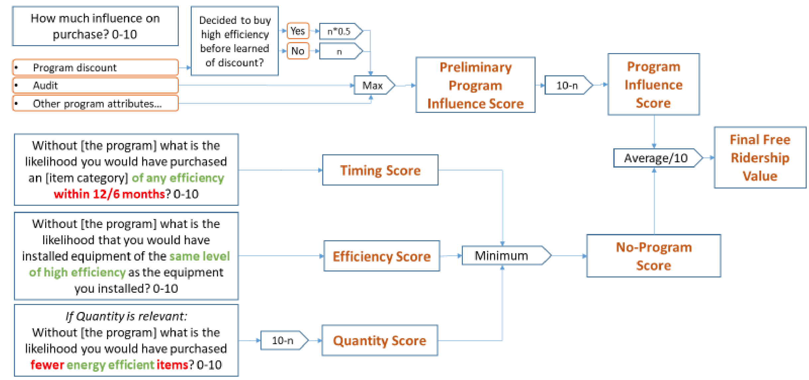
Source: 2024 Illinois Statewide Technical Reference Manual For Energy Efficiency. Version 12.0, Volume 4. Op. cit., page 78 of 149.

- Proposed Modified Free Ridership Protocol for Residential Participants
Guidehouse plans to deviate from the prescribed IL TRM Version 12.0 protocol by using a modified algorithm that was proposed and discussed in the Illinois NTG working group. The modified algorithm relies on assessing program and vendor influence on a participant’s decision to install energy efficient products as well as assessing a participant’s intention, as illustrated in Figure 2.
For 2024, Guidehouse plans to test this modified protocol for evaluation of residential prescriptive programs for the following reasons:
- This approach aims to establish a counterfactual with program participants, resulting in a direct assessment of actions a customer would have taken in the absence of the program, or a vendor trained by the program. This approach is informed by aspects of the recently revised core non-residential free ridership algorithm.
- This approach recognizes the important role that vendors play in implementing residential programs. The free ridership algorithm aims to assess the extent that a vendor’s recommendation influenced a customer’s decision to participate in the program, as well as explore what would have happened if the vendor had not been trained by the program.
- This approach benefits from improved language and sequencing of the question that addresses the timeframe that a customer would have installed the equipment in the absence of the program. The improved phrasing of this question focuses more on the 12-month period of that program year and accounts for diminishing forecast reliability of customer’s actions if these actions are anticipated a year or more later.
- This approach aims to improve accuracy of responses to influence questions by asking respondents about program features that may have been present or part of their participation; we believe this approach will contribute to a more accurate assessment of program influence by engaging the respondent to recall its program experience.

Figure 2. Proposed Free Ridership Protocol for Residential Prescriptive Rebate Programs
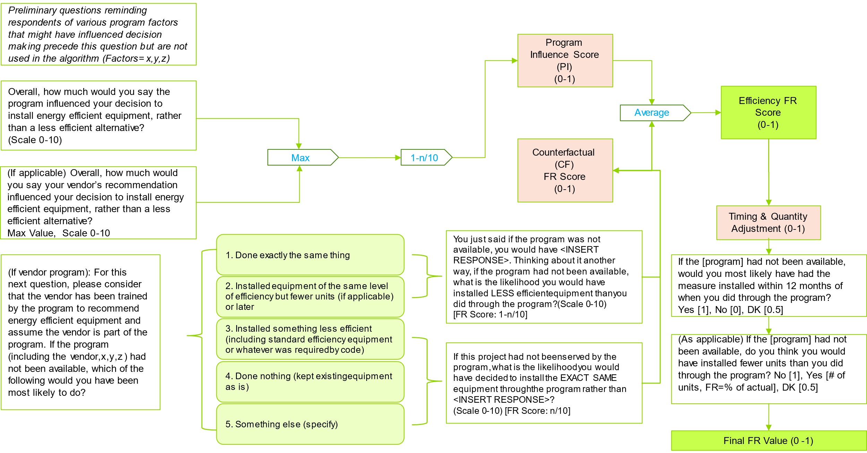
Source: Guidehouse rendition of Apex Analytics. Core Residential Free Ridership Recommendations provided to IL NTG Working Group, revisions dated Jan 9, 2024 and April 19, 2024.

- Proposed Free Ridership Testing Protocol
Guidehouse plans to assess results between the proposed protocol (in Figure 2) and a free-ridership algorithm version tested last year, documented in a memo to SAG. That memo presented information that the deviation from the TRM method was superior. For that reason, we plan to test this deviation (indicated above) against the one tested in 2023.
To test the algorithms, Guidehouse will analyze the first 70 responses of the first survey to launch, to achieve a 90/10 confidence/precision. We will calculate free ridership using each method (the 2024 deviation and the 2023 deviation).
For each respondent, two evaluators will independently review the free ridership results and the verbatim response to the following question (note the following is an approximation of the actual question):
Please describe any influence that the [program] had on your decision to implement the measure?
This question is designed to collect a verbal description of the respondent’s free ridership. Working independently from one another and without knowledge of the algorithm used to calculate each result, two evaluators then will select the result (from the two algorithms being tested) that better represents the verbatim response for each respondent. In instances where neither algorithm result is an obvious match, evaluators will indicate whether this was because the verbatim response was ambiguous or because the two results were too close to differentiate. As indicated in the deviation results memo cited above, results will divide each respondent into one of four results establishing which algorithm result was closest to the assessment of the verbatim response to the question above: Alternate (or 2024 deviation), 2023 deviation, ambiguous, or draw. Based on these results, Guidehouse will use the algorithm that better represents the verbatim response. Guidehouse plans to conduct this testing and provide results to IL SAG in a subsequent memo.

“Deviation to Residential Free Rider Algorithms for Reporting in 2023 – Test Results”, submitted to IL SAG, September 8, 2023. See SAG-Deviation-Memo-for-Res-FR-Test-Results-2023-09-08-002.pdf (ilsag.info).
2024 Illinois Statewide Technical Reference Manual For Energy Efficiency. Version 12.0. Volume 4: Cross-Cutting Measures and Attahements. Attachment A: Illinois Statewide Net-to-Gross Methodologies. FINAL. September 22, 2024. Effective: January 1st, 2024. Pg. 80-82.
2024 Illinois Statewide Technical Reference Manual For Energy Efficiency. Version 12.0. Volume 4, Op. cit., Figure 3-1, page 44 of 149.
“Deviation to Residential Free Rider Algorithms for Reporting in 2023 – Test Results”, op. cit.
Responses where the absolute difference between algorithm results was less than 0.10 will be excluded from review.

