**Memorandum**

|  |  |
| --- | --- |
| To: | Illinois SAG |
|  |  |
| From: | Amy Buege, Ethan Barquest, and Elizabeth Bullard, Verdant Associates  Christopher Frye, Laura Agapay-Read, Guidehouse |
|  |  |
| CC: | Elizabeth Horne, ICC; Kim Brown, ComEd |
|  |  |
| Date: | October 30, 2024 |
|  |  |
| Re: | Free Ridership Protocol Deviation from Illinois Statewide Technical Reference Manual, Version 12.0 |

This memorandum outlines the deviation to the residential free ridership (FR) protocol that Guidehouse, Inc. (Guidehouse) plans to use for its evaluation of two ComEd Retail/Online programs (Residential Appliance Rebates and Marketplace 2.0). A comparison test of the proposed deviation algorithm (referred to as the 2023 FR algorithm) and the algorithm included in the Illinois Statewide Technical Reference Manual Version 12.0[1] (IL TRM) was completed in 2023, and the 2023 FR algorithm was found to be superior.[2]

Below we present the FR protocol included in version 12 of the IL TRM and the proposed deviation algorithm (2023 FR algorithm), along with the rationale for this deviation.

**IL TRM Residential Participant Free-Ridership Protocol**

A diagram of the relevant algorithm in IL TRM Version 12.0 is shown in Figure 1 (page 2).

Figure 1. IL TRM v12 Free Ridership Protocol for Residential Prescriptive Rebate (with No Audit)

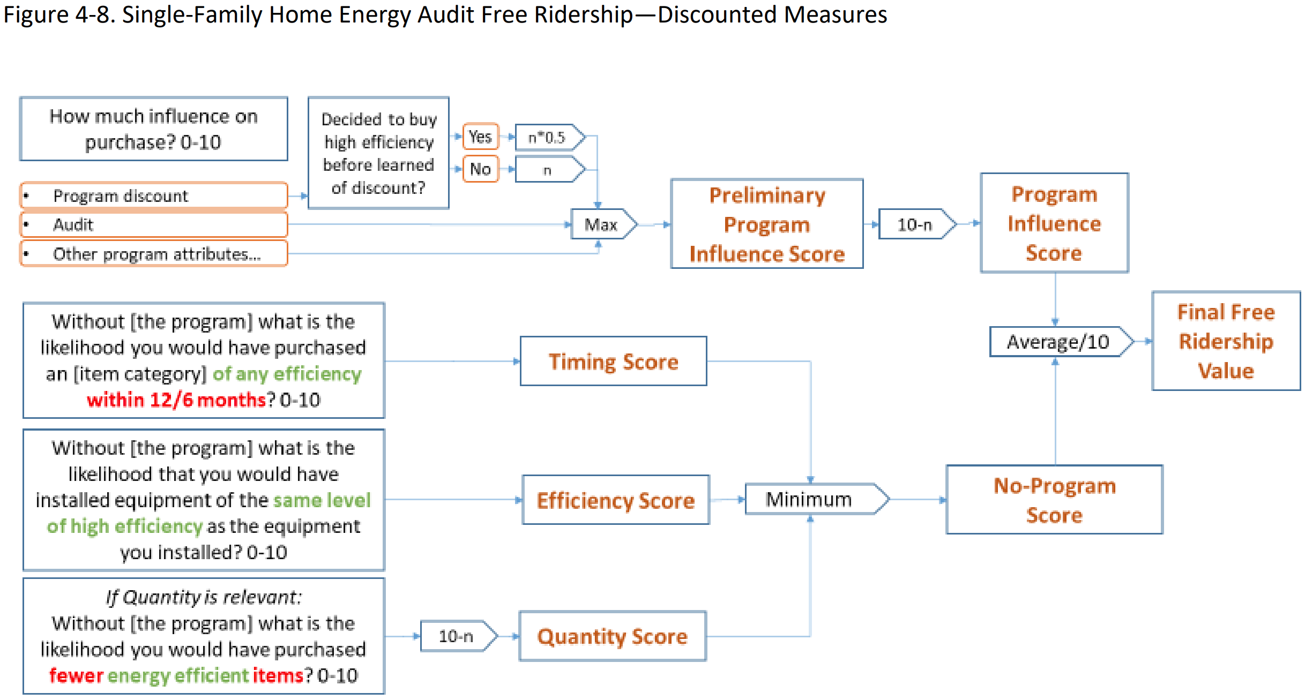

Source: 2024 Illinois Statewide Technical Reference Manual For Energy Efficiency. Version 12.0, Volume 4. Op. cit., page 78 of 149.

1. **Proposed Modified Free Ridership Protocol for Residential Participants**

Guidehouse plans to deviate from the IL TRM Version 12.0 protocol by using a Guidehouse-modified residential FR algorithm. The modifications were informed by 2022 modifications to the core non-residential free ridership algorithm which the Illinois NTG working group achieved consensus on and included in IL TRM v11. In 2023, Guidehouse tested this modified residential FR algorithm against the IL TRM version and found the modified algorithm more accurately estimated free ridership. The 2023 algorithm relies on assessing program influence on a participant’s decision to install energy efficient products as well as assessing a participant’s intention, as illustrated in Figure 2.

For 2024, Guidehouse plans to use the 2023 algorithm for evaluation of residential Retail/Online program free ridership.

Figure 2. Proposed Free Ridership Protocol for Residential Rebate Programs (2023 FR algorithm)

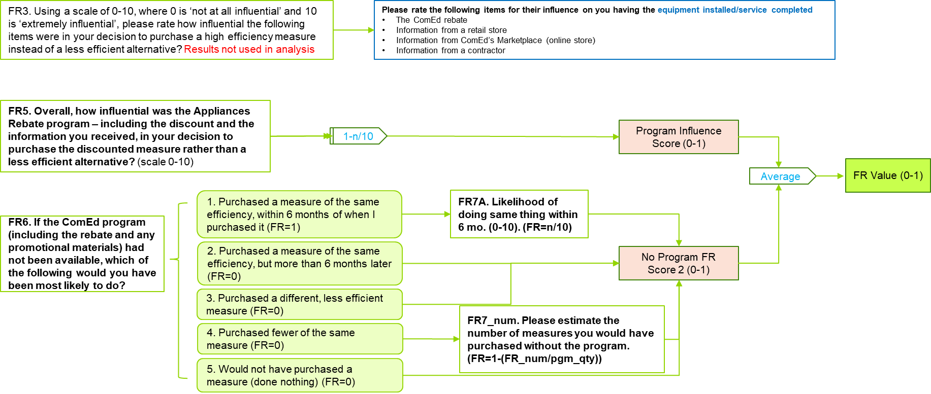

1. 2024 Illinois Statewide Technical Reference Manual For Energy Efficiency. Version 12.0. Volume 4: Cross-Cutting Measures and Attahements. Attachment A: Illinois Statewide Net-to-Gross Methodologies. FINAL. September 22, 2024. Effective: January 1st, 2024. Pg. 80-82.
2. [SAG-Deviation-Memo-for-Res-FR-Test-Results-2023-09-08-002.pdf](https://www.ilsag.info/wp-content/uploads/SAG-Deviation-Memo-for-Res-FR-Test-Results-2023-09-08-002.pdf) Note: The Illinois Net-to-Gross (NTG) Working Group is currently in discussion regarding an alternative to the TRM algorithm to estimate free ridership for residential prescriptive rebate programs; this algorithm is based on the 2023 FR algorithm but includes a few minor modifications. A test is currently underway comparing it to the 2023 FR algorithm.