Memorandum

|  |  |
| --- | --- |
| To: | Illinois SAG |
| From: | Christopher Frye, Laura Agapay-Read, Jeff Erickson, Guidehouse |
| CC: | Elizabeth Horne, ICC; Kim Brown, ComEd; Randy Opdyke, Nicor Gas; Zachary Ross, ODC |
| Date: | March 6, 2025 |
| Re: | Free Ridership Protocol Deviation from Illinois Statewide Technical Reference Manual, Version 13.0 |

This memorandum outlines the deviation to the residential free ridership (FR) protocol that Guidehouse, Inc. (Guidehouse) plans to use for its evaluation of the following programs this year:

* ComEd Retail/Online programs (Residential Appliance Rebates and Marketplace 2.0)
* Nicor Gas Home Energy Efficiency Rebates
* Nicor Gas Home Energy Savings

This deviation memo supersedes Guidehouse’s deviation memo submitted to IL-SAG on October 31, 2024[1].

# IL Technical Reference Manual Residential Participant Free-Ridership Protocol

A diagram of the relevant algorithm in IL Technical Reference Manual (TRM) Version 13.0 is shown in Figure 1 (page 2).

Figure . IL TRM v13 Free Ridership Protocol for Residential Prescriptive Rebate (with No Audit)

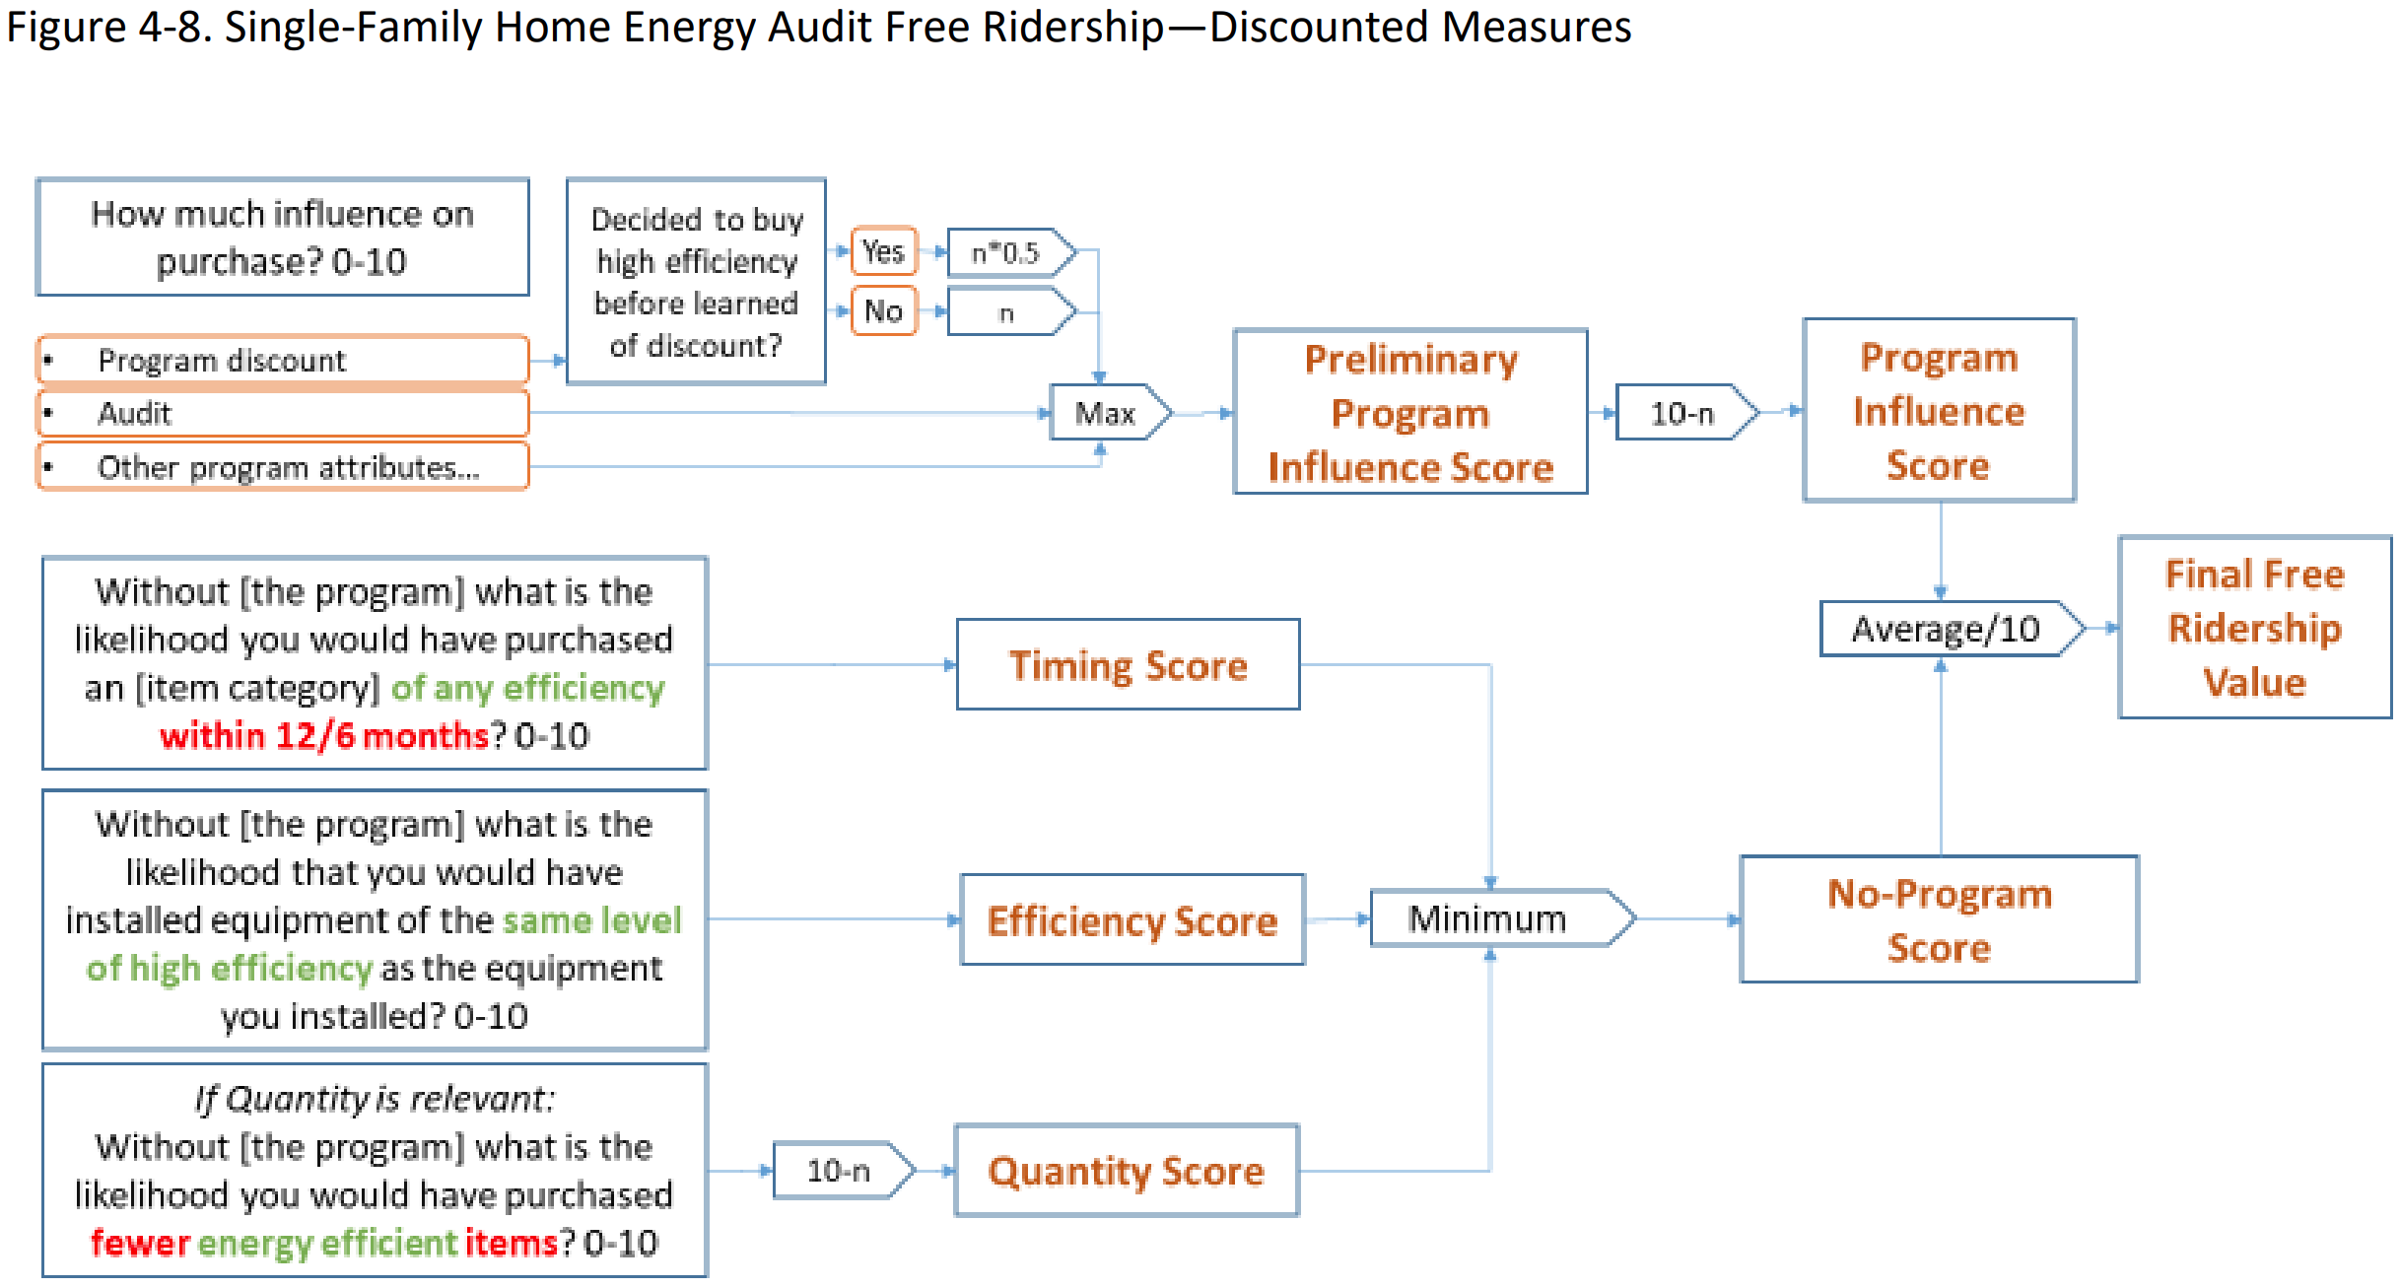

Source: 2025 Illinois Statewide Technical Reference Manual For Energy Efficiency. Version 13.0, Volume 4. Op. cit., page 80 of 151.

# Proposed Deviation

Guidehouse plans to deviate from the IL TRM Version 13.0 protocol for estimating FR of residential programs by using a Guidehouse-modified algorithm. The modifications are informed by Guidehouse’s 2023 residential free ridership algorithm[2] (which Guidehouse tested in 2023[3] and which we refer to as the 2023 algorithm) and by improvements to the non-residential FR algorithm that are analogous to the residential version, which were deliberated in the IL NTG Working Group and updated in the TRM.

In response to comments on the 2024 deviation memo which presented the 2023 algorithm, Guidehouse has revised it in the following manner (See Figure 2):

* Place two intervening questions (FR3 & FR4) between the initial set of individual ratings on program components and the overall program influence question.
* Expand the universe of respondents who are presented with a likelihood follow-up question after the counterfactual scenario question (FR7) to all respondents (instead of a sub-set indicated in Figure 4).
* Apply a timing and quantity adjustment to the final efficiency FR score as opposed to embedding concepts of timing and quantity in the counterfactual scenario question (FR6).

For 2025, Guidehouse plans to use this revised 2023 algorithm for evaluating free ridership in the programs indicated in the introduction to this memo.

Figure . Proposed Free Ridership Protocol for Residential Rebate Programs (Revised 2023)

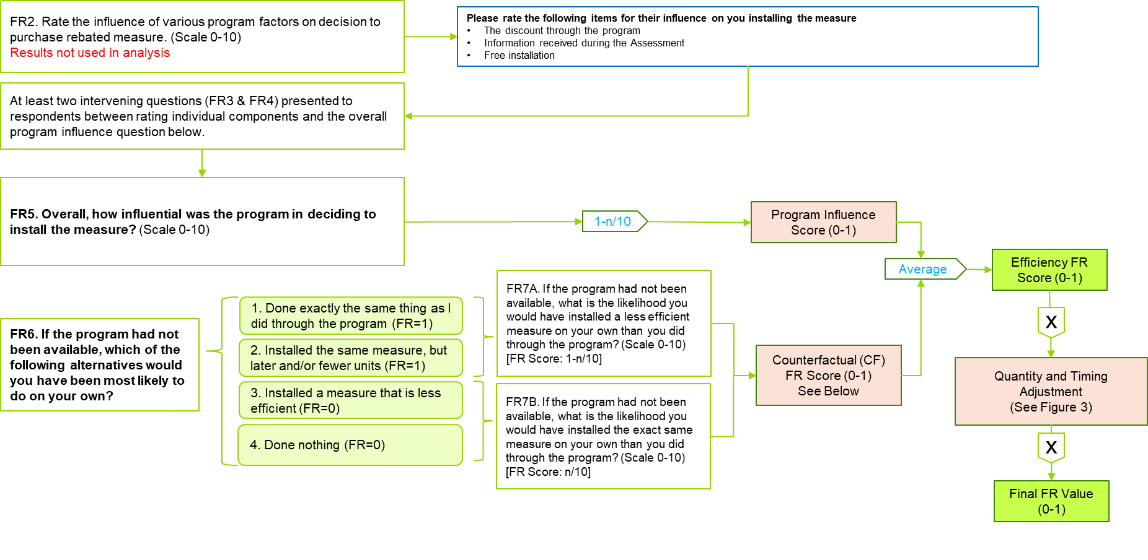

Figure Proposed Free Ridership Protocol for Residential Rebate Programs Quantity & Timing Adjustment

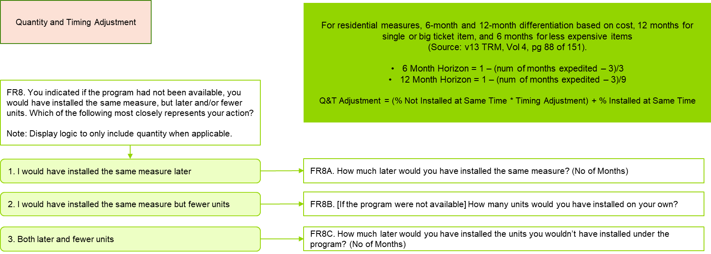

Figure . 2023 Residential FR Algorithm (from 10/31/2024 Deviation Memo)

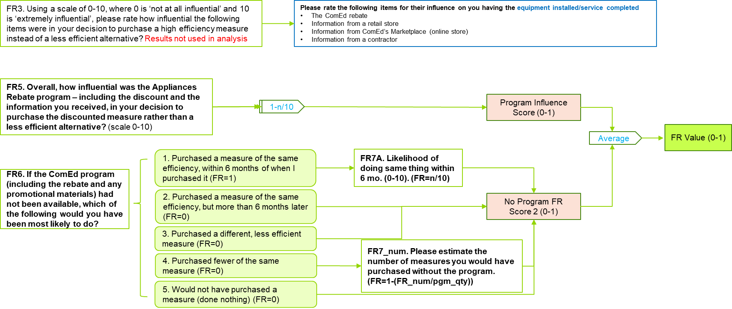

1. “Free Ridership Protocol Deviation from Illinois Statewide Technical Reference Manual, Version 12.0.” submitted October 31, 2024.
2. “Deviation to Residential Free Rider Algorithms for Reporting in 2023”, See [SAG-Deviation-Memo-for-Res-FR-2023-05-10.pdf](https://www.ilsag.info/wp-content/uploads/SAG-Deviation-Memo-for-Res-FR-2023-05-10.pdf).
3. “Deviation to Residential Free Rider Algorithms for Reporting in 2023 – Test Results”, See [SAG-Deviation-Memo-for-Res-FR-Test-Results-2023-09-08-002.pdf](https://www.ilsag.info/wp-content/uploads/SAG-Deviation-Memo-for-Res-FR-Test-Results-2023-09-08-002.pdf)