Illinois Stretch Codes Market Transformation Initiative

Theory-Based Logic Model for CY2024–CY2028

June 10th – DRAFT
Prepared by Slipstream and MEEA
Contact information: Jeannette LeZaks, jlezaks@slipstreaminc.org

1.0 Introduction
Building energy codes are recognized as an effective way to move the market for commercial and residential buildings toward more energy efficient buildings. Several states have energy efficiency programs that are designed to influence the building energy code and allow the utility administering the program to claim savings through a Market Transformation (MT) approach to program design and evaluation. California utilities have been actively influencing codes and standards since the late 1990s. States that have more recently developed code programs include Arizona, Massachusetts, Rhode Island and Colorado.
Attachment C: Framework for Counting Market Transformation in Illinois of the Illinois TRM v12 defines MT as the strategic process of intervening in a market to create lasting change that results in the accelerated adoption of energy efficient products, services, and practices. Applying an MT approach, utilities can play a role in energy codes in two distinct ways: first, by supporting state and municipal efforts to advance and adopt stretch codes through technical guidance and policy development, and second, through stretch code compliance support through programs that provide technical assistance and training for municipalities, contractors, and building owners in enforcement and adherence to stretch codes.
Attachment C describes three documents needed to define the MT approach: an energy savings framework, a program plan/logic model, and an evaluation plan. This document provides the program theory and logic model for how utilities can influence the market to adopt and comply with stretch codes.

2.0 Stretch Codes Paths in Illinois
A stretch code is a locally mandated code or alternative compliance path that requires a higher level of energy efficiency or sustainability than the adopted base energy code.
Passed in September 2021, Illinois Public Act 102-0662 (the Climate and Equitable Jobs Act, or CEJA) directed the Illinois Capital Development Board (CDB), which manages the state building energy code adoption process, to create a residential and commercial stretch energy code that can be adopted by individual municipalities. The CEJA-mandated model stretch code, which will be available for adoption by municipalities no later than July 1, 2024, will offer a pathway to driving higher energy performance in buildings located in those municipalities. While the legislation does not require that a municipality adopt the stretch code and enforce its compliance, utilities can influence and motivate local stretch code adoption and/or provide compliance support.

3.0 Market Transformation Stretch Code Policy Advancement and Compliance Support Logic Model
Several factors highlight the opportunity for advancement of stretch energy code programs:
- CEJA sets energy efficiency targets for a new state-developed stretch code that increases efficiency incrementally through 2032
- CEJA requires development of model stretch energy code language for commercial and residential buildings for the first energy efficiency targets by July 1, 2024
- Municipalities are increasingly considering the need for responses to climate change in their planning processes, for which stricter energy codes can be a useful action
- Existing utility resource acquisition programs are available to provide financial and technical assistance in implementing energy efficiency measures
- Attachment C of the IL TRM allows utilities to use energy efficiency funding to pursue a MT-based approach in support of stretch energy code advancement, implementation, and compliance
Program theory and the associated logic model illustrate how utility activities can drive market transformation in response to the opportunity identified above. The logic model identifies –
- barriers to adoption,
- utility activities designed to address the barriers and constraints
- outputs that directly measure results of the activities,
- expected/desired short, medium-term, and long-term outcomes

An overview of the factors to include in the logic model is outlined below, followed by the logic model itself (Figure 1) and Market Progress Indicators.

3.1 Stretch Code Support Activities

3.1.1 Stretch Code Advancement Activities
The process by which a stretch code is adopted at a municipal level is driven by a specific municipality’s policy-making process. Utilities may influence stretch code policy advancement by creating, providing and/or presenting utility-initiated research to key stakeholders and providing input to the policy-making process. A utility is uniquely positioned to be involved in and influence the process for stretch code adoption through example activities that may include:
- Conducting and disseminating research and technical analysis to city staff, building professionals, policymakers, or the general public
- Actively participating in discussions at public or decision-making meetings
- Writing and submitting comments on proposed policies
- Assisting municipalities with drafting of policy language to formally adopt state stretch code language or amended version
- Submitting policy language or recommendations for consideration of adoption to the state or local municipalities
- Funding and conducting participation in public processes via proxy
- Giving public testimony in support of or against specific policy language/ideas/activities

3.1.2. Stretch Code Compliance Support Activities
A stretch code compliance support program is an opportunity for utilities to work to increase compliance with an above-code policy that has been passed by the local jurisdiction. The stretch code compliance support program can be implemented once a policy is adopted and where the stretch codes become the minimum code in that jurisdiction. Not every building would immediately achieve 100% compliance with the adopted stretch code strategies; the inclusion of utility-support programs will increase compliance over time. Surveys and ongoing discussions with municipalities have illustrated that the existence of these programs also directly impacts the likelihood of adoption by municipalities. Specifically, if municipalities know that support exists after adoption that addresses cost or capacity concerns, they may generally feel more positive about adoption. Similar to stretch code policy advancement, utilities have a range of options for supporting municipalities in their implementation efforts. Some potential code compliance support activities include:
- Offering training programs targeting code officials, the design and construction community, and municipal staff to address knowledge gaps about general code topics, specific measures, or strategies for complying with the stretch code
- Providing technical assistance for professionals and municipal officials that may be unsure of how to comply with or measure compliance for specific code requirements (for example, providing on-demand telephone or email support, creating checklists or offering modeling assistance, or supporting a circuit rider which is a third-party specialist who is not a building code official but is expert in energy codes and compliance)
- Providing incentives for projects or measures that meet or exceed minimum stretch energy code requirements. Could be a new offering or include enhancements to existing utility new construction programs.

3.2 Target Markets
There are several target markets that would be impacted by a code policy advancement and implementation support program. These target markets are delineated into three main groups: the jurisdiction/policymaker and general public sector (TM1), the design and construction industry (TM2), and the enforcement industry (TM3), as shown in Table 1. The market actors are the same for both advancement and implementation support. The program will develop trainings and resources for each target market. It may be more difficult to evaluate the impact on the entire design and construction industry, but it is expected that a comprehensive approach is needed to impact the final objective of increasing buildings built to stretch code.
Table 1. Targeted market actors for utility stretch code advancement and compliance programs

Targeted market actors | Description of actors
Jurisdiction/Policy-Making Sector (TM1) | Jurisdiction-level code development or adoption bodies, such as city/county councils, mayors, sustainability managers, public stakeholders, and/or working groups  Entities and persons involved in state policy development and adoption, including Capital Development Board (CDB), Illinois Energy Codes Advisory Council, ASHRAE, International Code Council (ICC)  Local and state chapters of the International Code Council (ICC), ASHRAE, Illinois Council of Mayors, Metropolitan Mayors Caucus, and the numerous state and local code official associations in Illinois
Design and construction industry (TM2) | Construction industry market actors including builders, subcontractors, material supply houses, site superintendents, energy modelers, building scientists, architects, engineers, and designers  Building professional stakeholder groups and coalitions, including local and state chapters of Homebuilder Associations (HBA), American Institute of Architects (AIA), Illinois Plumbing and Heating Association, and Illinois Green Alliance, Association of Licensed Architects, Illuminating Engineering Society, Lighting Controls Association, International Association of Lighting Designers, Building Performance Institute (BPI), Associated General Contractors of America, and others
Enforcement industry (TM3) | Local building departments, code officials, and jurisdictional employees that review, permit, and inspect energy code requirements

3.3 Major Barriers
A summary of major barriers facing stretch energy code advancement and compliance are shown in Table 2.
Table 2. Barriers to advancing and achieving full compliance with stretch energy codes
Barrier | Description
Business and contractor and inspection community concerns with updates to the building code and new requirements (TM2, TM3) | There is a learning curve with new codes. Some contractor and business market actors may not want to add new regulations to their workload and may believe that their customers do not want to build higher performing buildings.
Municipalities often have limited resources to understand, adopt, and enforce more complex code (TM1, TM3) | Energy codes are enforced by code officials that are funded through municipal budgets. Staff time and resources are limited to enforce the code, as well as learn how to enforce increasingly more complex codes.
Design and construction contractors and municipalities may not be aware of the benefits of building more efficiently (TM1, TM2) | Information about the benefits of a more efficient code and buildings may not reach stakeholders.
Design and construction contractors and municipalities may not be aware of or prioritize updated or more complex codes. (TM1, TM2, TM3) | As new energy codes are adopted, building professionals need time to learn about and understand how updated codes will affect their current building practices. Municipalities may not prioritize energy codes to be the same priority as other life safety codes.
Design and construction contractors and municipalities may perceive a lack of consumer demand. (TM1, TM2) | Design and construction contractors and municipalities may not think that consumers care to have more efficient buildings.
Higher upfront costs for some energy efficiency investments. (TM1, TM2, TM3) | With higher efficiency building technologies or methods, there can be a higher upfront cost as compared to less efficient alternatives or compared to other nearby jurisdictions. Impact on total lifetime cost may be overlooked in discussions on cost impacts.

3.3.1 Logic Model and Stretch Code Activity Details
The logic model (Figure 1) lists the expected utility activities and resulting outputs to both drive adoption of stretch codes and enhance compliance with stretch codes. The activities and outputs should be revisited every few years to ensure that these are still leading to the expected outcomes and to identify any new or additional barriers or opportunities for utility MT support.

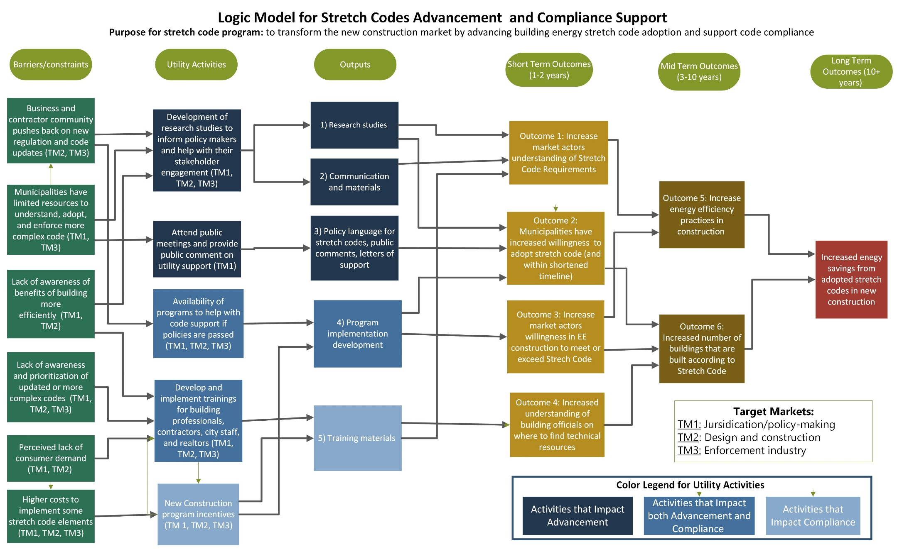
Figure 1. Logic model for stretch codes policy advancement and compliance support

3.3.2 Market Progress Indicators
Market Progress Indicators (MPIs) are the metrics that will be tracked to assess the effectiveness of the activities identified in the program logic model. MPIs assess the progress of market transformation efforts on the key outcomes outlined in the logic model. These MPIs assess impact from both advancement and compliance support programs.
Table 3 lists the MPIs and a data source to measure progress towards the indicator. The evaluator, Guidehouse, was actively involved in discussions around MPIs and has reviewed these MPIs. The MPIs are listed for the short-term and medium-term outcomes in the logic model. Progress towards these MPIs are expected to lead directly to the long-term outcome of increased energy savings. More details on MPIs and their measurement is detailed in the Evaluation Plan developed by Guidehouse.
Table 3. Stretch code advancement and compliance Market Progress Indicators and data sources
MPI | Logic Model Output/Outcome | Data Source
OC1.1. Increased understanding of requirements | Increase market actors understanding of stretch code requirements | Survey responses for municipal staff and design / new construction stakeholders across ComEd’s territory (measured across time)
OC2.1. Increased number of adopted stretch code ordinances | Municipalities have adopted stretch code within shortened timeline | Meeting notes, policy drafts, passed policy language, and survey responses for municipal staff across ComEd’s territory (measured across time)
OC2.2. Increased interest in adopting policy | Municipalities have increased willingness to adopt stretch code or to adopt within shortened timeline | Survey responses for municipal staff and council people across ComEd’s territory (measured across time)
OC3.1. Increased interest in EE construction | Increase market actors’ willingness in EE construction to meet or exceed stretch code | Survey responses for design/new construction (measured before program implementation and after, across time)
OC4.1. Increased engagement with online stretch code resources | Increased understanding of building officials on where to find technical resources. ComEd to help develop resources and help market materials. | Data on number of website visits and length of time on page, phone calls to hotlines, etc. Survey responses on website
OC4.2. Increased use of compliance resources and tools | Increased building officials understanding of technical resources and where to find; Documented usage and engagement trends for online resources. | Survey responses from building officials (measured directly before adoption, after adoption and at least 1 year later)
OC5.1. Increased energy efficiency measures installed | Increase energy efficiency practices in construction | Program participation data; efficiency measures installed data, survey responses (before and after adoption).
OC6.1. Number of buildings with permits for stretch code | Increased number of buildings that are built according to stretch code | Permit data from IL municipalities; percent over time that are stretch code
OC6.2. Compliance rates for new construction buildings | Increased number of buildings that are built according to stretch code | Compliance study and/or expert judgment panel completed (measured before and after statewide code updates)

IL TRM_Effective_010124_v12.0_Vol_4_X-Cutting_Measures_and_Attach_09222023_FINAL.pdf (ilsag.info).

