|  |  |
| --- | --- |
| To: | Erin Daughton, ComEd |
|  |  |
| CC: | Elizabeth Horne, ICC; Jeff Erickson, Nishant Mehta, Guidehouse |
|  |  |
| From: | Christopher Frye, David Bluestein, Guidehouse; Mike Frischmann, EcoMetric Consulting |
|  |  |
| Date: | September 4, 2024 |
|  |  |
| Re: | Net-to-Gross Research Results for the Incentives – Standard Program |

# Executive Summary

This memo presents findings from the net-to-gross (NTG) study of the ComEd Incentives – Standard Program. The NTG results for this program are based on the NTG algorithms specified in the Illinois Technical Reference Manual (TRM) version 12.0 and rely on free ridership (FR) and spillover (SO) research gathered via an online survey. The survey was administered to two populations: program participants, to assess the participant perspective, and Energy Efficiency Service Providers (EESPs), to assess the service provider perspective. The participant and EESP free ridership surveys covered participants in the CY2023 program. The participant spillover survey covered customers who participated in CY2022 and first half of CY2023, and the EESP spillover covered qualified respondents that generated savings in CY2023.

Table 1 summarizes the Standard Incentive Program FR and SO research findings based on the participant and EESP research. The participant results include the three strata by project type detailed in the sample design. NTG ratios by measure are a triangulated value of the participant and EESP NTG results, as directed by the TRM and explained in Section 4. Guidehouse expects to recommend to the Illinois Stakeholders Advisory Group (SAG) these values be used for this program in CY2025.

Table 1. Net-to-Gross Research Results for the Incentives – Standard Program

|  |  |  |  |  |  |
| --- | --- | --- | --- | --- | --- |
| Program Measure | Participant Free  Ridership | Participant  Spillover | EESP Free Ridership | EESP Spillover | NTG  Ratio* |
| Lighting | 0.19 | 0.01 | 0.18 | 0.03 | 0.85 |
| Non-Lighting | 0.19 | 0.01 | 0.18 | 0.03 | 0.86 |
| LED Streetlights - Municipal | 0.59 | 0.01 | 0.18 | 0.03 | 0.68 |

* Numbers may not sum due to rounding. The NTG ratio is calculated by triangulation and so the NTG ratio in this table cannot be calculated from the components in this table using 1-FR+SO. This is explained in the *Final NTG Results and Recommendations* section below.

Source: Evaluation team analysis

# Free Ridership and Spillover Research Sample Disposition

Guidehouse administered online web surveys to program participants and EESPs active in the ComEd service territory to gather free ridership and spillover feedback. For free ridership, the team surveyed program participants and EESPs from CY2023. For spillover, the team surveyed program participants from CY2022 and the first half of CY2023, and EESPs active in CY2023. To maximize survey response rates, the team offered customers $25 to complete the survey and EESPs $50. The survey opened on July 1, 2024, and closed on August 1, 2024. In addition to the initial invitation, Guidehouse sent three reminders with the third (and final) reminder sent on July 29, 2024.

Table 2 presents the sample disposition for the two categories of web surveys.

Table 2. Free Ridership Sample Disposition

|  |  |  |  |  |  |  |
| --- | --- | --- | --- | --- | --- | --- |
| Category | Sample of Unique Participants | Target Completes | Actual Completes | Analysed Completes* | Response Rate | Respondent Share of Program Savings (kWh) |
| Participant | 1,460 | 150 | 151 | 143 | 9% | 6% |
| EESP | 344 | Census | 91 | 88 | 28% | 37% |

*The evaluation team removed eight participant respondents from the FR analysis because they did not answer the timing questions required by the Core FR algorithm. The team also removed 3 EESPs from the FR analysis because they did not answer the counterfactual questions.

Source: Evaluation team analysis

Table 3. Spillover Sample Disposition

|  |  |  |  |  |  |  |
| --- | --- | --- | --- | --- | --- | --- |
| Category | Sample of Unique Participants | Target Completes | Actual Completes | Made Additional Efficiency Improvements | Qualified for Spillover | Share of Program Savings Represented by Qualified Spillover |
| Participant | 1,262 | Census | 77 | 45 | 10 | 0.1% |
| EESP | 344 | Census | 91 | 87 | 15 | 1.0% |

*The evaluation team removed 4 EESPs from the spillover analysis because they skipped the spillover portion of the NTG survey.

Source: Evaluation team analysis

# Free Ridership and Spillover Protocols

The evaluation team applied the participant FR, SO, and EESP protocols from the TRM v12.0, developed by the Illinois SAG NTG Working Group. The results from the two sets of surveys were combined using the methodology laid out in TRM v12.0 Section 5.1, “Combining Participant and EESP Free Ridership Scores.”

## Participant Free Ridership Estimation

Figure 1 describes the Core Free Ridership Algorithm for participant FR developed by the Illinois SAG NTG Working Group that the evaluation team used to calculate FR for the C&I Incentive - Standard program participant surveys.

Figure 1. Incentive – Standard Core Free Ridership Algorithm

Source: Illinois Statewide Technical Reference Manual for Energy Efficiency, Version 12.0, Volume 4, page 44 of 149 (Figure 3-1).

## Participant Spillover Estimation

Guidehouse calculated participant spillover based on TRM v12.0 Section 3.1.2, “Core Participant Spillover Protocol,” summarized in Figure 2.

Figure 2. Core Non-Residential Participant Spillover Protocol

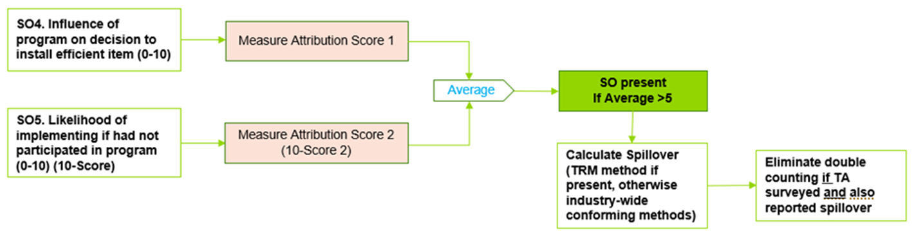

Source: Evaluation team representation of Illinois Statewide Technical Reference Manual for Energy Efficiency, Version 12.0, Volume 4, page 48 of 149.

## EESP Free Ridership Estimation

TRM v12.0 does not specify an approach for measuring the EESP perspective of participant FR. For this study, Guidehouse used the following method to assess participant FR from an EESP perspective. This methodology is summarized in Figure 3 below.

Figure 3. EESP Free Ridership Protocol

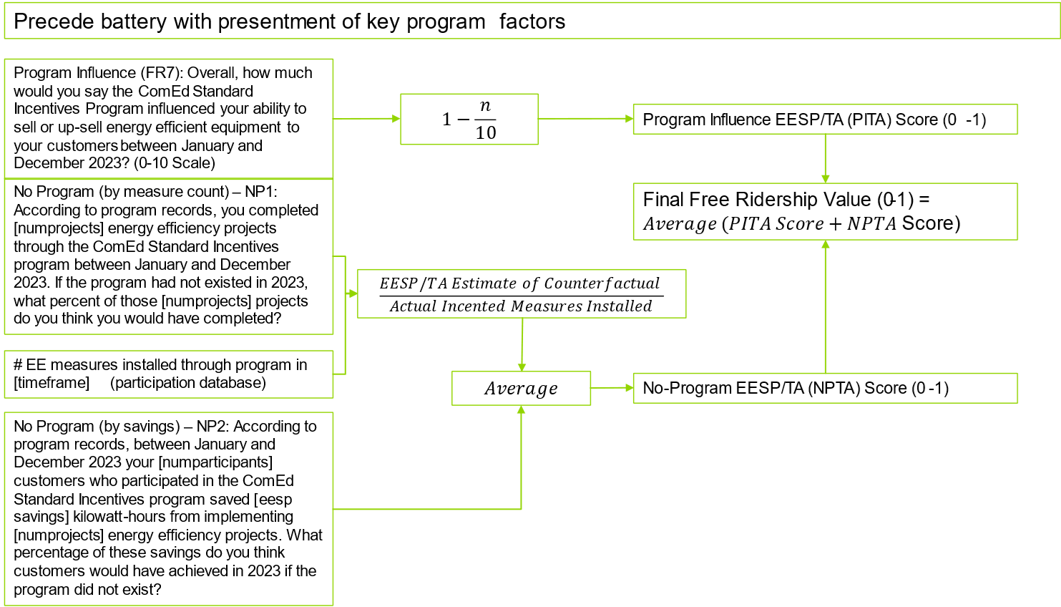

Source: Guidehouse interpretation of SAG NTG WG Consensus of participant Core FR algorithm applied to contractors, Fall 2023

## EESP Spillover Estimation

The evaluation team quantified the EESP’s perspective of participant spillover using the methodologies laid out in IL TRM v12.0. The team assessed EESP spillover by estimating the percentage of high efficiency equipment EESPs sold during the evaluation period either incentivized or not incentivized through the Incentives - Standard program.

The process to calculate spillover from the EESP perspective includes the following steps (as defined in the TRM v12.0, Section 5.2.1.1):

1. Calculate the percentage of an individual EESP’s high efficiency equipment sales that received an incentive. 
2. Calculate the energy savings of the high efficiency equipment sales that did not receive an incentive.



1. Develop the spillover ratio for sampled EESPs by summing individual EESP spillover savings and dividing that total by program-tracked savings achieved by the sampled EESPs.
2. Develop spillover savings for the population of active EESPs by applying the spillover ratio from step 3 to all program savings associated with active EESPs.
3. Develop the overall spillover ratio for active EESPs by dividing the EESP spillover estimate from step 4 by total program savings.

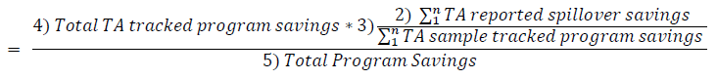

## Free Ridership Consistency Check Analysis

The evaluation team checked for consistency in free rider responses. Respondents were asked to describe in their own words any influence that the ComEd Incentive program had on their decision to implement the measures at their facilities, or what they would have done if the program and its technical assistance and financial incentives, did not exist (see Figure 1).

According to the IL TRM v12.0, Volume 4, Attachment A page 46 of 149, a program Influence/Counterfactual consistency check is triggered when either of the following conditions are met:

A Program Influence/Counterfactual consistency check is triggered when either of the following conditions are met:

1) The Program Influence FR Score is greater than 0.7 AND the Counterfactual FR Score is less than 0.3.

OR

2) The Program Influence FR Score is less than 0.3 AND the Counterfactual FR Score is greater than 0.7.

For respondents that failed the consistency checks, the evaluation team reviewed the verbatim responses to determine the weight of the program influence against the counterfactual responses and timing adjustments to arrive at a free ridership score.

The evaluation team determined that 26 of the 151 participant respondents failed the consistency check, which triggered a detailed review of the verbatim responses. Seventeen out of the 26 respondents gave answers to the verbatim question that were inconsistent with their Counterfactual score. As a result, and in accordance with the TRM, the evaluation team removed the Counterfactual score from the calculation (which means the Program Influence scores drove the free ridership score since the respondents mentioned verbatim that program incentives were key for installing their projects). The team left the remaining nine inconsistent responses untouched as the verbatim responses did not provide adequate reason to adjust scores.

The evaluation team also removed eight respondents from the FR analysis because they did not provide answers to the timing question required by the Core FR Algorithm. The team did not have any basis for assuming the timing of these projects and decided to remove them from analysis altogether.

The evaluation team found two inconsistencies in the FR responses for the EESPs and, based on verbatim responses, removed one counterfactual score and one influence score for those two respondents. Additionally, three EESPs skipped the spillover portion of the NTG survey so the evaluation team removed them from the final analysis.

# Combining Participant and EESP Free Ridership

Guidehouse calculated a combined participant and EESP FR estimate utilizing the triangulation approach outlined in IL TRM v12.0, Volume 4, Section 5.1 (page 92 of 149). This approach calculated a weighted average of the participant and EESP FR results using the weighting approach shown in Table 4 below.

This approach rates the participant and EESP survey data on three aspects: accuracy, validity, and representativeness, using a scale where 100% means “extremely so” and 0% means “not at all.”

1. **Accuracy**: How likely is the approach to provide an accurate estimate of FR?
   1. Guidehouse calculated the participant and EESP portions of accuracy (50% and 50%, respectively) based on a comparison of the relative precision (RP) associated with the participant and EESP FR estimates. The relative precision for both groups was approximately 4% so the team calculated each share as:

Participant or EESP RP/sum of (Participant RP + EESP RP)

1. **Validity**: How valid are the data collected and analysis?
   1. Guidehouse assigned the participant portion a score of 80% because the research closely followed the TRM approach. However, the 9% response rate may have produced some nonresponse bias.
   2. Guidehouse assigned the EESP portion a score of 80% because the research closely followed the TRM approach. The response rate was 28%, and the responses are quantitative estimates that rely on best estimates covering an entire program year made at the time the survey was completed.
2. **Representativeness**: How representative is the sample?
   1. Guidehouse assigned the participant portion a score of 6% representing the percentage of Standard Incentive Program savings in the Participant Free Ridership survey sample to the total savings of the program.
   2. Guidehouse assigned the participant portion a score of 37% representing the percentage of Standard Incentive Program savings in the EESP survey sample to the total savings of the program.

Table 4. Free Ridership Triangulation Weighting Approach for Standard Incentive Program

|  |  |  |
| --- | --- | --- |
| Free Ridership Triangulation Data and Analysis | Participant | EESP |
| How likely is this approach to provide an accurate estimate of free ridership? | 50% | 50% |
| How valid is the data collected/analysis? | 80% | 80% |
| How representative is the sample? | 6% | 37% |
| Average Score | 45% | 55% |
| Sum of Averages | 101% | |
| Weight | 45% | 55% |

Source: Evaluation Team analysis

Applying these participant and EESP weights to the FR estimates yields the blended FR estimates shown in the equation below.

$$Free Ridership=\left(Participant FR\right)*\left(Participant Weight\right)+\left(EESP FR\right)*\left(EESP Weight\right)$$

$$=0.200*0.45+0.184*0.55$$

$$=19.1\%$$

The evaluation team used this formula to combine the 20.0% (0.200) participant free ridership with the 18.4% (0.184) service provider free ridership to produce the combined free ridership of 19.1%.

# Participant and EESP Free Ridership Results

Using the protocols detailed above and data collected during the participant and EESP surveys, the evaluation team calculated FR estimates for the Incentive program participants and EESPs. Table 5 below presents the FR estimates and the relative precision of the estimates. As this table shows, participant-based FR estimates varied across strata, ranging from 0.19 to 0.59 with a weighted average of 0.20. The EESP-based weighted average FR estimate was 0.18. The combined weighted FR value was 0.19.

Table 5. Participant and EESP Free Ridership Research Results

|  |  |  |  |
| --- | --- | --- | --- |
| Population | Strata | Free Ridership | Relative Precision @90% CI |
| Participant | Lighting | 0.193 | 4% |
| Non-Lighting | 0.186 | 12% |
| LED Streetlighting - Municipal | 0.589 | 178% |
| **Overall Participant FR** |  | **0.200** | **4%** |
| **Overall EESP FR** |  | **0.184** | **4%** |
| **Combined Results** |  | **0.191** | **3%** |

Note: Due to the low response associated with LED Streetlighting – Municipal, we are not recommending using this research, but rather reverting to the previously research values, or 0.19 (free ridership) and 0.81 (NTG).

Source: Evaluation Team Analysis

# Participant and EESP Spillover Results

Of the 77 participant survey respondents included in the participant spillover analysis, 45 reported that they had installed additional energy efficient measures and of those, 28 indicated they had not received program incentives or influence. Of the 28, 7 passed the spillover screening criteria[1] and the evaluation team estimated gross energy savings from these non-rebated spillover measures at 170,469 kWh. The gross energy savings of the 77 participants who responded to the survey was 14,614,538 kWh, which resulted in a participant spillover rate of 1.2%.

Figure 4. Qualified Participant Spillover Screening Results

Of the 87 EESPs included in the EESP analysis, 40 reported selling additional non-program incented high efficiency lighting measures. Twenty-two of these 40 passed all spillover screening criteria and the estimated gross energy savings from these non-rebated spillover measures was 1,949,307 kWh. The gross energy savings from the 87 EESPs who responded to the survey was 64,492,353 kWh which resulted in a EESP spillover rate of 3.1%.

Figure 5. Qualified EESP Spillover Screening Results

To ensure that spillover from the participant and EESP sources did not lead to double counting, the evaluation team examined the data to exclude any reported spillover transactions from participants who purchased their measure from a EESP who reported spillover. The team found no participant who qualified for spillover was a customer of the qualified EESP spillover respondents.

Table 6 presents the participant and EESP spillover results, as well as the total spillover calculated, which is the sum of those results. This is then combined with the FR rate to estimate the NTG ratio.

Table 6. Spillover Research Results

|  |  |
| --- | --- |
| Population | Spillover Results |
| Participant Spillover | 0.012 |
| EESP Spillover | 0.031 |
| Total Spillover | 0.043 |

Source: Evaluation Team Analysis

# Final NTG Results and Recommendations

The final NTG value is calculated as 1- free ridership + spillover, using savings-weighted values from participants and EESPs using the following formula:

$$NTG=1-\left[\left(Participant FR*Participant Weight\right)+\left(EESP FR*EESP Weight\right)\right]+Participant Spillover+EESP Spillover$$

The final, combined components of the NTG are shown in Table 7. Note the LED Streetlighting Municipal values appearing below are based on the previous researched value given the very low response (and high relative precision) for that measure segment.

Table 7. Summary of Free Ridership, Spillover, and NTG Research Results for the Standard Incentive Program

|  |  |  |  |  |  |
| --- | --- | --- | --- | --- | --- |
| Program Measure | Participant Free  Ridership | Participant  Spillover | EESP Free Ridership | EESP Spillover | NTG  Ratio* |
| Lighting | 0.19 | 0.01 | 0.18 | 0.03 | 0.85 |
| Non-Lighting | 0.19 | 0.01 | 0.18 | 0.03 | 0.86 |
| LED Streetlighting - Municipal | 0.19 |  |  |  | 0.81 |

* Numbers may not sum due to rounding.

Source: Evaluation team analysis

##### Standard Incentive NTG History

|  | **Standard Incentive Offer** |
| --- | --- |
| PY1 | NTG 0.67  Free-Ridership 33%  Participant Spillover 0% (qualitative evidence observed, not quantified)  Method: Customer self-report. 95 interviews completed covering 101 projects from a population of 455 projects. |
| PY2 | NTG 0.74  Free-Ridership 27%  Participant Spillover 1%  Method: Customer self-report. 90 interviews completed covering 114 projects from a population of 1,739 projects.  Enhanced method. Ten EESPs called for 11 participants and their responses factored in to the customer free ridership calculation. |
| PY3 | NTG 0.72  Free-Ridership 28%  Participant Spillover 0% (qualitative evidence observed, not quantified)  Method: Customer self-report. 108 interviews completed covering 292 projects from a population of 3,794 projects.  Enhanced method. Two EESPs and three account managers were called for five participants and their responses factored in to the customer free ridership calculation. |
| PY4 | Deemed using PY2 values.  PY4 Research NTG 0.70  Free-Ridership 31%  Participant Spillover 1%  Method: Customer self-report. 110 interviews completed covering 166 projects from a population of 4,603 projects.  Enhanced method. Two EESPs called for two participants and their responses factored in to the customer free ridership calculation.  NTGR (Free-Ridership only): All lighting =0.70 (90/±5%); Lighting, no T12s reported in base case 0.66 (90/±9%); Lighting, T12s reported in base case 0.80 (90/±14%) Non-Lighting = 0.63 (90/±16%). |
| PY5 | SAG Consensus:   * Lighting: 0.74 * Non-Lighting: 0.62 |
| PY6 | SAG Consensus:   * Lighting: 0.70 * Non-Lighting: 0.63 |
| PY7 | Lighting  NTG: 0.81  Free Ridership: Measured and equal to 0.26  Justification: EPY5 ComEd Standard Program research, 63 participants  Total Recommended Spillover = 0.07  Participant and Non-Participant Spillover Identified by Participating Standard Program EESPs: Measured and equal to 0.05  Justification: EPY5 ComEd Standard Program research, participating EESP sample 55  Participant and Non-Participant Spillover Identified by Non-Participating Standard Program EESPs: Not measured for ComEd; a value of 0.02 is recommended  Justification: Based on GPY2 results from Nicor Gas (0.02), and Peoples Gas and North Shore Gas (0.02).  Non-Lighting  NTG: 0.77  Free Ridership: Measured and equal to 0.31  Justification: EPY5 ComEd Standard Program research, 64 participants  Total Recommended Spillover = 0.08  Participant and Non-Participant Spillover Identified by Participating Standard Program EESPs: Measured and equal to 0.06  Justification: EPY5 ComEd Standard Program research, participating EESP sample 10.  Participant and Non-Participant Spillover Identified by Non-Participating Standard Program EESPs: Not measured for ComEd; a value of 0.02 is recommended  Justification: Based on GPY2 results from Nicor Gas (0.02), and Peoples Gas and North Shore Gas (0.02). |
| PY8 | Recommendation (based upon PY6 research):  NTG Lighting: 0.74  NTG Non-Lighting: 0.63  Free-Ridership, Lighting: 0.27  Free-Ridership, Non-Lighting: 0.38  SO: 0.01  Free Ridership was estimated in PY6 as 0.27 for lighting  Free Ridership = 0.38 for non-lighting  Both based on customer self-report data collected through phone interviews (n=59).  In PY6, EESPs and business customers were interviewed in a separate study to estimate spillover broadly across the C&I market.  The results of the cross-cutting C&I spillover study will be reported separately. |
| PY9 | Recommendation (based upon PY7 research):  NTG Lighting: 0.70  NTG Non-Lighting: 0.69  Free-Ridership, Lighting: 0.31  Free-Ridership, Non-Lighting: 0.32  Spillover, Lighting: 0.01  Spillover, Non-Lighting: 0.01  NTG Research Source:  FR = PY7 Participant Customers and EESPs  SO = PY6 C&I NTG study |
| CY2018 | Recommendation (based upon PY7 and PY8 research):  NTG Lighting: 0.71  NTG Non-Lighting: 0.70  Free-Ridership, Lighting: 0.31  Free-Ridership, Non-Lighting: 0.32  Spillover, Lighting: 0.02  Spillover, Non-Lighting: 0.02  NTG Research Source:  FR = PY7 Participant Customers and EESPs  SO = PY8 TA and Contractor Self-Report |
| CY2019 | Recommendation (based upon PY9 research):  NTG Lighting: 0.83  NTG Non-Lighting: 0.78  Free-Ridership, Lighting: 0.19  Free-Ridership, Non-Lighting: 0.24  Spillover, Lighting: 0.02  Spillover, Non-Lighting: 0.02  NTG Research Source:  FR = PY9 Participating Customer Surveys  SO = PY8 TA and Contractor Self-Report |
| CY2020 | Unchanged from CY2019  Recommendation (based upon PY9 research):  NTG Lighting: 0.83  NTG Non-Lighting: 0.78  Free-Ridership, Lighting: 0.19  Free-Ridership, Non-Lighting: 0.24  Spillover, Lighting: 0.02  Spillover, Non-Lighting: 0.02  NTG Research Source:  FR = PY9 Participating Customer Surveys  SO = PY8 TA and Contractor Self-Report |
| CY2021 | Unchanged from CY2020  Recommendation (based upon PY9 research):  NTG Lighting: 0.83  NTG Non-Lighting: 0.78  Free-Ridership, Lighting: 0.19  Free-Ridership, Non-Lighting: 0.24  Spillover, Lighting: 0.02  Spillover, Non-Lighting: 0.02  NTG Research Source:  FR = PY9 Participating Customer Surveys  SO = PY8 TA and Contractor Self-Report |
| CY2022 | Unchanged from CY2021  Recommendation (based upon PY9 research):  NTG Lighting: 0.83  NTG Non-Lighting: 0.78  Free-Ridership, Lighting: 0.19  Free-Ridership, Non-Lighting: 0.24  Spillover, Lighting: 0.02  Spillover, Non-Lighting: 0.02  NTG Research Source:  FR = PY9 Participating Customer Surveys  SO = PY8 TA and Contractor Self-Report |
| CY2023 | Unchanged from CY2021  Recommendation (based upon PY9 research):  NTG Lighting: 0.83  NTG Non-Lighting: 0.78  Free-Ridership, Lighting: 0.19  Free-Ridership, Non-Lighting: 0.24  Spillover, Lighting: 0.02  Spillover, Non-Lighting: 0.02  NTG Research Source:  FR = PY9 Participating Customer Surveys  SO = PY8 TA and Contractor Self-Report |

Source: <https://www.ilsag.info/wp-content/uploads/ComEd-NTG-CY2023-Recommendations-Final-2022-09-30.xlsx> and current research

1. Respondents who did not receive a rebate or received a rebate but not from ComEd and answers to the program influence and counterfactual questions resulted in a spillover score greater than 5.