To: | Erin Daughton, ComEd
CC: | Elizabeth Horne, David Brightwell, ICC Staff; Jeff Erickson, Nishant Mehta, Christopher Frye, Guidehouse
From: | Amy Buege and Kumar Chittory, Verdant Associates
Date: | Aug 28, 2024
Re: | Net-to-Gross Research Results for the Industrial Systems Program

Executive Summary
This memo presents the findings from the net-to-gross (NTG) study of the ComEd Industrial Systems Program. These results will inform Guidehouse’s September 2024 recommendations to the Illinois SAG of NTG values to be used for this program in CY2025.

The findings are derived from in-depth telephone interviews and web surveys conducted with customers who participated in the program in CY2021, CY2022, and CY2023. These interviews and surveys researched free ridership (FR) and spillover (SO) effects. The NTG findings are based on the outcome of 29 in-depth interviews and 12 web surveys completed on 41 projects over the three program years. These 41 interviews represent 12% of the ex-ante savings from the population of 1,130 Industrial Systems projects across all three years combined.

The combined energy savings NTG value of 0.77 is a weighted average, based on NTGs researched during CY2021, CY2022 and CY2023. This new value is the same as the previous NTG value that was researched using CY2018, CY2019 and CY2020. These results indicate strong program influence within each year, as well as across the three program years.
The combined FR and NTG research results for energy and demand savings are presented below in Table 1.
Table 1. Three Year Combined kWh and kW Free Ridership and NTG Research Results for the Industrial Systems Program
Measure Type | Researched Year | Savings Type |  | Free Ridership | Spillover | NTG Ratio
Overall Program | CY2021 | kWh | 0.28 |  | 0.00 | 0.72
Overall Program | CY2022 | kWh | 0.25 |  | 0.00 | 0.75
Overall Program | CY2023 | kWh | 0.23 |  | 0.00 | 0.77
Overall Program | Combined Average (3 years) | kWh | 0.23 |  | 0.00 | 0.77
Overall Program | CY2021 | kW | 0.19 |  | 0.00 | 0.81
Overall Program | CY2022 | kW | 0.28 |  | 0.00 | 0.72
Overall Program | CY2023 | kW | 0.23 |  | 0.00 | 0.77
Overall Program | Combined Average (3 years) | kW | 0.20 |  | 0.00 | 0.80
Source: Evaluation team analysis

The combined values are based on a larger and more robust sample representing three years’ worth of projects and reflect the latest available information. The EM&V team recommends that the combined CY2021/2022/2023 energy NTG value of 0.77 be used to compute program-verified energy savings for CY2025 projects.
Overall, these findings demonstrate strong program influence. Contributing factors include the program incentive, the free study by the Service Provider that identifies and quantifies energy savings opportunities, and information provided by the program representative.

Free Ridership and Spillover Survey Disposition for Industrial Systems Projects
In-depth telephone interviews and web surveys were conducted with key decision-makers for sampled projects during each of the three years studied (CY2021, CY2022 and CY2023). For Industrial Systems projects, data was collected from 41 participants. The survey interview guides followed the standard NTG question structure, but the in-depth format allowed for greater flexibility for follow-up probing and consistency checking. Table 2 below reports survey dispositions for free ridership and spillover question batteries.

Table 2. Industrial Systems Projects Free Ridership and Spillover Research Representation
Project Year | Population | Target Completes | Analyzed Completes† | Share of Program Savings Represented by Analyzed Completes± | Projects Qualified for Spillover
CY2021 | 307 | 10 | 8 | 12% | 0
CY2022 | 446 | 15 | 15 | 10% | 0
CY2023 | 377 | 15 | 18 | 15% | 0
Total | 1,130 | 40 | 41 | 12% | 0
† Analyzed completes is the count of responses used to develop the free ridership and spillover estimates.
Source: Evaluation Team Analysis
The entire population was stratified into three categories based on ex ante savings (Stratum 1 – Large projects, Stratum 2 – Medium projects, and Stratum 3 – Small projects) similar to the gross evaluation. To avoid delays in contacting decision-makers after project completion, data collection was done at the end of each program year. To maintain consistency, no changes were made to the survey instrument across the three years. For CY2021 and CY2022, the evaluation team targeted in-depth interviews with the key decision makers for all projects that overlapped with the Industrial Systems gross sample. However, since the response rate for the in-depth interviews was very low in CY2023 for Stratum 3, the evaluation team conducted a combination of in-depth telephone interviews and web surveys with key decision makers. For this strata, in-depth interviews were attempted for five projects that overlap with the gross sample and web surveys were emailed to all Stratum 3 (small projects) decision makers who were not included in the in-depth interview sample.

Free Ridership and Spillover Protocols

Participant Free Ridership Estimation
Figure 1 describes the Illinois SAG NTG TRM algorithm that the Guidehouse team used to calculate the level of FR for Industrial Systems Projects. The questions and analysis are based on the TRM v9 Core Non-Residential Free Ridership algorithm, with updates based on the Illinois SAG NTG Working Group consensus in 2020. The survey instrument was specifically designed for this algorithm and remained unchanged throughout the three years of data collection (CY2021, CY2022 and CY2023).

Figure 1. Industrial Systems Program Free Ridership Overview
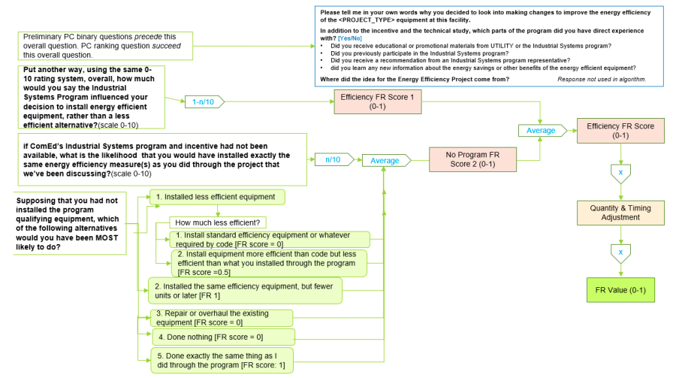

Source: Based on TRM v9 Core Non-Residential Free Ridership algorithm, with updates based on the Illinois SAG NTG Working Group consensus in 2020.

The Quantity and Timing adjustment shown in the NTG algorithm above is estimated using the equations from Illinois TRM v12.0.

Source: https://www.ilsag.info/wp-content/uploads/IL-TRM-Version-12.0-Volumes-1-4-Compiled-Final.pdf Page47

Participant Spillover Estimation
The evaluation team used the Core Participant Spillover protocol as specified in Illinois TRM v12.0 (Section 3.1.2, “Core Non-Residential Participant Spillover Protocol,”) to qualify non-rebated energy efficiency improvements as spillover. This protocol is applicable to most commercial, industrial, and public sector programs. Figure 3 illustrates the spillover qualification screening process for the Industrial Systems Projects as recommended by TRM v12.0.

Figure 3. Core Non-Residential Participant Spillover Protocol
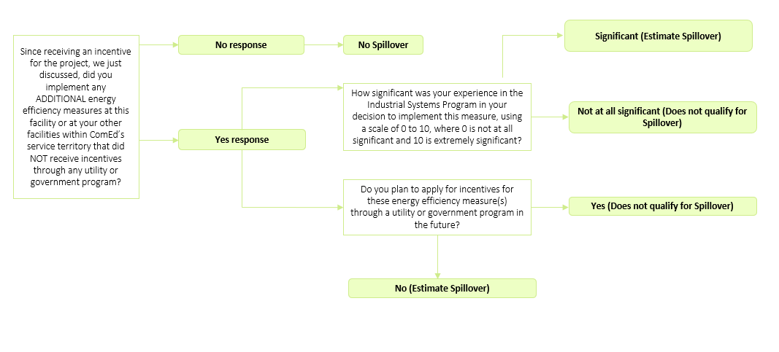
Source: Evaluation team representation of TRM v12.0

Detailed NTG Results
Table 3 below provides a detailed summary of NTG findings for Industrial Systems Projects across the three sampling size strata based on the energy savings. Note that Stratum 1 represents the largest projects, Stratum 2 consists of medium-sized projects, and Stratum 3 contains the smallest projects.

None of the respondents who completed a phone interview or web survey reported completing additional high efficiency improvements that qualified as spillover and thus the spillover incorporated into the NTG ratios is zero.

Table 3. Industrial Systems Breakdown by Sampling Strata
Sampling Stratum | Number of Projects Analyzed | Ex Ante kWh in Population | Ex Ante kWh in Sample | Percent of Savings | kWh FR | Spillover | NTG Ratio
Stratum 1 Large Projects | 9 | 50,225,589 | 12,469,673 | 25% | 0.21 | 0.00 | 0.79
Stratum 2 Medium Projects | 13 | 50,532,097 | 5,093,850 | 10% | 0.17 | 0.00 | 0.83
Stratum 3 Small Projects | 19 | 50,521,951 | 1,064,454 | 2% | 0.34 | 0.00 | 0.66
Source: Evaluation team analysis

Stratum 1 Industrial Systems Projects Summary
For Stratum 1, data collection was completed for nine projects using professional in-depth interviews. The nine evaluated projects in Stratum 1 had Free ridership (FR) that ranged from 0.02 to 0.4.
- Seven of the nine projects in this stratum had a FR lower than 0.22. The Industrial System Program audit and the incentive played a significant role in these projects.
- One project in Stratum 1 showed a moderate FR of 0.4. The decision maker said that the existing compressors were nearing the end of their useful life. The program accelerated the installation of the new energy efficiency air compressors. In the absence of the program, the decision maker reported they would have installed equipment more efficient than the code but less efficient than what was installed through the program.

Stratum 2 Industrial Systems Projects Summary
For Stratum 2, data collection was completed for 13 projects using professional in-depth interviews. The FR for these Stratum 2 projects ranged from 0.0 to 0.38.
- Nine of the thirteen Stratum 3 projects had FR less than 0.25. The ComEd program helped the customer to identify opportunities via the audits and the program incentive enabled the customer to opt for high efficiency equipment instead of a less efficient alternative.
- Four projects had moderately low FR ranging from 0.3 to 0.38. For a couple of leak repair projects, the decision makers stated they are aware of the costs of air and consistently ensure they are not losing money on potential air leaks. They have their own internal leak check and repair processes in place at their facilities. For two capital cost projects, the customers said they would have completed the same projects at a later date or only implemented a few measures in the absence of the program.

Stratum 3 Industrial Systems Projects Summary
For Stratum 3, data collection was carried out through professional in-depth interviews for seven projects from CY2021 and CY2022. However, for CY2023, the evaluation team faced challenges scheduling in-depth interviews for most of the sample. As a result, data collection for 12 CY2023 projects in Stratum 3 was completed using a combination of in-depth interviews and web surveys, with most of the data coming from the web surveys.

The 19 Stratum 3 projects included in the analysis had FR that ranged from 0.02 to 0.75.
- Eight of the nineteen projects had a low FR of less than 0.16. For these projects, the decision makers reported the incentive, and the ComEd Program audit were highly influential in their decision making.
- An additional eight of the nineteen projects had a moderately low FR that ranged from 0.20 to 0.38. Five of these eight projects were leak repair projects. Decision makers cited the Service Provider study as very important to helping them identify leaks that they were previously unaware of and accelerated the leak repairs in some cases. They also acknowledged that the availability of free leak repairs eliminated barriers on their part to getting the work done. The majority of these respondents indicated that absent the program they would have completed the leak repair project but at a later date.
- The remaining three leak repair projects had high FR that ranged from 0.50 to 0.75. The decision makers noted that they would have completed an audit and leak repair at the same time even without the program.
None of the respondents who completed a phone interview or web surveys reported completing additional high efficiency improvements that qualified as spillover and thus, the spillover incorporated into the NTG ratios is zero.

Final NTG Results and Recommendations
The energy savings weighted FR value from this new research is 0.23 which results in NTG of 0.77 as we did not identify any spillover. The evaluation team recommends this value for CY2025 projects. We are recommending the three-year value as it is based on a larger and more robust sample, and it reflects the latest available information from the evaluation effort.
Table 4 summarizes Guidehouse’s draft recommendations for the Industrial Systems Program to be used in CY2025.
Table 4. Three Year Combined kWh Free Ridership and NTG Research Results
for the Industrial Systems Program
Measure Type | Savings Type | Free Ridership | Spillover | NTG Ratio
Overall Program | kWh | 0.23 | 0.00 | 0.77
Overall Program | kW | 0.20 | 0.00 | 0.80

Breakdown for each Program Year by Sampling Strata

Table 5, Table 6 and Table 7 summarize the number of completed telephone surveys for each program year and the percentage of ex ante kWh claims represented by stratum.

Table 5. CY2021 Industrial Systems Projects Breakdown by Sampling Strata
Sampling Stratum | Number of Projects Analyzed | Ex-Ante kWh in Sample | Ex Ante kWh in Population | Percent of Savings | NTG Ratio
Stratum 1 – Large Projects | 2 | 3,600,338 | 14,253,203 | 25% | 0.76
Stratum 2 – Medium Projects | 4 | 1,718,248 | 16,060,651 | 11% | 0.80
Stratum 3 – Small Projects | 2 | 67,316 | 15,193,795 | <1% | 0.61
Source: Evaluation team analysis

Table 6. CY2022 Industrial Systems Projects Breakdown by Sampling Strata
Sampling Stratum | Number of Projects Analyzed | Ex-Ante kWh in Sample | Ex Ante kWh in Population | Percent of Savings | NTG Ratio
Stratum 1 – Large Projects | 5 | 3,591,223 | 18,785,783 | 19% | 0.78
Stratum 2 – Medium Projects | 5 | 1,794,350 | 19,045,345 | 9% | 0.86
Stratum 3 – Small Projects | 5 | 461,126 | 19,151,252 | 2% | 0.62
Source: Evaluation team analysis

Table 7. CY2023 Industrial Systems Projects Breakdown by Sampling Strata
Sampling Stratum | Number of Projects Analyzed | Ex-Ante kWh in Sample | Ex Ante kWh in Population | Percent of Savings | NTG Ratio
Stratum 1 – Large Projects | 4 | 6,256,258 | 15,738,375 | 40% | 0.87
Stratum 2 – Medium Projects | 2 | 603,106 | 16,634,887 | 4% | 0.70
Stratum 3 – Small Projects | 12 | 536,012 | 16,416,346 | 3% | 0.74
Source: Evaluation team analysis

Table 8 provides program-level energy and demand NTGRs, relative precision, and spillover for CY2021, CY2022, and CY2023.

Table 8. NTG and FR Results and Relative Precision at 90% Confidence Level
Program Year | Savings Type | NTG Ratio | Free Ridership | Relative Precision at 90% CI | Spillover
CY2021 | kWh | 0.72 | 0.28 | 16% | 0
CY2022 | kWh | 0.75 | 0.25 | 5% | 0
CY2023 | kWh | 0.77 | 0.23 | 9% | 0
CY2021 | kW | 0.81 | 0.19 | 6% | 0
CY2022 | kW | 0.72 | 0.28 | 6% | 0
CY2023 | kW | 0.77 | 0.23 | 7% | 0
Source: Evaluation team analysis

Industrial Systems NTG History

 | Industrial Systems Program
EPY1 | Program did not exist
EPY2 | Program did not exist
EPY3 | Program did not exist
EPY4 | Retroactive application of NTG: 0.67 for kWh and 0.72 for kW (EPY4 Compressed Air)  Free Ridership 33% kWh and 0.28 kW  Spillover 0%  Method: Customer self-reports. Seven surveys completed from a population of 9.
EPY5 | Illinois SAG Consensus:  - 0.67
EPY6 | Illinois SAG Consensus:  0.67
EPY7 | NTG: 0.68  Free Ridership: 0.33  Participants Spillover: 0.01  Nonparticipants Spillover: Negligible  Free ridership and participant spillover was measured in a participant survey on 35 projects. Interviews were completed with five of 11 Industrial System projects.
EPY8 | NTG: 0.74  Free Ridership, kWh: 0.26  Spillover, kWh: Negligible  NTG, kW: 0.83  Free Ridership, kW: 0.17  Spillover, kW: Negligible  NTG research methods in PY6 consisted of participant and technical service provider survey data collection and analysis (n=17).  The net program impacts were quantified solely on the estimated level of free ridership. Information regarding participant spillover was also collected, but ultimately did not support a finding of any spillover.
EPY9 | Industrial Systems NTG: 0.80  Industrial Systems Free Ridership: 0.20  Industrial Systems Spillover: Negligible  NTG Research Source:  Free Ridership: PY7 participant and vendor self-report data  Spillover: PY7 participant and vendor self-report data
CY2018 | Industrial Systems NTG kWh: 0.80  Industrial Systems NTG kW: 0.81  Industrial Systems Free Ridership kWh: 0.20  Industrial Systems Free Ridership kW: 0.19  Industrial Systems Spillover: Negligible  NTG Research Source:  Free-Ridership: PY7 Participant and vendor self-report data  Spillover: PY7 Participant and vendor self-report data  The evaluation team performed telephone surveys in PY8, but the analysis will be performed  and combined with PY9 findings.
CY2019 | Industrial Systems NTG kWh: 0.77  Industrial Systems NTG kW: 0.78  Industrial Systems Free Ridership kWh: 0.23  Industrial Systems Free Ridership kW: 0.22  Industrial Systems Spillover: Negligible  NTG Research Source:  Free-Ridership: PY8 and PY9 Participating customer surveys  Spillover: PY8 and PY9 Participating customer surveys  The evaluation team performed telephone surveys in PY8, but deferred analysis until PY9.  The recommended values are based on the combined PY8/9 results.
CY2020 | Industrial Systems NTG kWh: 0.77  Industrial Systems NTG kW: 0.78  Industrial Systems Free Ridership kWh: 0.23  Industrial Systems Free Ridership kW: 0.22  Industrial Systems Spillover: Negligible  NTG Research Source:  Free-Ridership: PY8 and PY9 Participating customer surveys  Spillover: PY8 and PY9 Participating customer surveys
CY2021 | Unchanged from CY2020  Industrial Systems NTG kWh: 0.77  Industrial Systems NTG kW: 0.78  Industrial Systems Free Ridership kWh: 0.23  Industrial Systems Free Ridership kW: 0.22  Industrial Systems Spillover: Negligible  NTG Research Source:  Free-Ridership: PY8 and PY9 Participating customer surveys  Spillover: PY8 and PY9 Participating customer surveys
CY2022 | Industrial Systems NTG kWh: 0.77  Industrial Systems NTG kW: 0.77  Industrial Systems Free Ridership kWh: 0.23  Industrial Systems Free Ridership kW: 0.23  Industrial Systems Spillover: Negligible  NTG Research Source:  Free-Ridership: CY2018, CY2019 and CY2020 Participating customer surveys  Spillover: CY2018, CY2019 and CY2020 Participating customer surveys
CY2023 | Unchanged from CY2022  Industrial Systems NTG kWh: 0.77  Industrial Systems NTG kW: 0.77  Industrial Systems Free Ridership kWh: 0.23  Industrial Systems Free Ridership kW: 0.23  Industrial Systems Spillover: Negligible  NTG Research Source:  Free-Ridership: CY2018, CY2019 and CY2020 Participating customer surveys  Spillover: CY2018, CY2019 and CY2020 Participating customer surveys
CY2024 | Unchanged from CY2023  Industrial Systems NTG kWh: 0.77  Industrial Systems NTG kW: 0.77  Industrial Systems Free Ridership kWh: 0.23  Industrial Systems Free Ridership kW: 0.23  Industrial Systems Spillover: Negligible  NTG Research Source:  Free-Ridership: CY2018, CY2019 and CY2020 Participating customer surveys  Spillover: CY2018, CY2019 and CY2020 Participating customer surveys
CY2025 | Industrial Systems NTG kWh: 0.77  Industrial Systems NTG kW: 0.80  Industrial Systems Free Ridership kWh: 0.23  Industrial Systems Free Ridership kW: 0.20  Industrial Systems Spillover: Negligible  NTG Research Source:  Free-Ridership: CY2021, CY2022 and CY2023 Participating customer surveys  Spillover: CY2021, CY2022 and CY2023 Participating customer surveys

