Ameren Illinois Company
2024 Business Program Impact Evaluation Report
Appendix D: Custom Initiative Project Reports

Draft
March 13, 2024

Contents

Custom Initiative Project Reports 5
Project 2300987 5
Project 2400146 12
Project 2400006 15
Project 2300804 20
Project 2300092 26
Project 2400148 34
Project 2301013 36
Project 2200025 41
Project 2300006 46
Project 2300012 55
Project 2300044 60
Project 2200065 63

TABLES and Figures
Table 1. Summary of Project 2300987 Savings 6
Table 2. Summary of Implemented Energy Savings Strategies 6
Table 3. Flow Fraction and Part Load Ratio 9
Table 4. Summary of Project 2400146 Savings 12
Table 5. Summary of Project 2400006 Savings 16
Table 6. Baseline and New Conditions for Savings from Trane Trace Energy Modeling 16
Table 7. Summary of Project 2300804 Savings 21
Table 8. Summary of Project 2300804 Key Findings 24
Table 9. Summary of Project 2300092 Savings 27
Table 10. Summary of Project 2400148 Savings 35
Table 11. Baseline and Proposed Calculation Categories 35
Table 12. Summary of Project 2301013 Savings 37
Table 13. Summary of Project 2200025 Savings 41
Table 14. Verified Calculation Results 45
Table 15. Summary of Project 2300006 Savings 47
Table 16. Verified Model Inputs and Parameters for Project 2300006 53
Table 17. Summary of Project 2300012 Savings 55
Table 18. Project 2300012 Unallocated Verified Savings 56
Table 19. Summary of Project 2300044 Savings 60
Table 20. Summary of Project 2200065 Savings 63
Table 21. Summary of Electric Calculations 64

Figure 1. Simulated Baseline Energy Consumption 17
Figure 2. Simulated Proposed Case Energy Consumption 17
Figure 3. Energy Management System Weekly Schedule 18
Figure 4. Weather-Normalized Annual Electricity Usage Comparison 19
Figure 5. Weather-Normalized Gas Usage Analysis 20
Figure 6. Graph of Pulsaire Fan Model 22
Figure 7. Power Factor vs. %FLA for 40 - 75 HP Fan Motor 25
Figure 8. Power Factor vs. %FLA for 150 HP Grinder #2 Motor 25
Figure 9. Baseline System 28
Figure 10. Proposed System Part 1 – Sequencer Online 29
Figure 11. Proposed New SAV150G2 + Sequencer Online 30
Figure 12. Interpolated Data Calculated Using Incorrect CAGI Sheet at 125 psig 30
Figure 13. CAGI Sheet for SAV150G2 Operating at 125 psig 31
Figure 14. Correlation between CFM and Percent of Full Load Power 33
Figure 15. Verified Savings Calculations 34
Figure 16. Equipment Annual Energy Usage 38
Figure 17. Input Summary 39
Figure 18. Systems Overview 40
Figure 19. Post-Installation Equipment Correlation 44
Figure 20. Pre-Installation Equipment Correlation 45
Figure 21. Baseline Parameters 48
Figure 22. Baseline Annual Building Energy Usage 49
Figure 23. Proposed Annual Building Energy Usage 49
Figure 24. Proposed Monthly Building Energy Usage 50
Figure 25. Mechanical Strategies and Verified Status 50
Figure 26. Lighting Strategies and Verified Status 51
Figure 27. Verified Isolated Strategy Results – Most Impactful Measures 52
Figure 28. Average Steam Usage vs. Average Wet Bulb Temperature 58
Figure 29. Boiler #4 NG (MBH) vs. Steam pph 59
Figure 30. Chiller kWh vs. CDD 50°F WB 59

Custom Initiative Project Reports
In this section, we present detailed project-level desk review, remote measurement and verification (M&V), and on-site M&V reports for 12 Custom Initiative projects evaluated as part of the 2024 Business Program impact evaluation.

Project 2300987
Project ID#: | 2300987
Measure: | New Construction High Efficiency HVAC and Lighting
Ex Ante Savings: | 795,427 kWh; 182.4 kW
Facility Type: | Shopping Center
End Use: | HVAC and Lighting
Sampled For: | Electric
Wave: | Wave 3

Measure Description
This project was completed as part of the new construction of a shopping center. This project involves installing equipment that exceeds code minimum efficiencies specified in ASHRAE 90.1-2016. The modeling program DOE 2.1E was used to model the building baseline, proposed case, and energy savings. A custom interface for the DOE 2.1E program called NEO was used in the savings analysis. Most of the electric savings come from reducing the lighting power density (LPD) in showrooms, achieving variable airflow down to 30% on rooftop units (RTUs), and reducing the fan power and increasing the cooling efficiency of the RTUs beyond code minimum requirements. This project was completed on July 31, 2024.

Key Findings
The evaluation team determined that the ex ante savings claimed for the two new construction 15-ton RTUs (322,181 kWh), which account for a third of ex ante savings, exceeded the amount of energy that the baseline RTUs, which are code complaint, would be expected to consume under typical operation (approximately 100,000 kWh). As a result of the limited project documentation regarding the inputs used in the savings calculations, the exact source of these errors could not be identified. A potential source of discrepancy, which could not be confirmed, is double counting of savings associated with reducing fan power baseline allowance, minimizing variable airflow, and increasing cooling efficiency, which are all interactive. Analyzing these measures independently of each other might result in overestimating total savings.
The evaluation team found that the occupancy sensor measure assumed a code-maximum baseline lighting power density. Savings for the lighting controls measure should have applied the installed (efficient) LPD because use of the baseline LPD would effectively double count savings from the improved lighting efficiency. In the verified savings, the evaluation team used the installed LPD rather than the baseline LPD for the lighting controls measure, which led to reduced savings.
The resulting project savings are shown in Table 1.

Table 1. Summary of Project 2300987 Savings
 | kW | kWh
Ex Ante | 182.2 | 795,427
Verified | 112.3 | 523,767
Realization Rate | 62% | 66%

Summary of the Ex Ante Calculations
The implementation team calculated the savings using building simulations provided by the contractor. The simulations were completed using DOE-2.1E software with an interface called NEO, which the trade partner developed in-house. Since the customer could not provide any information about the model, the evaluation team is unaware of most of the calculations' inputs and baseline values.
The process of developing the ex ante savings followed a three-step approach. First, the contractor estimated the project savings given the initial design documents. Before the project was completed, the contractor reviewed the most recent version of the construction documents and made any necessary adjustments to their estimated savings. Once the project was completed and the building was occupied, the contractor verified all inputs and adjusted their simulations as necessary to produce a final savings value. Specific baseline values were not provided to the evaluation team, but Table 2 summarizes the most impactful energy-saving strategies that were implemented; strategies resulting in lesser savings are not included in the table.
Table 2. Summary of Implemented Energy Savings Strategies
Space/Area | Strategy | Savings (kWh)
RTU | Achieve variable air flow down to 30% of design flow | 110,914
RTU | Reduce the fan power baseline allowance by 50% | 116,679
RTU | Reduce cooling efficiency by 10% beyond baseline requirement | 3,006
RTU | Premium efficiency DX part load performance | 74,003
RTU | Demand control ventilation for showrooms | 17,561
Showrooms | Occupancy sensor control of 50% of the space | 51,408
Showrooms | Lighting power reduced to 0.32 W/square foot | 535,354
When added up, the energy savings total 908,943 kWh rather than the claimed 795,427 kWh. A breakdown of the final savings by measure was not available to determine the source of the difference.

Early Review Notes
This project was subject to an early review prior to authorization. The following comments highlight the evaluation team’s early review recommendations as well as findings during the evaluation:
- Many of the measures included in the Bundle Requirements Document (the “bundle”) do not provide the specifications for the equipment in the baseline and proposed systems. The evaluation team suggests invoices and/or specification sheets for the various equipment purchased for this redevelopment be obtained to support the claimed equipment efficiencies and savings.
  - This was done for the new light fixtures but not fully for the RTUs.
- The bundle states, "one month before completion, Wildan will request Construction Documents and Specifications (electronic format).” Assuming no construction delays have occurred, this work's projected completion date is 1/31/2024. Thus, these documents should be received by Wildan on 12/31/2023. If this project is evaluated in the future, this documentation will be vital to the evaluation efforts.
  - The documentation was not fully available.
- For the lighting measures, the redevelopment’s electrical plans and lighting controls schedule should be obtained. If this project is evaluated after completion, these plans will allow the evaluation team to perform an internal LPD analysis to ensure that the desired LPD of 0.32 W/ft² is realized. Furthermore, these plans (or other proof of controls installation) will provide evidence that the controls intended for the space were installed.
  - A specification sheet and a rough drawing of the building were provided.
For the mechanical measures, the following equipment-specific documentation should be obtained:
- An invoice for—or proof of installation of—the VFD/ECM referenced in the “Variable speed supply air fan” measure.
  - This was not available.
- An invoice for the “efficient fan/motor,” or proof of “thoughtful duct design” referenced for the fan system power measure. Information and/or documentation verifying the power of the as-built fan system is 0.47 BHP/1000 cubic feet per minute (CFM) or lower.
  - This was not available.
- Specification sheets for the installed cooling equipment to ensure that they comply with the efficiency ratings (in EER).
  - This was not available.
- An invoice for—or proof of installation of—the VFD/ECM referenced in the “Premium efficiency DX cooling compressor” measure.
  - This was not available.
- An invoice—or proof of installation—for the destratification fans referenced in the “Destratification fans” measure.
  - This was not available.
- Wildan should ensure that all applicable energy efficiency codes are accounted for in the baseline model. For instance, demand control ventilation may be required for some of the areas. Also, for most systems, variable or two-stage fan capacity control is generally required for most air handling units with cooling.
  - This could not be verified by the evaluation team.
- Since both the baseline and proposed systems were modeled using DOE2.1E, .pdf, documents of both the input and output parameters should be included in future submissions for evaluation(s). This allows the evaluation team greater insight into possible sources of error in energy model(s) instead of strictly providing before-and-after values.
  - This was not available.
- With the proposed energy-saving measures, the resulting energy use intensity (EUI) of the redevelopment is expected to be lower than a typical mercantile building. Based on the building area and modeled usage, the electrical EUI of the baseline case is 8.78 kWh/ft² per year, and the proposed case is 2.78 kWh/ft² per year. Based on CBECS 2018 data, a typical shopping mall with electric cooling and gas heating in this part of the country consumes between 17.7 and 20.1 kWh/ft² per year (as seen in Table 6), so the evaluation team has concerns regarding the accuracy of the developed models, as the proposed model possesses an electrical EUI that is 85% lower than typical shopping malls.
  - It does not appear that this was addressed.
- The evaluation team recommends that after the project is completed, the energy model be calibrated to billed usage data such that the modeled post-case usage aligns with the actual energy consumption of the facility, following ASHRAE 90.1 Appendix G guidelines.
  - It does not appear that this was done.
- Several strategies are being employed to reduce the energy consumption of the rooftop units, including variable speed fans, DCV, reduced fan system power, improved DX cooling efficiency, and premium efficiency DX compressors with improved part-load performance. The collective savings for these strategies is one-third of the modeled savings (11.4% for variable speed fans, 1.8% for DCV, 10.8% for the fan efficiency, 2.2% for improved DX cooling efficiency, and 7.6% for the premium efficiency DX compressors with part load capabilities). One-third of the claimed savings for this project (834,784 kWh) is just over 281,000 kWh. Using the baseline modeled energy consumption and details about the other energy-using systems in the baseline building (the baseline LPD of 1.06 W/ ft², expected operating hours of 4,099 hours per year per the IL-TRM, plus an assumed plug/process load of 0.3 W/ft²), the baseline energy use of the RTUs is deduced to be approximately 450,000 kWh/year. Therefore, the expected savings for the RTUs are over half of the estimated baseline consumption for this equipment. To achieve this magnitude of savings, the enumerated mechanical measures in this project are essentially claiming to more than double the operational efficiency of the RTUs. The evaluation team is concerned that this magnitude of savings from primarily equipment efficiency improvements is unrealistic. It is possible that some of the reported savings metrics for equipment efficiency are bolstered by interactive effect savings, but it is also possible that the model may be unrealistically inflating the efficiency improvements that are feasible for a project of this kind.
  - It does not appear that this was fully addressed. The savings were reduced only slightly.

Summary of the Verified Calculations
Because the evaluation team was given limited information about the model inputs, assumptions, and calculations for the project, we performed prescriptive savings calculations based on IL-TRM V12.0 as a gut check of the claimed savings. Overall, it was found that many of the ex ante savings differ significantly from expectations based on the evaluation team’s analysis. Given the data limitations, the evaluation team was unable to pinpoint exactly where the differences between the verified and ex ante estimates occurred.
Equation 1 from section 4.4.26 of the IL-TRM was used to evaluate the savings associated with achieving variable airflow down to 30% of the design flow.
Equation 1. Energy Savings from the Reduction of Minimum Airflow
$$kWh = \left(0.746×HP×\frac{LF}{Eff}\right)×Hours×\sum_{0\%}^{100\%}{\left(\%FF×PLR\right)}×Quantity$$
In this algorithm, HP represents the motor horsepower (5 hp for both units), LF is the load factor, the hours are the annual total fan run hours (TRM value of 6,921 for a retail space), and the summation represents a typical fan loading and flow fraction profile. The %FF is the percentage of run-time spent within a given flow fraction and PLR is the part load ratio for a given flow fraction range based on the flow control type. Table 3 shows a flow fraction table that puts limits on the baseline to reflect the code minimum flow (66%) as well as the energy-efficient minimum (30%). These are based on the flow fraction tables in the TRM, adjusted to reflect the code-minimum and installed controls.
Table 3. Flow Fraction and Part Load Ratio
Flow Fraction Range | PLR – VFD (low/no duct static pressure) | Percent Time - Baseline | Percent Time - Proposed
10% | 0.05 | 0 | 0
20% | 0.06 | 0 | 0
30% | 0.09 | 0 | 7%
40% | 0.12 | 0 | 16%
50% | 0.18 | 0 | 22%
60% | 0.27 | 0 | 25%
66% | 0.39 | 80% | 11%
70% | 0.39 | 8% | 8%
80% | 0.55 | 9% | 9%
90% | 0.75 | 3% | 3%
100% | 1.00 | 1% | 1%
In the baseline case, the flow fraction ranges from 66% to 100%, and the PLR ranges from 0.39 to 1. Here, the summation is 42%. The same equation is used for the proposed case; however, the flow fraction now ranges from 30% to 100%, and the PLR ranges from 0.09 to 1. In this case, the summation is 28%.
By subtracting the baseline from the proposed energy usage, the resulting energy savings are 5,158 kWh. Because systems are expected to operate at high loading during peak periods, there are no peak demand savings for the RTUs having a reduced minimum speed. Energy savings come from ramping down the fan to lower speeds during periods of low loads, which will generally occur during shoulder season months and unoccupied hours. The resulting energy savings are only 3% of what was claimed for this measure in the ex ante savings.
Next, the evaluation team determined the savings resulting from reducing the specific fan power to 50% of code allowances. This was done with the fan power allowance in IECC 2016 (0.94 bhp per 1,000 CFM), the rated flow rates of the installed RTUs, and the rated fan brake horsepower values of the installed units. Equation 2 shows the equation used to calculate the energy savings for this measure.
Equation 2. Energy Savings from the Reduction of Fan Power Baseline Allowance
$$ΔkWh = Quantity×Hours×\frac{\left(\frac{kW}{1000 CFM}\left(base\right)-\frac{kW}{1000 CFM}\left(EE\right)\right)}{1000}×CFM$$
In this algorithm, the CFM from the RTU specification sheets is 5,250, the baseline kW/1000 CFM is given to us as 0.7, and the energy efficient value is given to us as 0.313. Hours were back-calculated by setting the equation equal to the proposed energy usage from the previous measure (10,495 kWh). The EFLH came out to be 1,425. The resulting energy savings are 5,806 kWh. Dividing by the EFLH, multiplying by one plus the demand interactive effects (0.157), and multiplying by the peak part load ratio at the average flow fraction (0.75), yields demand savings of 3.53 kW. The resulting energy savings are just 5% of the claimed value for the same reasons cited for the first measure.
For the RTU measure of adding demand control ventilation (DCV) to the showrooms, Equation 3 from section 4.4.19 of the IL-TRM was applied.
Equation 3. Energy Savings from DCV
$$ΔkWh = \frac{Area}{1000}×SF_{cooling}$$
The project documentation specifies the area as 138,941 ft2, and the SF_cooling is the cooling savings factor from the IL-TRM (290 kWh/1000 sf). The resulting energy savings are 40,293 kWh; dividing by the operating hours (2,704 annual hours, determined from the store’s operating hours) gives us demand savings of 14.9 kW. The energy savings are 229% of the ex ante claimed savings for this measure.
For the RTU measure of reducing the cooling efficiency by 10% beyond the baseline, Equation 4 from section 4.4.0 of the IL-TRM was applied.
Equation 4. Energy Savings from the Reduction of DX Cooling Efficiency
$$ΔkWh = FLH_{cool}×Capacity×\frac{\left(\frac{1}{EER_{base}}-\frac{1}{EER_{EE}}\right)}{1000}×Quantity$$
The FLH_cool is the full load cooling hours (930 from the TRM), capacity is 180,000 Btu/hr, EER_base is a code minimum value of 10.8, and EER_EE is 10.94 from the project documents. The resulting energy savings are 398 kWh (13% of what was claimed in the ex ante savings). Dividing by the EFLH and multiplying by the summer system peak coincidence factor (0.466) results in demand savings of 0.20 kW.
For the premium efficiency DX part load performance RTU measure, Equation 5 from section 4.4.15 of the IL-TRM was applied.
Equation 5. Energy Savings from Premium Part Load Efficiency
$$ΔkWh = Capacity×\left(\frac{1}{IEER_{base}}-\frac{1}{IEER_{EE}}\right)×EFLH×Quantity$$
Capacity is 180 kBtu/hr, IEER base is a code minimum 12.2, IEER_EE is 14.5 (from the equipment spec sheet), and EFLH is 930 (from the TRM). The resulting energy savings are 4,352 kWh (6% of the ex ante claim); dividing by EFLH and multiplying by the summer system peak coincidence factor (0.478) results in demand savings of 2.24 kW.
For the lighting measures, we applied Equation 6 to estimate the savings for the reduction of the LPD.
Equation 6. Energy Savings from a Reduced LPD
$$∆kWh=({WSF}_{Base}-{WSF}_{EE})/1000×SF×Hours×{WHF}_{E}$$
WSF_base is the baseline LPD (1.06 Watts/sf -- code minimum obtained from the TRM), WSF_EE is the energy efficient LPD (0.37 Watts/sf, value from the final verification report), hours are 4,093 (from the TRM), SF is area (138,941), and the WHF_E is the waste heat factor for energy (1.12, from the TRM). The evaluation team used the deemed lighting hours from the TRM (4,093). The resulting energy savings are 439,480 kWh (82% of the ex ante claim). Demand savings were estimated using Equation 7.
Equation 7. Reduced LPD Demand Savings
$$∆kW=({WSF}_{Base}-{WSF}_{EE})/1000×SF×{WHF}_{D}×CF$$
WHF_D is the demand waste heat factor (1.29) and CF is the summer peak coincidence factor (0.71). The resulting demand savings are 87.81 kW.
The last measure claimed for this facility was occupancy sensor control of 50% of the showroom space. Equation 8 shows how these savings were quantified.
Equation 8. Energy Savings from Occupancy Sensors
$$∆kWh={kW}_{Controlled}×Hours×({ESF}_{EE}-{ESF}_{Base})×WHF_E$$
The hours remained the same as the LPD measure at 4,093 hours, the ESF_EE (energy savings factor) was 0.24, ESF_Base was 0, WFH_E stayed the same at 1.12, and the kW_Controlled per fixture was 0.075. The quantity of fixtures was calculated using Equation 9.
Equation 9. Quantity of Fixtures in the Showroom
$$Quantity= \frac{Area×LPD}{Watts/fixture}$$
Here, the area is the same (138,941 sf), LPD is the claimed energy efficient LPD value of 0.37 (Watts/sf), and the watts/fixture is 150W (provided by the customer). The resulting quantity is 342.74. The resulting energy savings are 28,280 kWh (55% of what was claimed). Demand savings were found using Equation 10.
Equation 10. Occupancy Sensor Demand Savings
$$∆kW={kW}_{Controlled}×{WHF}_{D}(CF-{CF}_{LLC})$$
Here, kW_controlled, WHF_Demand, and CF are the same as what was used in the LPD measure and CF_LLC is the retrofit summer peak coincidence factor for a lighting system with controls (0.15). The resulting demand savings are 18.57 kW.

Project 2400146
Project ID#: | 2400146
Measure: | Regenerative Thermal Oxidizer
Ex Ante Savings: | 399,763 therms
Facility Type: | Manufacturing
End Use: | Process
Sampled For: | Gas
Wave: | 3

Measure Description
The customer relocated a production line from an existing plant in a different state and installed the line at an existing plant in Illinois. The new line produces volatile organic compounds (VOCs) and required the installation of equipment to reduce VOC emissions in accordance with state regulatory air quality standards. The new system is a completely refurbished regenerative thermal oxidizer (RTO). The RTO uses a gas-fired burner to raise the temperature of the air to be treated to temperatures from 1,400°F to 1,600°F. The RTO uses a two-chamber ceramic bed as its heat exchanger system. The exhaust air passes through one bed and heats the ceramic media, while the intake air passes through the other bed, capturing the waste heat from the previous cycle. The flow reverses every few minutes where the intake bed becomes the exhaust bed and vice versa.

Key Findings
There were several reasons for the reduction in savings. The primary reason for the reduction in savings is that the evaluation team assumed that it would not be necessary to maintain warm temperature in the baseline recuperative thermal oxidizer when it was in standby mode. We also found that the RTO air flow was only 15,800 CFM compared to the 20,000 CFM value used in the ex ante calculations.
The resulting project savings are shown in Table 4.
Table 4. Summary of Project 2400146 Savings
 | Therms
Ex Ante | 399,763
Verified | 140,632
Realization Rate | 35%

Summary of the Ex Ante Calculations
The ex ante baseline is a recuperative thermal oxidizer. A recuperative thermal oxidizer is a heat exchanger that continuously heats intake air with heated exhaust. The thermal rate efficiency (TRE) of a recuperative oxidizer is typically between 50% and 70%. The implementation team assumed a baseline TRE of 70%. The vendor claims 95% TRE for the proposed RTO.
Per the Illinois TRM, RTO savings are calculated using the following algorithm.
$$ΔTherms = ((Baseline Q_{T}- Proposed Q_{T}) x Hours) / LHV$$
Where:
LHV = Latent Heat of Vaporization
= If the post is regenerative thermal oxidizer, LHV = 0.953
Baseline and Proposed Q_{T} values are modeled using a similar heat balance equation:
$$Q_{T} \left(btuh\right)= Q_{i} + Q_{cc} + Q_{RL} – Q_{VOC}$$

Where:
Q_{T} = Total Energy Input
Q_{I} = Energy (btuh) used to raise the temperature of process air (FI)
= FI * 1.08 * (TO – TI)
T_{O} = Average stack outlet temperature (°F)
T_{I} = Inlet air temperature (°F), this is the temperature of the air coming from the process
F_{I} = Process air flow (CFM), actual loading or use maximum design value
1.08 = Conversion Factor (Standard conditions of intake air)
Q_{CC} = Heat (btuh) used to raise the temperature of combustion air (FCC)
= FCC * 1.08 * (TO – TA)
F_{CC} = Additional combustion air flow (CFM) at provided FI value
T_{O} = Average outlet temperature (°F) (same as above)
T_{A} = Combustion intake air temperature (°F)
Q_{RL} = Radiation heat loss (btuh) from RTO
Q_{VOC} = Heat release (btuh) provided by VOC combustion
VOC = Average lbs/hr from process to oxidizer
HC = btu/lb, site-specific weighted average for the heat of combustion of VOCS
%Dest = Destruction efficiency of VOCs provided by the manufacturer
Following this approach, the total ex ante claimed savings are 399,763 therms.

Measurement and Verification Plan
This project was selected for a desk review and report. The evaluation team found the approach to estimating ex ante savings to be reasonable and consistent with IL-TRM guidelines.
The evaluation team will collect the following information from the customer via phone or email communications:
- Normal hours of operation @ 100% production
- Seasonal variations?
- Hours of operation at reduced flow (25%?)
- What is the reduced flow %?
- How is reduced flow achieved? VFD?
- Trend data for operation, incl gas flow/usage, VOC loading, air flow, inlet and outlet temperatures

Early Review Notes
This project was subject to an early review prior to authorization. Below are the recommendations provided through the early review as well as the findings made through this evaluation.
- The ex ante savings calculations use the Illinois TRM algorithms and values in a spreadsheet. The calculations and assumptions are consistent with the TRM. An EUL of 20 years was also used, which is consistent with the TRM.
- A recuperative thermal oxidizer is an appropriate baseline for a new construction project.
Recommendations from the early review included:
- The calculations should account for idle time and start-up energy use if the RTO is not operating continuously. If the temperature of the RTO is lowered for weekends or other shutdowns, the RTO media must be preheated before VOC destruction starts.
  - Finding: The implementation team assumed that the RTO would remain in keep-warm mode at 40% BTUH when not in operation. The RTO would run at 100% capacity 40 hours per week and the rest of the time would be in idle mode. The team also assumed that the baseline recuperative oxidizer would be kept warm when operating in standby mode.
- Regenerative thermal oxidizers will have higher pressure drops than recuperative thermal oxidizers. As a result, the forced-draft blower will need more power, subsequently increasing electrical energy usage. The calculations should account for this electrical penalty.
  - Finding: There were no electrical energy savings or penalties claimed.
- Given that the unit being refurbished and installed for this project is already older than the 20-year EUL for RTOs, further investigation is recommended for determining the EUL that should be applied to this project. The equipment was manufactured in 2001 and was in use until 2022. While the efforts going into the refurbishment process seem thorough, such as replacing the ceramic media and central controls, the evaluation team does have some concerns about the remaining life of the components and materials that make up the combustion chamber and the media chamber, in particular. Given the age of the equipment, an EUL of 50% (10 years) is likely more reasonable, but there is inherent uncertainty as to the operational life of refurbished equipment that differs from original manufacturing estimates.
  - Finding: The EUL was set to 10 years.
- Post-installation verification should include collection of the following information to update savings calculations: VOC loading and composition, exhaust and combustion air temperatures and flows, hours of operation, RTO idle hours, including keep-warm and warm-up temperatures, forced-draft motor power, and RTO outlet temperatures.
  - Finding: The evaluation team was not able to locate run-time information.

Summary of the Verified Calculations
The ex ante calculations and assumptions are consistent with the IL-TRM algorithms and values. The evaluation team found this to be a reasonable approach and used it to estimate the verified savings. We updated inputs as needed according to information collected during the M&V process.
The evaluation team interviewed the customer by phone and collected operating data via email. We adjusted the following inputs to the ex ante calculation:
- We changed hours of operation during production to 2,625 hours, whereas the ex ante calculations used 2,007 hours.
- We changed the operating air flow during production to 15,800 CFM. The ex ante calculations assumed 20,000 CFM.
- We assumed that the baseline recuperative oxidizer would not need to be kept warm during idle periods, which is typical. We added 10% to production hours to account for preheating after idle periods for the regenerative oxidizer.
- We calculated standby operation for the RTO separately. Only combustion air heating was considered. We also reduced the standby air flow to 25% of the normal 15,800 CFM, or 10,400 CFM. The RTO vendor recommends keeping the RTO warm when idle, but the customer stated that they hope to shut off heat to the RTO during part of the summer. We accounted for that by reducing the standby hours by 20%.
The customer was not able to provide updated VOC loading to the evaluation team in time for this report, so we applied the ex ante values. The customer also reported that they are currently running four days per week due to market demand. They stated that normal production would be five days per week, which was used in our calculations.

Project 2400006
Project ID#: | 2400006
Measure: | Replace steam boiler, BAS, HVAC Controls, 2 RTUs, DHWH and seal building envelope
Ex Ante Savings: | 69,486 kWh; 16.0 kW; 7,221 therms
Facility Type: | Public Assembly
End Use: | HVAC, DHW, Building Envelope
Sampled For: | Electric and Gas
Wave: | Wave 1

Measure Description
This project involves the installation of two new 800 MBH 96.1% efficient condensing gas-fired hot water boilers to replace an old steam boiler system with an estimated efficiency of 65%. The boilers are used for building space heating and domestic hot water heating. New five horsepower (hp) hot water pumps with variable frequency drives (VFD) and modulating controls were installed to replace the old five hp constant speed pumps. Two packaged rooftop units with higher efficiencies and capacities of 25- and 30-tons were installed to replace older same sized gas-fired packaged rooftop units with direct expansion (DX) cooling. A new building automation system was installed, including new controllers on all variable air volume (VAV) terminal units. Additionally, a new high efficiency hot water heater was installed. The building envelope was sealed by replacing worn out weather stripping and caulking.
In addition, the following operating conditions are understood to have been implemented with the new building automation system (BAS):
- The current system will go from running in occupied mode 24/7 to implementing a night setback in both heating and cooling mode.
- Thermostat schedules and setpoints will be as follows: Occupied M-F, 7 am - 6pm, heating 70°F/60°F (occupied/unoccupied), cooling 74°F/80°F (occupied/unoccupied).
- The fans for RTU-1 & RTU-2will cycle with occupancy (7am - 6pm).
- The BAS will enable optimum start (morning warmup) and add dry bulb economizer.

Key Findings
The ex ante calculations leveraged an energy simulation software, Trane Trace, to estimate savings between a baseline, and efficient ‘proposed’ scenario. The evaluation team used the provided weather and usage data to create a regression model. Our analysis yielded lower natural gas savings compared to the ex ante savings, and higher electrical energy and demand savings compared to the ex ante claimed values.
The resulting project savings are shown in Table 5.
Table 5. Summary of Project 2400006 Savings
 | kW | kWh | Therms
Ex Ante | 16.0 | 69,486 | 7,221
Verified | 18.3 | 95,992 | 5,176
Realization Rate | 114% | 138% | 72%

Summary of the Ex Ante Calculations
The implementer modeled both the baseline and proposed conditions of the building. Two gas-fired packaged rooftop units with DX cooling were replaced by energy efficient alternatives with upgraded controls. In these models, two steam boilers with efficiencies of 77% were replaced with two hot water boilers with efficiencies of 96%. A VFD was added to two new 5-hp hot water pumps. A domestic hot water boiler with 75% efficiency was replaced by a boiler with a nameplate efficiency of 92%. Control strategies were implemented as detailed below.
To realize the savings, the new modeled conditions differ from the baseline modeled conditions as shown below in Table 6.
Table 6. Baseline and New Conditions for Savings from Trane Trace Energy Modeling
Item # | Baseline | New
1 | Two 77% efficient Steam Boilers | Two 96% efficient Hot water boilers
2 | No optimal start/stop strategy | Implemented optimal start/stop
3 | Occupied: 24/7  Cooling setpoint: occupied 72°F, unoccupied 72°F  Heating setpoint: occupied 70°F, unoccupied 70°F | Occupied: Monday-Friday, 7 a.m. to 6 p.m.  Cooling setpoint: occupied 74°F, unoccupied 80°F  Heating setpoint: occupied 70°F, unoccupied 60°F
4 | Ventilation did not depend on the occupied status | Changed the ventilation schedule to match occupancy
5 | Hot water pumps operate continuously | Hot water pumps are VFD enabled
6 | Baseline building sealing with 0.6 Air Change/hr (ACH) infiltration | Sealed building with 0.0 ACH infiltration
7 | No dry bulb economizer | Dry bulb economizer enabled
8 | RTU fans run continuously | RTU fans cycle with occupancy
9 | Baseline standard efficiency RTUs | High efficiency RTUs
10 | Standard efficiency water heater | High efficiency water heater
As a result of this project, the annual electric energy use of the facility was simulated to decrease from 337,912 kWh to 264,739 kWh; a savings of 72,719 kWh. The annual natural gas consumption of the facility was simulated to decrease from 12,789 therms to 3,714 therms; with an adjusted savings of 7,221 therms.
A screenshot of the simulated baseline energy consumption is shown in Figure 1 and a screenshot of the simulated proposed (energy-efficient) energy consumption is shown in Figure 2.
Figure 1. Simulated Baseline Energy Consumption
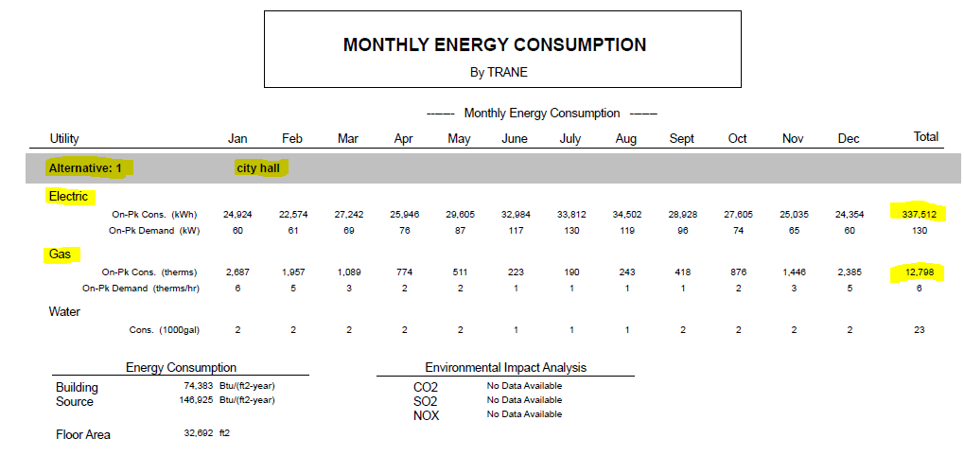
Figure 2. Simulated Proposed Case Energy Consumption
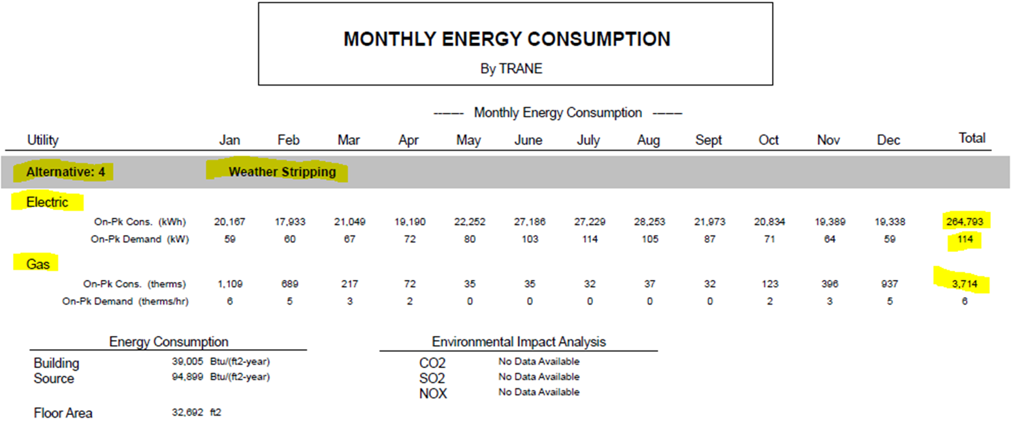

Measurement and Verification Plan
To verify the savings, the evaluation team will create a weather-normalized regression analysis using historical weather data, TMY3 weather data from a nearby location, and if possible, a building occupancy schedule to quantify the electric and gas savings estimated by the Trane Trace energy model.
The evaluation team plans to compare the monthly kWh and therms usage estimates against the regression analysis results as well as the billed data to highlight any discrepancies. The evaluation team will also take a trip to the project location to verify all new equipment is installed properly and the current BAS settings are still in place.
The following questions will need to be asked:
- Have any other projects been completed at the facility that could impact the energy consumption of the building (lighting upgrades, etc.)?
- Have there been any notable changes in the usage patterns or occupancy levels of the building?

Summary of the Verified Calculations
To verify the reported savings, the evaluation team used a weather-normalized regression analysis using historical and TMY3 weather data from a nearby station. It was confirmed through an onsite visit that the building automation system parameters are still the same as when initially submitted. An example of the building schedule witnessed in the Energy Management System for the building during the site visit is shown below in Figure 3.
Figure 3. Energy Management System Weekly Schedule
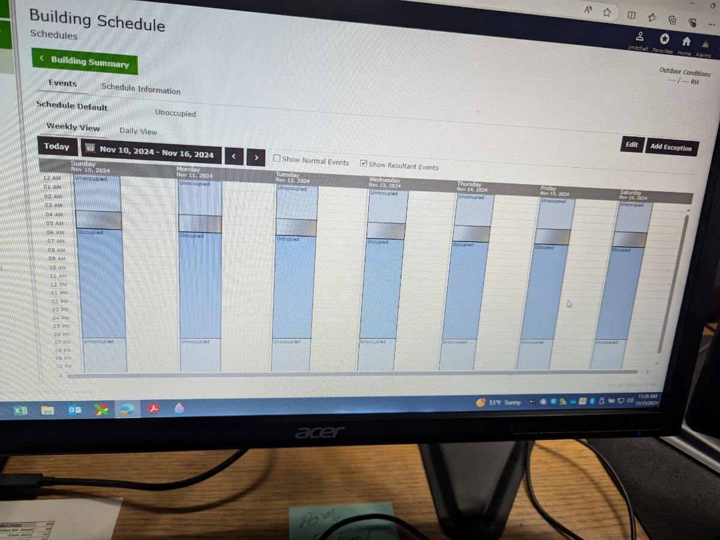

It was also confirmed through an interview conducted during the site visit that there have not been any notable changes to the controls, equipment at the facility, occupancy levels, or other work completed at the facility that could have an impact on the energy consumption of the building.
The usage both before and after the completion of the project was used to create separate regressions relating the usage of the facility to historical weather data, weekday vs weekends, and included a binary variable to account for holidays. Applying these regression models to TMY3 weather data yields the weather-normalized usage shown below in Figure 4.
Figure 4. Weather-Normalized Annual Electricity Usage Comparison
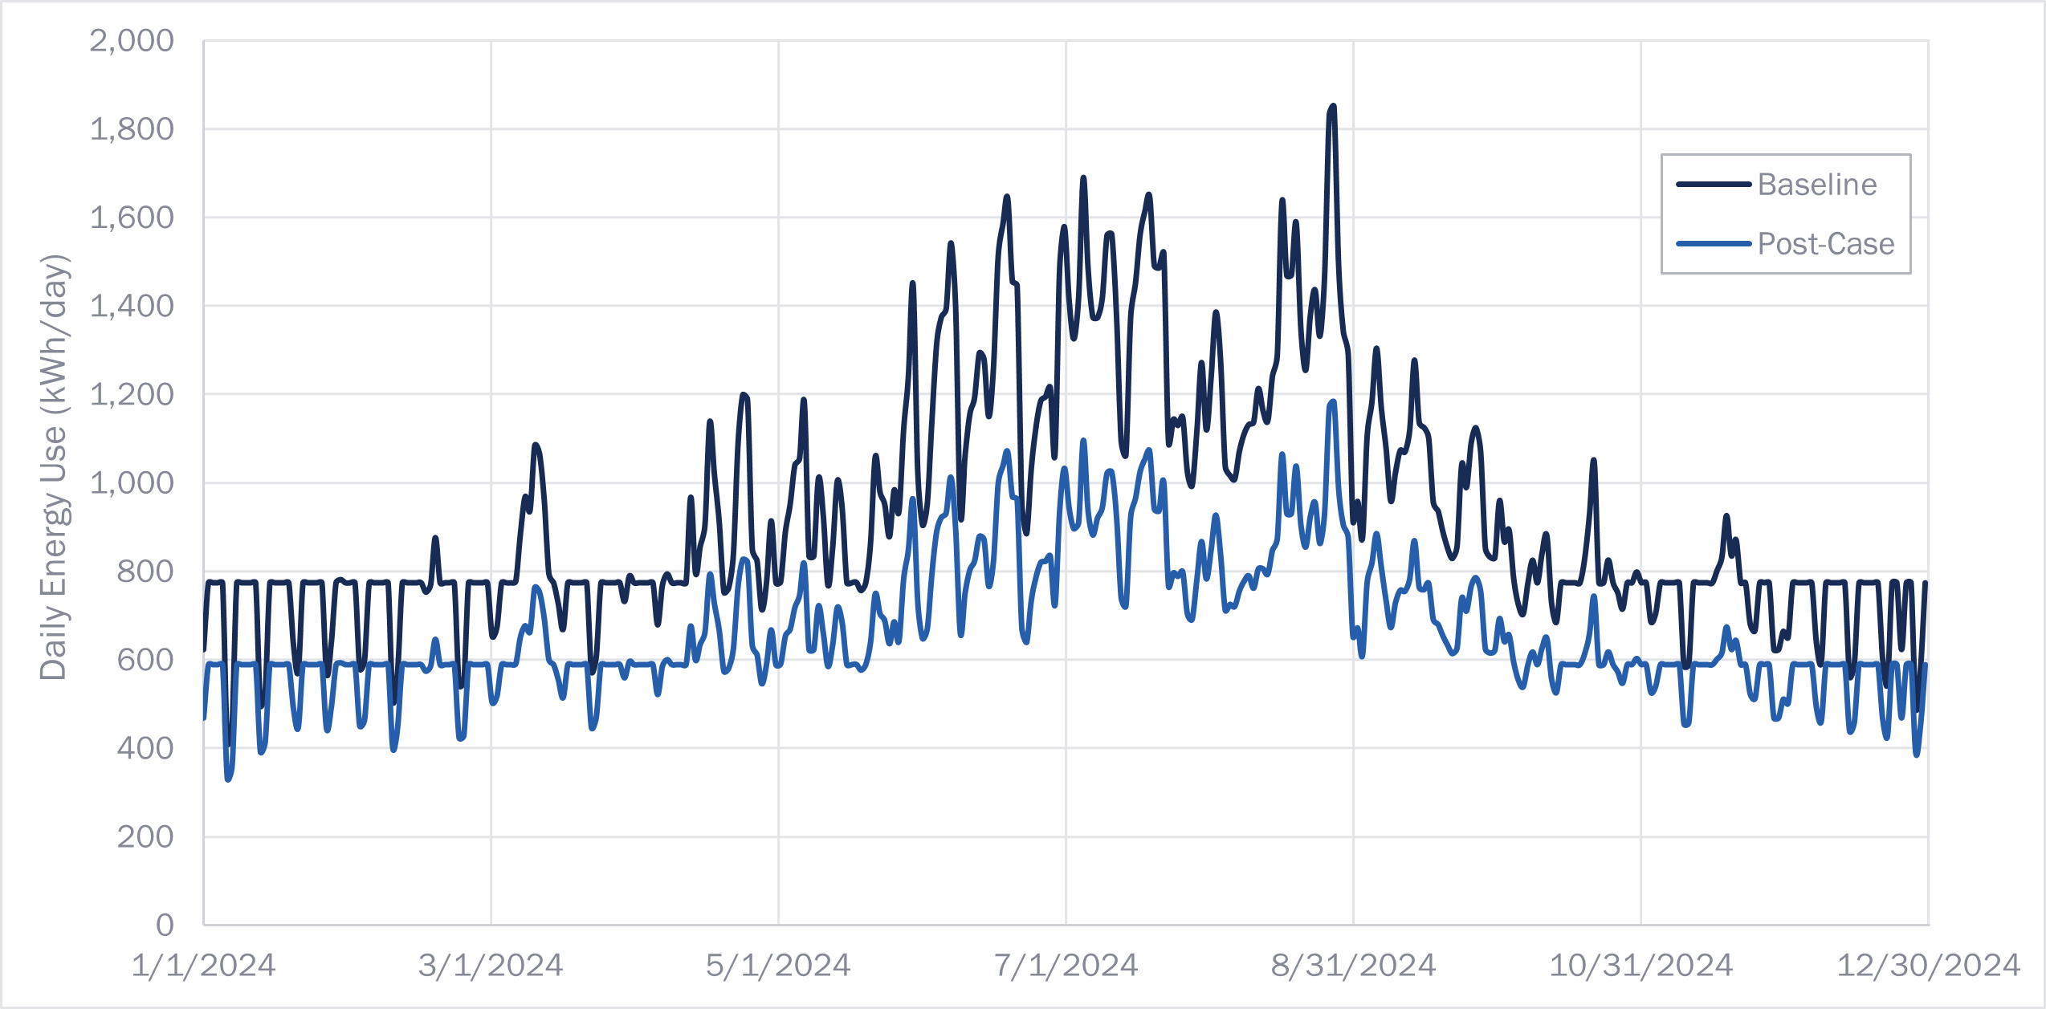
The result is an annual savings of 95,992 kWh. The original project modeled savings of 72,719 kWh. The developed models show that energy savings are achieved year-round, with the greatest savings achieved during the cooling season. The developed regressions have favorable goodness-of-fit metrics, and the evaluation team feels confident that the resulting savings are reflective of the impacts of the completion of the project. The weather-normalized annual usage is very close to the modeled usage, differing by only 1% for the baseline and by 7% for the post-case.
Demand savings for this project have a minor discrepancy between the ex ante savings and the evaluation team’s verified estimates. The demand reduction quantified for weekdays during summer months is 18.3 kW, compared to 16 kW from the ex ante Trane Trace model.
Below is a chart of the weather-normalized natural gas usage and savings from the regression model developed by the evaluation team using the consumption data, historical weather data, and TMY3 dataset.
Figure 5. Weather-Normalized Gas Usage Analysis
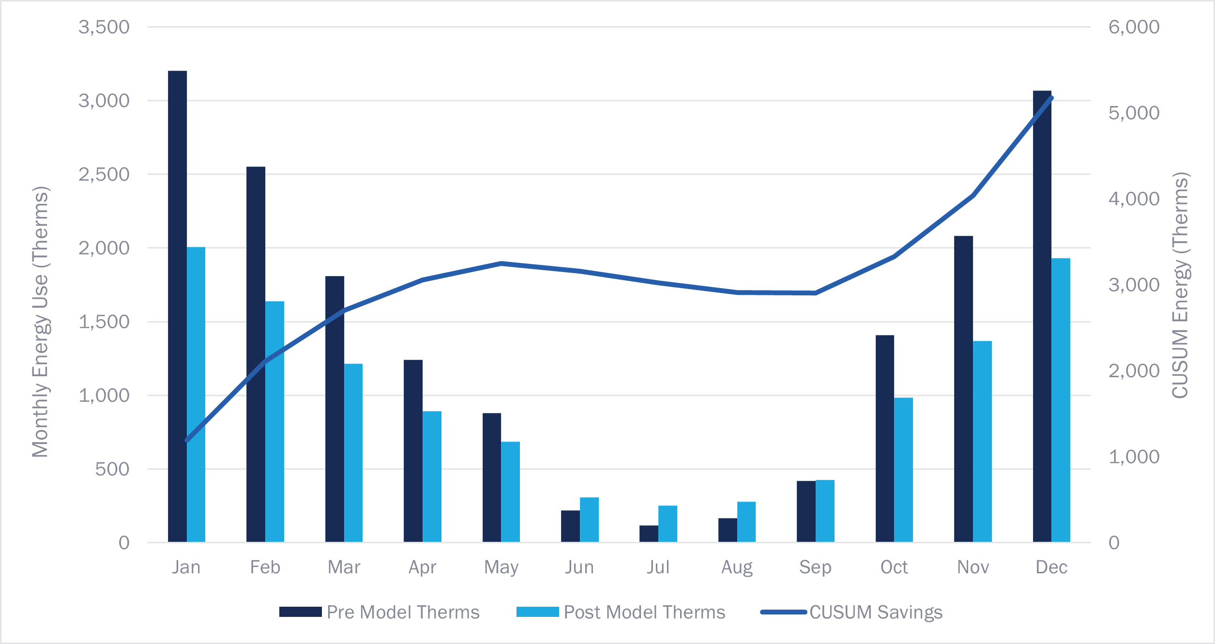
The modeled natural gas savings fall short of the ex ante estimate. The evaluation team estimated savings of 5,176 therms, whereas the implementation team estimated ex ante savings of 7,221 therms. The evaluation team notes that the Trane Trace model used to determine the ex ante gas savings does not align well with the actual pre-case consumption of the facility (the baseline weather-normalized consumption was roughly 34% higher than the Trane Trace model predicted), and that on a percentage basis, the Trane Trace models suggests that gas consumption was expected to decrease by more than 70% as a result of the project , which is unusually high for projects of this nature, suggesting that some of the changes made to the post-case model may have been idealistic or overrepresented the improvements being made to the facility.

Project 2300804
Project ID#: | 2300804
Measure: | Install VFDs and control logic for custom grinding process
Ex Ante Savings: | 449,388 kWh; 91.9kW
Facility Type: | Manufacturing
End Use: | Grinding Process
Sampled For: | Electric
Wave: | Wave 1

Measure Description
The customer completed the installation of five variable frequency drives (VFD) and control logic on five existing food processing line conveyance fans and grinders in August 2023. The VFDs can control flow by reducing the speed of the fan motor shafts which significantly reduces energy usage. The baseline equipment for the variable speed drive retrofits on the process fans is an existing motor operating without a method of variable control, per L-TRM V12.0 Section 4.8.13. The baseline conditions for the other measures were conveyance fans running full speed with manually controlled duct dampers and second stream grinders running or idling for 7,884 hours per year. The savings for this project are realized by the difference in efficiency between the baseline and efficient conditions.

Key Findings
The change in savings between the ex ante and verified estimates can be attributed to the correction of various parameters and equipment specifications used throughout the calculations. When comparing assumptions made in the ex ante calculations to the values sourced from historical trending data, there were notable differences in motor efficiency. Additionally, during a virtual onsite visit, the idle load was found to be notably higher in the baseline and proposed cases than what was assumed in the ex ante calculations. Lastly, the evaluation team adjusted the motor power factors for the fans and grinders to a function of load rather than a constant value as assumed in the ex ante calculations.
The correction of values used for idle loading and power factors resulted in decreased savings. The resulting project savings are shown in Table 7.
Table 7. Summary of Project 2300804 Savings
 | kW | kWh
Ex Ante | 91.9 | 449,388
Verified | 22.7 | 198,630
Realization Rate | 25% | 44%

Summary of the Ex Ante Calculations
The implementation team developed savings calculations for the installation of VFDs and control logic on five conveyance fans by determining the fan model needed to build a linear regression relating airflow and current. The customer used the hourly air flow in standard cubic feet per minute (SCFM) collected from the process history over a one year period for fans #1 through #5 to develop the Pulsaire Fan Model as shown below in Equation 11 and Figure 6.
Equation 11. Pulsaire Fan Model SCFM vs. Amperage
$$y=160.61x-3265$$
$$R^{2}=0.9919$$

Figure 6. Graph of Pulsaire Fan Model
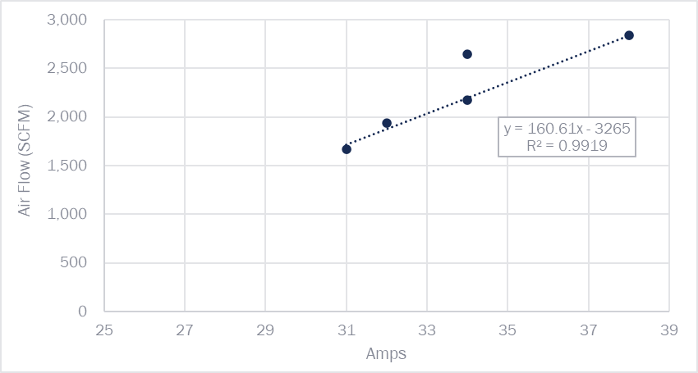
Using Equation 11, the customer built a linear regression model to correlate the current and airflow for the baseline case and proposed case. With this method, the amperages of fans #1 through #5 were determined for the baseline. Following the preapproval process, the implementation team used post installation data collected by historical trending software to capture the VFD percent loads. Finally, the power for three-phase motors was calculated assuming 460 volts, a power factor of 0.88, full load amps for fan #1, and full load amps of 45 amps for fans #2 through #4. Annual energy usage was determined using continuous hours of use (8,760 hours per year) and a 90% duty cycle for an estimated 7,884 hours. Overall, this yields 210,281 kWh per year for the savings correlating to the grinding fans VFD upgrade.
The savings from reducing grinder operation were determined based on grinder #2 system inputs for motor horsepower, an assumed 40% idle load, the motor's efficiency during idle periods, and 7,884 hours of operation. With the grinder, classifier, and fan deactivated, these units would lead to an annual energy savings of 239,108 kWh; resulting in total annual energy savings of 449,389 kWh.

Early Review Notes
The evaluation team reviewed the provided project documentation and savings analysis and generated the following comments prior to project approval:
- In the signed application and the checklist page of the calculation workbook, the hours of operation are listed as 7,884 hours per year, but the calculation on the measure summary tab uses 7,448 hours per year. This is likely just a typo, as the notes and description of the usage also have 7,884 hours, and the other tab shows the hours calculated from continuous (8,760 hours) at a 90% duty cycle.
  - Evaluation Finding: Per the recommendation above, the hours per year were changed from 7,448 hours to 7,884 hours in the calculation on the measure summary tab.
- The grinder calculation in the “Summary-Leidos” tab assumes grinder #2 will be shut off completely. In the notes, it appears it will be shut off until needed. What are the new expected hours of use? This will reduce overall savings because the grinder will not be shut down all year. Furthermore, this analysis uses idle load but then uses hours of operation of 90% of 8,760, the same as the conveyance fans. Is it correct to assume from this that the grinder, classifier, and associated fan operate at 40% load (idle load) for 7,884 hours? The term “idle load” implies loading when idle, when not in active use, which creates some confusion, insinuating that this equipment is always idle. The evaluation team recommends adjusting the hours of use and the %-load using a bin style to account for all possible %-loads and the associated estimated run hours at that load.
  - Evaluation Finding: Hours of use for grinder #2 were confirmed to be 90% downtime and 2% idle time. Adjustment of hours of use and the %-load was not performed.
- This may be a simple explanation or fix, but why was 460 volts used rather than 480 volts? If these fans and grinders are all 3-phase, as the calculation suggests, then the power factor should account for any losses, so 480 volts can be used to calculate the power draw.
  - Evaluation Finding: Fan voltage used throughout the savings calculations were not adjusted to the recommended 480 volts. Photos acquired during the implementation team’s inspection provided confirmation of 460 volts for each fan.
- The implementation team used the centrifugal fan affinity laws to calculate the proposed system power for each fan. They have very high static pressure requirements, which can happen in conveyance systems. The blowers operate at 38 inches of water as a static pressure, which will greatly reduce the savings from VFD control. The evaluation team recommends that instead of using a 2.5 exponent in the affinity law analysis, the implementers use the Vaillencourt equation, which accounts for high static pressure appropriately. This link provides a set of equations, and we believe equation 15 is the correct one in this case: VFD Equation - Canterbury Energy Engineering, LLC (studylib.net)
  - Evaluation Finding: The Vaillencourt equation, as described above, was not used. It is explained in notes that the applicant was unable to apply the Vaillencourt equation without access to system curves for each fan system or design fan curves. Furthermore, the applicant stated a preference to use a suitable affinity law exponents for this type of fan conveyance system that would correlate to the Vaillencourt equation.
- Overall process improvement: On the notes from April 2023, there is a suggestion to do pre- and post-data logging. The applicant responded by saying that the VFD % load readouts would suffice. Gathering that data would be helpful but doing pre- and post-data logging would be a better, more defensible way to track actual savings. Can the implementation team meter the electrical usage of the fans and grinder (classifier, feeder, airlock, and fan) before and after the changes? The evaluation team recommends that the equipment be metered for at least two weeks before the completion of the project and an additional two weeks after the installation. The difference between the baseline and post-case energy usage can then be used to calculate the annualized savings for this project. This is especially important for the grinder shutdown portion of the project because those savings are based on 40% load assumptions for all involved equipment. In the evaluation team’s experience, grinding equipment can be loaded very lightly (<10%) when not actively processing because it has to be designed to have enough torque for the initial start-up of the process or very heavy material when most of the time, it doesn’t need that much power or torque. The current energy consumption may be significantly lower than shown in the implementation team analysis. Metering the existing equipment will remove this uncertainty. The grinder portion of the project amounts to 64% of the total project savings yet hinges entirely on idle load assumptions.
  - Evaluation Finding: Metering, as described above, was not performed to remove uncertainty regarding energy consumption and idle load assumptions in the ex ante calculations. Instead, VFD percent load feedback collected by the historical trending software was used to verify assumptions and grinder #2 system downtime was logged by recording the holding contacts of the fan, grinder, and feeder for approximately (2) weeks.

Summary of the Verified Calculations
To verify the project savings, the evaluation team reviewed the data collected by the historical trending software at the customer site and equipment photos collected through the post installation inspection. Differences between ex ante and verified assumptions are presented in Table 8, and discussed below.
Table 8. Summary of Project 2300804 Key Findings
Description | Ex Ante | Verified
Voltage | 460 | 460
Motor Efficiency, constant | 92.8% | 93.6%
Motor Efficiency, Grinder #2 Fan | 92.5% | 93.6%
Idle Load (%), Pre Install | 40% | 13%
Idle Load (%), Post Install | 0% | 0%
Average Power Factor, Fan # 1 | 88% | 33%
Average Power Factor, Fan # 2 | 88% | 79%
Average Power Factor, Fan # 3 | 88% | 44%
Average Power Factor, Fan # 4 | 88% | 79%
Average Power Factor, Fan # 5 | 88% | 75%
Average Power Factor, Grinder # 2 | 88% | 29%
For pre-installation data, the historical trending software collected fan amperage, grinder load feedback, and fan air flows. For post-installation data, grinder load feedback was collected by the historical trending software.
The evaluation team verified the five grinder fans in this system are powered by Siemens Inverter Duty Motors on 460 Volts AC with nominal efficiency of 93.6%. Typically, 3-phase process equipment has a 480 volt rating, and as part of our evaluation, we confirmed the correct voltage for the grinder fans. Additionally, post inspection photos of the fan motor nameplates confirmed other motor specifications. The motor efficiency used in the equations for fan demand and grinder #2 fan demand were corrected to 93.6% by the evaluation team and the motor power factor for each fan and grinder #2 were calculated using a correlation of motor power factor as a function of percent full-load amperage.
In the ex ante savings analysis, the power factor of the motors was assumed to be constant across all motor loading. No power factor measurements were taken at various motor loading conditions. The evaluation team referred to a U.S. Department of Energy publication to obtain curves relating power factor to percent of full-load amp (%FLA) for motors of various sizes. For the fan motors, the power factor was determined by Equation 12 and Figure 7 below, which was generated based on the compressor curve from the DOE publication.
Equation 12. 4th order polynomial – Fan Motor Power Factor as a function of %FLA
$$y=-15.371x^{4}+48.237x^{3}-56.755x^{2}+29.754x-5.0675$$
Figure 7. Power Factor vs. %FLA for 40 - 75 HP Fan Motor
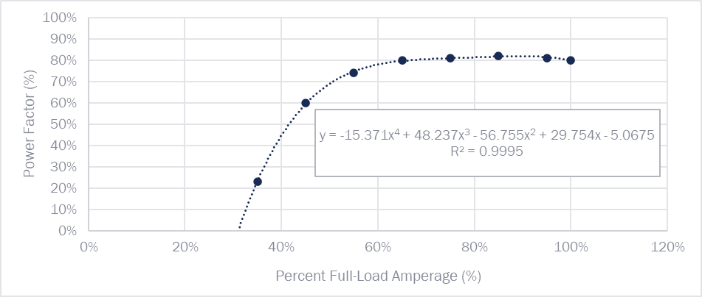
The trended %FLA data from the fans was used with the power factor curves to determine the baseline and proposed fan powers, and the resulting annual usage and savings. These adjustments to the calculations caused the average total demand of the fans to decrease from 100.47 kW to 86.34 kW, and the annual consumption to decrease from 659,335 kWh to 530,720 kWh, a savings of 128,615 kWh per year.
In a similar manner as was done for the fan motors, the power factor for grinder #2 was calculated using Equation 13 and Figure 8, below.
Equation 13. 4th order polynomial – Grinder Motor Power Factor as a Function of %FLA
$$y=-16.713x^{4}+52.054x^{3}-60.733x^{2}+31.56x-5.329$$
Figure 8. Power Factor vs. %FLA for 150 HP Grinder #2 Motor
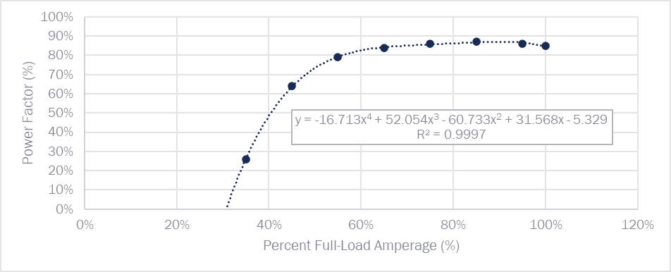
The demand for fans #1-5 and grinder #2 were estimated using the demand formula for three-phase power calculation as shown in Equation 14.
Equation 14. Power Formula
$$kW=\frac{\sqrt{3}*PF*I*V}{1000}$$
During the pre-approval process, the implementation team assumed the idle load of grinder #2 to be 40% in the pre-case and 0% in the post-case. The post-case idle load was assumed to be 0% due to plans to shut down grinder #2 completely. During the virtual onsite visit, the evaluation team confirmed that grinder #2 still operates during heavy periods of production and routine maintenance of the other grinder systems. Trended data included in the post-completion dataset shows the idle time of the grinder went from 44% in the baseline to 5% in the post-case. The reduction in idle time of the grinder was confirmed with the customer, but the idle power of the grinder was adjusted using the power factor profile shown in Figure 8. The result is a baseline idle load of 13% and a post-case idle load of 18%, the higher post-case idle load likely being due to VFD losses. The grinder VFD results in energy savings because a substantial amount of idle load was eliminated, during which the energy consumption is assumed to be zero. The idle power consumption of the grinder was calculated to be 82,600 kWh in the baseline and 11,646 kWh in the post-case, yielding savings of 70,964 kWh.
The resulting total annual energy savings for the fans and the grinder is 199,579 kWh. Because the system is in operation year-round with little-to-no apparent time-of-day dependencies, the demand savings for this project were determined by dividing the quantified annual energy savings by 8,760 hours, yielding demand savings of 22.7 kW. The verified demand savings are less than the ex ante savings partially due to the power factor adjustments made in the calculations as described above, but also due to how the demand savings for the grinder shutdown were quantified. The ex ante calculations quantified the full demand savings that occur during the grinder shutdown as demand savings to be claimed for the project, whereas the evaluation team quantified the demand savings as the average demand savings being achieved during the utility peak periods.

Project 2300092
Project ID#: | 2300092
Measure: | Variable Displacement Air Compressor
Ex Ante Savings: | 775,048 kWh; 90.21 kW
Facility Type: | Manufacturing/Industrial
End Use: | Compressed Air
Sampled For: | Electric
Wave: | Wave 2

Measure Description
The customer proposed several improvements to their compressed air system. The existing system is comprised of three inlet modulation compressors, all rated at 100 pounds per square inch gauge (psig) operating pressure: two older units (Gardner Denver ST150) and one newer unit (GD SAV150).
The customer is replacing the SAV150 unit (which has a faulty turn valve) with a more efficient 125-psig variable-displacement compressor (Gardner Denver SAV150G2). Due to the faulty turn valve, the existing compressor is continuously operated at about 30% capacity.
The customer is also repairing an existing compressor sequencer that is nonfunctional. Instead of being sequenced based on airflow demand, the compressed air system operates all three compressors simultaneously due to controller issues and the faulty turn valve. With the new controls, the variable-displacement unit will serve as the trim compressor and modulate as needed to meet demand. One or two ST150 units will be enabled to be fully loaded as needed when demand exceeds the trim compressor capacity. The facility operates at 100 psig.

Key Findings
The evaluation team used CAGI specification sheets to ensure the energy savings calculations for each compressor were completed using the correct calculation for the compressor operating pressure. It was found that the savings calculations used the CAGI sheet for the new SAV150G2 unit at 125 psig instead of the 100 psig CAGI sheet. The total power output was adjusted downwards for the new compressor based on the 0.5% power reduction/psig rule of thumb to approximate power input at 100 psig. The full load percentage was plotted against the corresponding flow from the 125 psig CAGI sheet, and the correlation was close to linear, so those values were not changed in the verified adjustment.
The resulting project savings are shown in Table 9.
Table 9. Summary of Project 2300092 Savings
 | kW | kWh
Ex Ante | 90.21 | 775,048
Verified | 104.50 | 897,722
Realization Rate | 116% | 116%

Summary of the Ex Ante Calculations
The implementation team used customer-supplied airflow demand data to develop a load profile for the facility. The team allocated a portion of the total airflow to each compressor. The team calculated the compressor power at each loading condition using compressor curves. The compressor full load percentage value calculations linked to a lookup table in an external workbook that consisted of interpolated values calculated using CAGI data for each compressor. It was confirmed that the data for compressor 3, the SAV150G2 in Figure 3 came from the incorrect CAGI sheet at 125 psig instead of the 100 psig sheet, shown in Figure 12 and Figure 13. Screenshots of the compressor values and the overall results for each scenario are included in Figure 9, Figure 10, and Figure 11.
Figure 9. Baseline System
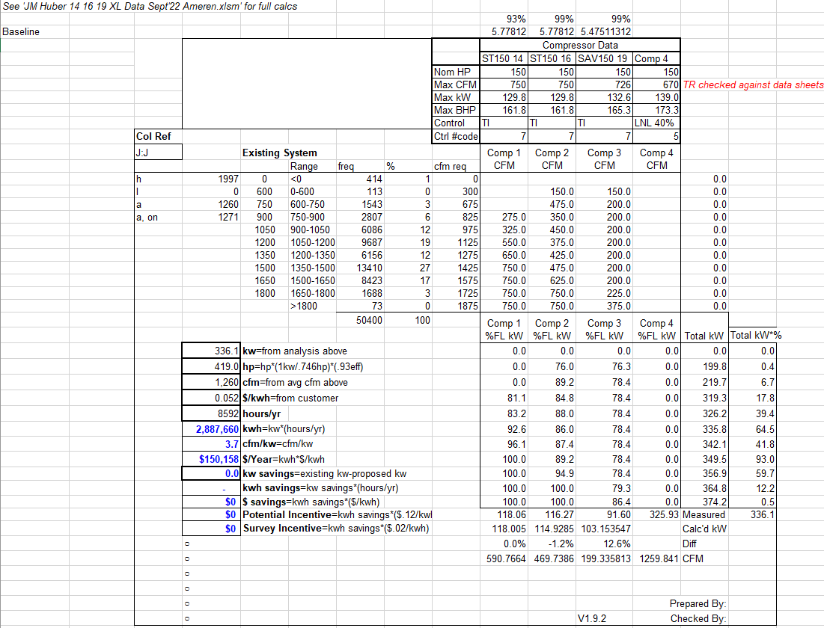

Figure 10. Proposed System Part 1 – Sequencer Online
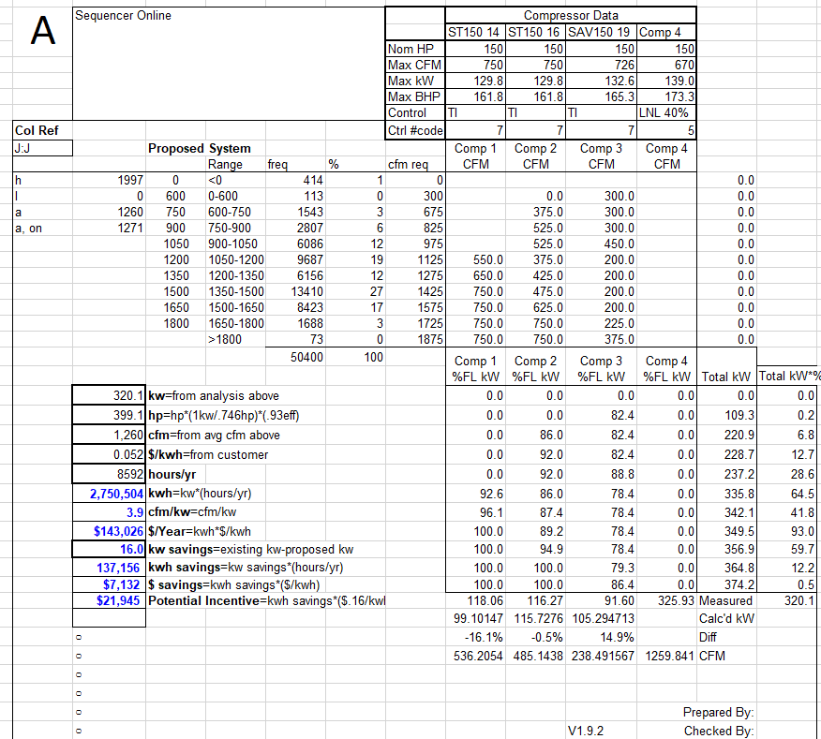
Figure 11. Proposed New SAV150G2 + Sequencer Online
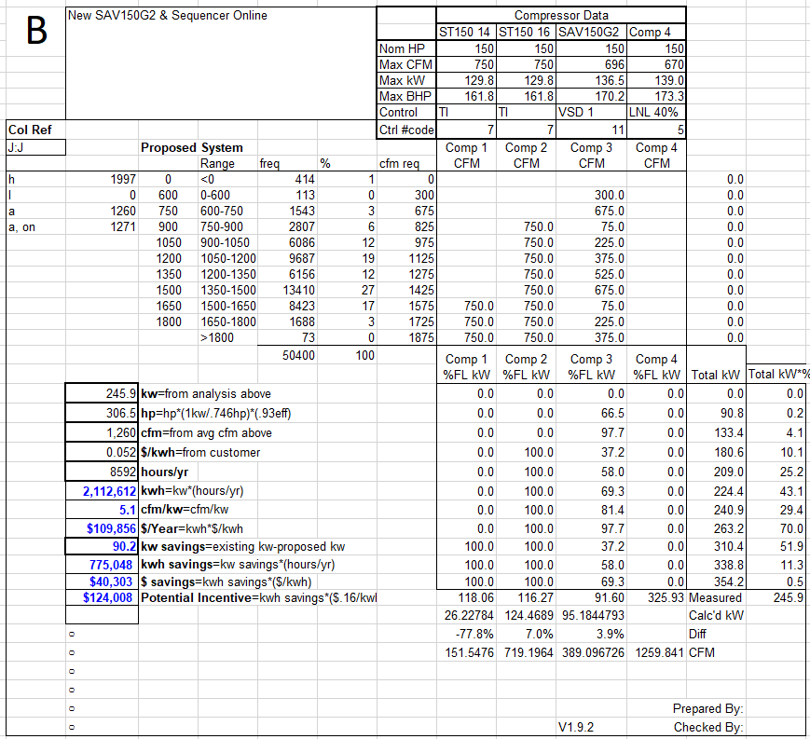
Figure 12. Interpolated Data Calculated Using Incorrect CAGI Sheet at 125 psig
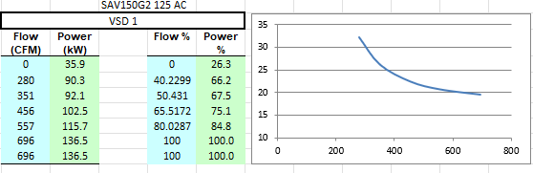
Figure 13. CAGI Sheet for SAV150G2 Operating at 125 psig
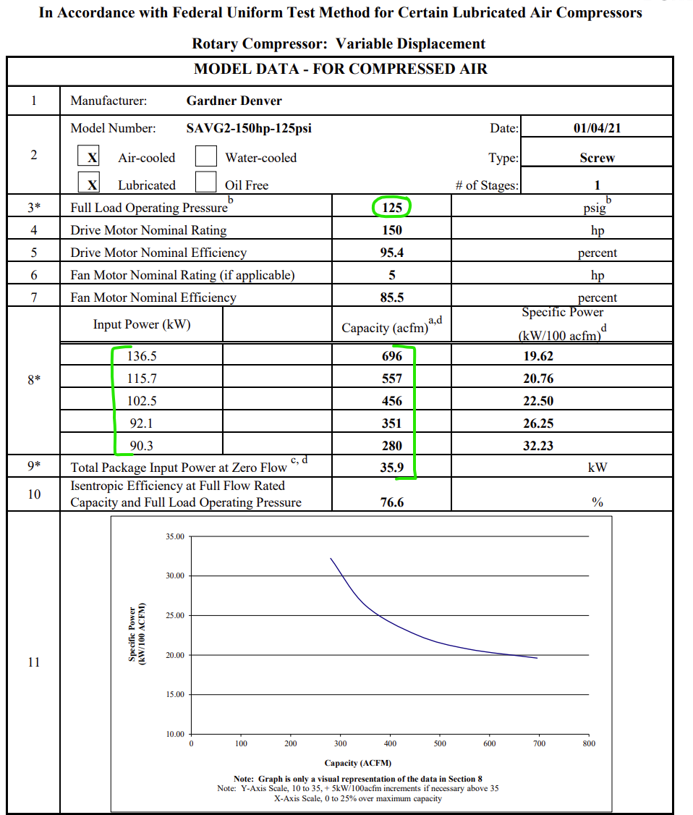

Measurement and Verification Plan
The evaluation team prepared the following questions and requests for the customer:
- Confirm operating hours
- Request calculation spreadsheet that is referenced in the final workbook
- Confirm installation was as described
- Request construction documents
- Confirm the state of the old compressor
- What would have happened if the project hadn’t been done through Ameren programs? Would you have continued to operate the old compressor with the malfunctioning valve as-is for a while or had it fixed? Would you have replaced the compressor even without the program/incentive?
The plan to verify savings was to confirm with the owner if the operation has remained the same since installation including operating hours, and plant operating pressure and flow, adjusting the compressor performance data as needed for lower or higher pressures. Per the early review notes, to verify demand savings, we also planned to investigate whether the ex ante airflow during peak demand periods is reflective of current operation. Finally, we planned to verify that the airflow data was allocated to each compressor properly.

Early Review Notes
The evaluation team conducted an early review of this project and had the following questions. We include the evaluation finding for each bulleted question.
- What is the plant operating pressure? Assuming it’s 100 psig, the performance data for the proposed compressor needs to be corrected for a lower pressure as the rated input power (136.5 kW) reflects operation at 125 psig and not the assumed 100 psig.
  - Evaluation Finding: The evaluation team found that the ex-ante calculations applied the 125 psig.
- Consider revising the demand savings to reflect the average or maximum airflow during peak demand periods (1-5 PM on weekdays, June-August). Although it’s from September only, the trend data indicates an average airflow of 1,233 CFM during this window and a maximum of 1,582 CFM (Monday at 1 PM).
  - Evaluation Finding: The evaluation team determined that the demand savings calculation was not changed.
- How was airflow demand allocated among the three compressors? Are these assumed splits or based on the actual metered data? A cursory inspection of average metered values shows that the baseline splits are reasonable. However, the demand allocation on SAV150 seems to be a bit high – metered data shows that the unit is rarely loaded above 20%.
  - Evaluation Finding: The evaluation team determined that the airflow demand was unchanged in the final ex ante calculations.
- The measure description and associated project writeups mention that the new compressor is a variable-speed drive (VSD) unit, and the proposed compressor curve is labeled “VSD” in the calculations. However, the specs sheets note that the SAV150G2 is a variable-displacement unit. The calculations and compressor curves correctly use the variable-displacement performance as indicated in the spec sheets, so it appears to be a typo. This discrepancy should be corrected to avoid confusion.
  - Evaluation Finding: The evaluation team determined that this was corrected in the final ex ante calculations.

Summary of the Verified Calculations
The evaluation of the savings calculations for this project began by comparing the full load % power in kW per CFM to the provided CAGI sheets to ensure accuracy. As described in the key findings above, the plant operates at 100 psig, so the CAGI sheet provided displaying power outputs at 125 psig is not the version that should have been used. Instead, the values from the CAGI sheet for the SAV150G2 unit at 100 psig should have been used. This CAGI sheet could not be found, however, the correlation between CFM and percentage full load kW was linear, as shown in Figure 14 below, so the evaluation team maintained the %kW same values after adjusting the full load kW to reflect the lower operating pressure as shown Figure 15.
Figure 14. Correlation between CFM and Percent of Full Load Power
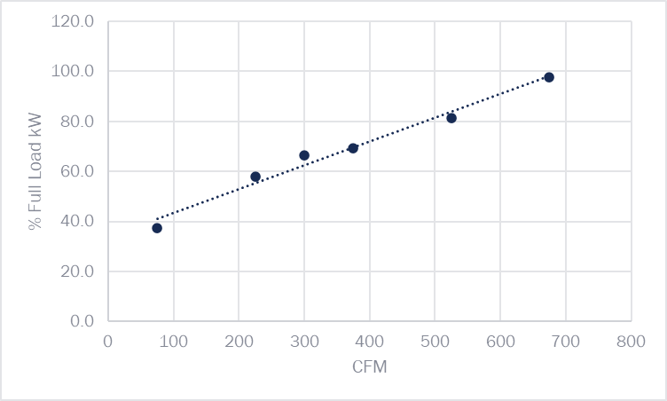

$$Assumption:0.5\% power reduction per 1 psig decrease$$
$$Claimed PSI=125, Loaded PSI=100$$
$$=12.5\% decrease$$

$$Original SAV150GS full load kW=132.632$$
$$Adjusted SAV150G2 full load kW=132.632*0.875$$
$$=116.025$$
Figure 15. Verified Savings Calculations
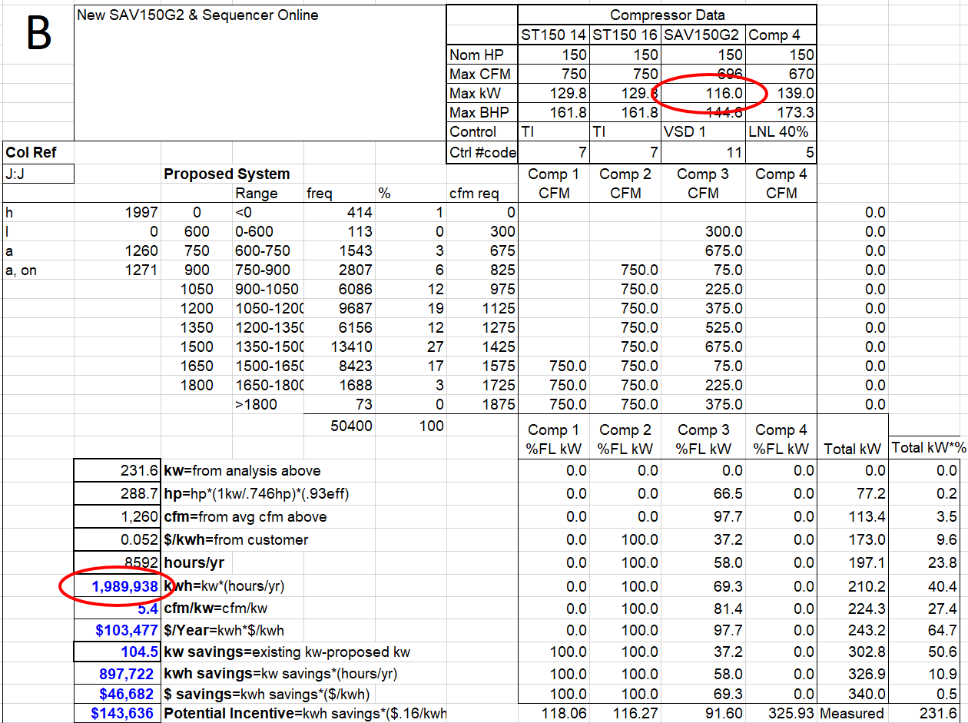
$$Annual kWh Savings=Baseline-Proposed$$
$$Annual kWh Savings=2,887,660-1,989,938$$
$$Annual kWh Savings=897,722 kWh$$

Project 2400148
Project ID#: | 2400148
Measure: | New Burner
Ex Ante Savings: | 49,068 Therms
Facility Type: | Manufacturing Facility
End Use: | Process Heating
Sampled For: | Gas
Wave: | 2

Measure Description
This measure involves installing an efficient burner that provides heat for drying substrate in the manufacturing of asphalt. The baseline case is an open-collar burner that supplies combustion air at a constant rate, resulting in excess air at low firing rates. The proposed case is a closed burner that varies the volume of combustion air with firing rate, which provides gas savings by heating less air. The measure was completed on March 5th, 2024.

Key Findings
We found that the baseline gas usage from the ex ante calculations significantly exceeded the billed annual usage. In the ex ante calculation, the baseline gas usage was 640,348 therms and the proposed gas usage was 591,280 therms. The utility data shows that, in the past year, the customer only used 391,630 therms.
The resulting project savings are shown in Table 10.
Table 10. Summary of Project 2400148 Savings
 | Therms
Ex Ante | 49,068
Verified | 30,010
Realization Rate | 61%

Summary of the Ex Ante Calculations
The implementation team estimated measure savings using a method that categorizes burner firing rates, associated with burner input, into four distinct categories: 20%, 30%, 40%, 50%. Their calculation approximated the hours spent at each firing rate, which are different in the baseline and new cases. The product sheets for the existing and new burners only provide performance data at a few distinct firing rates, so they conducted calculations to approximate gas input at various firing rates. They took gas inputs at each firing rate from manufacturer specifications. The data does not explicitly provide the baseline firing rates used in the calculation, so they used an average to calculate the heat input at the specified firing rates. The dryer removes the same amount of water in both the baseline and new cases. Table 11 below shows the five distinct firing rates and the percentage of total hours spent at each firing rate. The total estimated hours of operation in the baseline and new cases are 1,600 hours.
Table 11. Baseline and Proposed Calculation Categories
Firing Rate | % Operating Hours, Baseline | % Operating Hours, Proposed
Low | 14% | 17%
20% | 12% | 18%
30% | 14% | 25%
40% | 45% | 20%
50% | 15% | 20%

Measurement and Verification Plan
This site was selected for a desk review that consisted of reviewing the provided information for accuracy of inputs and calculations, as well as verifications of some inputs with the customer. The evaluation team determined that the approach used by the implementation team was reasonable, so we used the same approach. We reviewed the formulation of the calculations for accuracy and made adjustments as deemed appropriate.
The evaluation team verified the following information/inputs:
- Current installation status of new equipment
- Current operation schedule of new equipment
- Operation schedule of baseline equipment
- Condition of baseline equipment
- Capacity of baseline/new equipment

Summary of the Verified Calculations
The evaluation team explored a billing analysis to verify savings, but there is no data that can show strong predictors of gas usage. The drying process is dependent on a multitude of factors including aggregate type, aggregate saturation, humidity, and water levels near the aggregate stockpile. The customer does not track this information, so a billed usage analysis was not possible. The evaluation team found that the methodology used by the implementation team to establish project savings was reasonable, so the same approach was used to verify savings. The verified baseline is the existing burner, as it was confirmed that the existing burner was still operational. Based on electric interval data, it appeared that the aggregate dryer may not operate for the 1,600 hours that are specified in the ex ante calculation. The plant may operate for 1,600 hours annually, but not necessarily the dryer. The evaluation team used the iterative algorithm to match the estimated baseline gas consumption to the annual billed gas consumption by adjusting the annual operating hours. The annual hours of operation were adjusted down to 979 hours, leading to a verified baseline usage of 391,630 therms annually and a proposed gas usage of 361,620 therms annually. With these new baseline and proposed usages, the new annual gas savings are 30,010 therms.

Project 2301013
Project ID#: | 2301013
Measure: | Upgrade to CO2 Refrigerant
Ex Ante Savings: | 77,017 kWh; 8.79 kW
Facility Type: | Grocery
End Use: | Refrigeration
Sampled For: | Electric
Wave: | Wave 2

Measure Description
The customer is building a new grocery store with a transcritical CO2 (R744) refrigeration system with adiabatic condensing. The baseline system is a refrigeration rack with floating pressure controls that uses R448A HFC refrigerant.

Key Findings
The evaluation team found the ex ante savings calculations provide a reasonable value for energy savings. The evaluation team verified that the baseline and efficient case entries for the energy model come directly from the manufacturer for the installed system, and that the baseline system was consistent with average operation of a system using R448A refrigerant. Through research and conversation with the customer, we noted several factors of the new system that provide energy efficiencies over the baseline R448A HFC system. This includes moving from an air-cooled condenser to an adiabatic condenser, lower design condition operation temperature for the compressor, higher design condition operation temperature for the evaporator on the medium temperature configuration, and a lower compressor temperature on the low temperature configuration. Case studies and commentary provided by the vendor confirm that this type of upgrade results in about 30% savings compared to the baseline system.
The resulting project savings are shown in Table 12.
Table 12. Summary of Project 2301013 Savings
 | kW | kWh
Ex Ante | 8.79 | 77,017
Verified | 8.79 | 77,017
Realization Rate | 100% | 100%

Summary of the Ex Ante Calculations
The implementation team used calculations provided by the vendor to establish ex ante measure savings. The baseline equipment is a rack system with two single-stage compressors using R448A HFC refrigerant, and the new design is a two-stage transcritical CO2 system. The vendor established measure savings using “Pack Calculation Pro” software, which uses input parameters such as refrigerant type, medium and low temperature design condition temperatures for the evaporator and condenser, capacity, and condenser type, and the software generates an annual savings summary as shown in Figure 16 and Figure 17. The software automatically estimated baseline and new COP based on the Low and Medium temperature design operation conditions.
Figure 16. Equipment Annual Energy Usage
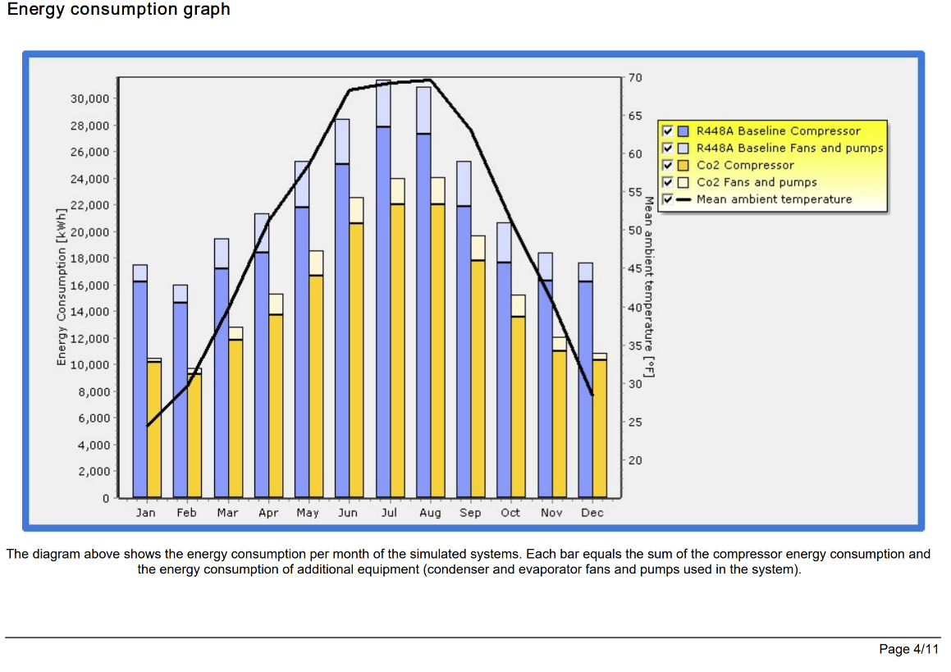

Figure 17. Input Summary
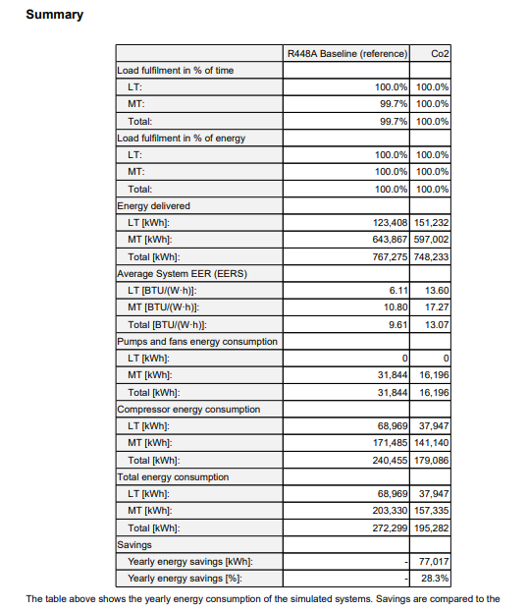
The vendor assumed that the refrigeration system runs 8,760 hours per year. They established baseline system annual energy usage of 272,299 kWh and new system energy usage of 195,282 kWh, resulting in 77,017 kWh of electric energy savings.
The vendor determined demand savings by dividing the baseline and new annual electrical usage by 8,760 hours, with the difference resulting in 8.79 kW of demand savings.
The implementation team used the inputs for the baseline and new systems, as shown in Figure 18, in the Pack Pro calculation. The evaluation team confirmed that these values were taken directly from the manufacturer legend for the CO2 2-stage transcritical system.
Figure 18. Systems Overview
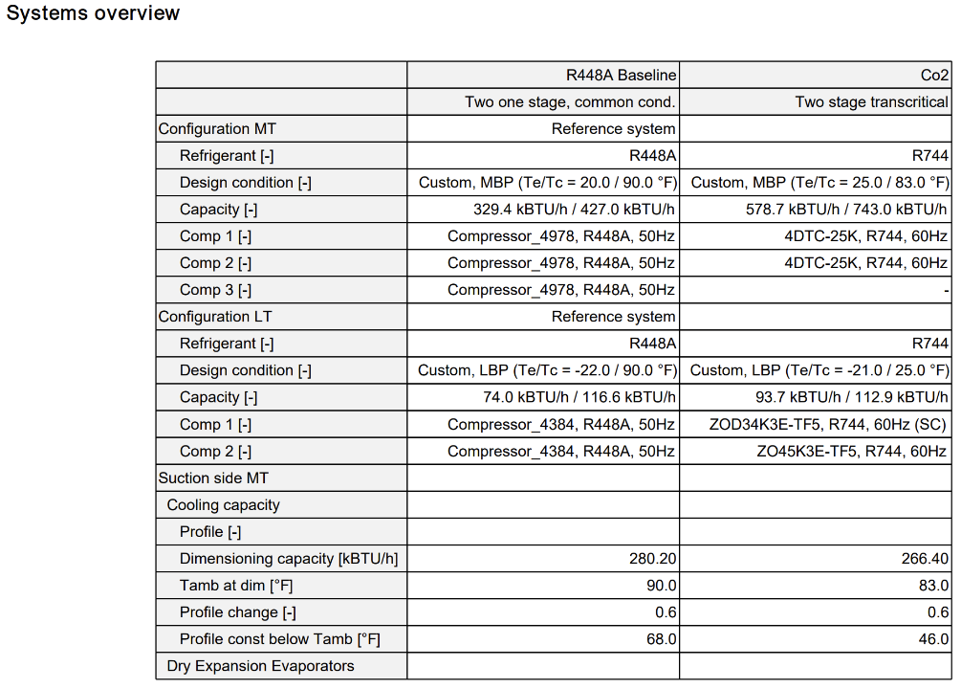

Measurement and Verification Plan
The evaluation team met with the energy consultant to review the following questions and information requests:
- Confirm operating hours
- Confirm cooler/freezer temperatures
- White papers referenced in the final calculation spreadsheet
- Confirm installation was as described
- Request construction documents
- Confirm with the current owner if the operation is the same as expected, including operating hours.
- Check if the system is capable of remote monitoring (and maybe trending) and request screenshots of the system in operation.
- What is the system COP, and how was this determined?
In addition to verifying these parameters, the verification team sought to verify savings by researching cases of refrigerant changes saving energy. We were not able to acquire Pack Pro to confirm the implementation team results.

Summary of the Verified Calculations
The evaluation team interviewed the vendor to confirm the source of the input parameters for the baseline and new system. We reviewed the final report from Pack Pro and located the entries for the new system from the manufacturer specifications. We validated the results by reviewing case studies posted on NASRC.org in 2016 for transcritical CO2 systems from the manufacturer. The claimed savings for this project are 28.3% compared to the baseline, which falls in line with the efficiency gains of 7% to 37% reported in the case studies.

Project 2200025
Project ID#: | 2200025
Measure: | Wastewater Process Improvement
Ex Ante Savings: | 919,155 kWh; 224.8 kW
Facility Type: | Municipality
End Use: | Wastewater Process
Sampled For: | Electric
Wave: | Wave 2

Measure Description
The customer operates a wastewater treatment plant, which uses a liquid lime system to balance the pH of the solids removed from the wastewater stream. The existing system used four 60-hp pumps that operated approximately 7,000 hours per year to mix sludge with the lime before it was removed. A new system that presses the water out and adds the lime to balance the pH was added installed and all existing pumps were removed. This project was completed on 3/15/2024.

Key Findings
The verified savings are based on regression models between pre- and post-metered energy use and flow, whereas the ex ante savings are based on engineering calculations with assumed input parameters. The evaluation team suspects that over-estimating motor load factors was the primary reason for the reduced savings, as expected load factors in these applications are typically in the range of only 50% to 60%. A less significant factor is that the implementation team also assumed that power for all motors equipped with variable speed drives (VSD) would follow the Affinity Laws, and scaled baseline and proposed system energy usage accordingly. However, many of the VSD-equipped motors are on constant-torque applications, e.g. positive-displacement pumps, mixers, and conveyors, for which power is linearly proportional to speed. An additional driving factor to the low realization rate for demand savings is that the evaluation team only used the difference in the average demand during the summer peak period (June through August), while the implementation team utilized the entire year.
The resulting project savings are shown in Table 13.
Table 13. Summary of Project 2200025 Savings
 | kW | kWh
Ex Ante | 224.8 | 919,155
Verified | 15.4 | 646,936
Realization Rate | 7% | 70%

Summary of the Ex Ante Calculations
The ex ante calculations compared the energy usage of the equipment before and after the switch to a dry lime stabilization process. Each machine was listed (before and after) with the purpose, quantity, hp, and annual hours of operation. The calculations used Equation 15 to estimate the annual energy usage for each piece of equipment.
Equation 15. Equipment Annual Energy Usage
$$kWh = \frac{\left(0.746×Quantity×hp×Annual Hours of Operation×Adj Factor\right)}{Motor Eff}$$
Here, quantity, horsepower (hp), annual hours of operation, and motor efficiency are unique to each motor. The adjustment factor is 0.94 which was an estimated value to calibrate to expected metered savings, and 0.746 is the conversion factor from hp to kW. The pump’s hours of use were estimated from the EM&V pre-review and were adjusted from the design load of 4.0 million gallons per day (MGD) to 4.2 MGD. The baseline system had four 60-hp storage tank mixing pumps that were used to mix the lime into the sludge. These mixing pumps were 93% of the baseline energy usage. There were two 15-hp mixers and a 5-hp air scrubber that ran for a significant number of hours. All other miscellaneous pumps ran for a minimal number of hours.
The vendor estimated the existing system ran for approximately 7,000 hours per year and used approximately 1,354,566 kWh per year based on 4.2 MGD without including the adjustment factor and motor efficiency. Including these parameters, the existing system energy usage increases to 1,357,898 kWh per year.
In the efficient case, a screw press is used for dewatering the sludge. Lime is then fed into the solids to balance the pH. The system was completely new, and the total system horsepower of 119.08 hp was significantly less than the existing system (441.5 hp). The new system was designed for an average flow of 5.8 MGD, but hours were adjusted in the calculation to match the baseline flow rate of 4.0 MGD. The evaluation team assumed that all the motors were for a batch system, and that flow rate directly impacts pump hours by cycling motors.
The vendor estimated that most of the equipment in the new system would operate for around 3,066 hours , resulting in annual energy usage of approximately 435,411 kWh before including load factor and motor efficiency. Including these parameters resulted in energy usage of 443,853 kWh.
Before including the load factor and motor efficiency, the estimated energy savings for this project were 919,155 kWh per year, which is what was claimed as the ex ante savings. If the ex ante calculations implemented the recommendations from the early review, the savings would have been 914,045 kWh.
Demand savings were estimated using each annual energy usage estimate and dividing by 4,318 hours per year, a weighted average of the baseline hours. This calculation resulted in a power demand of 313.67 kW for the existing system and 88.83 kW for the efficient system, equating to 224.84 kW of savings.
In order to justify the calculated savings, the ex ante analysis also looked at metered data from pre and post installation. The metered data included water flow through the plant in millions of gallons (MG) and energy usage over a three-month period. A daily average flow and energy usage was calculated for the plant and extrapolated for the whole year using Equation 16.
Equation 16. Extrapolated Plant Energy Usage
$$kWh=\frac{ \frac{\sum{Monthly Energy Usage}}{Total Days}}{\frac{\sum{Monthly Flow}}{Total Days}}×Daily Average MG×365$$
In the equation, the daily average throughput is 4.2 MGD which was based on 2015 and 2020 data. For both pre and post installation, April, June, and July months were used, and a post-installation energy usage of 2,600,258 kWh and a pre-installation energy usage of 2,031,080 kWh were calculated.
To normalize the energy usage between years, an affinity law correction factor (CF) was used. Equation 17 shows how this was calculated.
Equation 17. Correction Factor
$$CF={(\frac{Post Daily Average MG}{Pre Daily Average MG})}^{Affinity Law Exponent}$$
Here, the implementation team assumed the affinity law exponent was 2.7, a conservative value. Once the CF was calculated, it was applied to the post-installation energy usage to estimate savings, as shown in Equation 18.
Equation 18. Energy Savings
$$∆kWh=Pre Energy Usage-\frac{Post Energy Usage}{CF}$$
The resulting energy savings were 966,714 kWh. Because this number was larger than the savings found in the early review, the implementation team utilized the ex ante calculations from before implementing the early review recommendations and deemed this value to be conservative.

Early Review Notes
We note that this project was subject to early review prior to authorization. Our early review comments, and findings stemming from this evaluation, included the following:
- The evaluation team suggested that the calculation method be altered to account for individual pump loading, efficiency, and hours.
  - Evaluation Finding: The implementation team addressed this in the final ex ante calculations.
- We recommended using a load factor (even a relatively high one) if doing spot checks of the current motor loading is not possible. The vendor mentioned NEMA premium motor efficiencies for the proposed case. The assumed motor efficiency can be lined up for a typical TEFC (or ODP, whichever is more conservative) for most motors. For the existing motors, typical standard efficiencies can be used.
  - Evaluation Finding: The implementation team addressed this in the final ex ante calculations.
- We recommended verifying that none of the existing lime system motors utilize VFDs. If any pumps were to utilize VFDs, we recommended adjusting the loading in the calculations for those pumps.
  - Evaluation Finding: The evaluation team determined that this suggestion was not adopted in the final ex ante calculations by the implementation team.
- We recommend adjusting the baseline hours to the equivalent hours needed to process 4.2 MGD.
  - Evaluation Finding: The implementation team addressed this in the final ex ante calculations.
- The calculation of baseline demand uses a more conservative 8,760 hours per year even though only one of the relatively smaller motors is used 8,760 hours per year. The larger storage tank mixing pumps constitute most of the energy usage in the baseline and operate 7,000 hours per year. We recommend estimating the hours of use by creating a weighted average based on run-time and the size of the motor.
  - Evaluation Finding: The implementation team addressed this in the final ex ante calculations.
- The proposed system’s demand calculation uses 8,760 hours even though the greatest hours of use in the proposed is 3,066. This methodology underestimates the new system demand and overestimates the demand savings. We recommend dividing the individual pumps’ energy usage by their respective hours of use and then summing the kW to get the proposed system’s total demand.
  - Evaluation Finding: The implementation team addressed this in the final ex ante calculations.
- If still operating as usual, we recommend metering all four existing storage tank mixing pumps to determine current loads and run hours compared to flow.
  - Evaluation Finding: The implementation team addressed this in the final ex ante calculations.
Though most of the recommendations suggested in the early review were executed, the final claimed ex ante savings were the savings calculated before implementing the suggestions.

Summary of the Verified Calculations
The evaluation team analyzed baseline data collected for 2023 and data from April 2024 through November 2024 to represent post-installation operation. We did not use data from May 2024 because the customer reported that there were operational issues during that month. We attempted to establish linear correlations between monthly flow and billed energy usage. We were able to establish a reasonable correlation with the new operating conditions. While the R² value for the correlation is only fair, at 0.711, the coefficient of variance was very good at 0.05. The correlation is shown in Figure 19.
Figure 19. Post-Installation Equipment Correlation
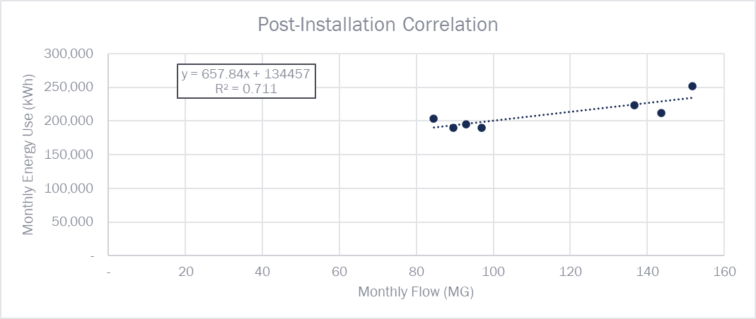
The correlation between 2023 monthly flow and monthly billed energy usage in the pre-installation case was very poor, as shown in Figure 20.
Figure 20. Pre-Installation Equipment Correlation
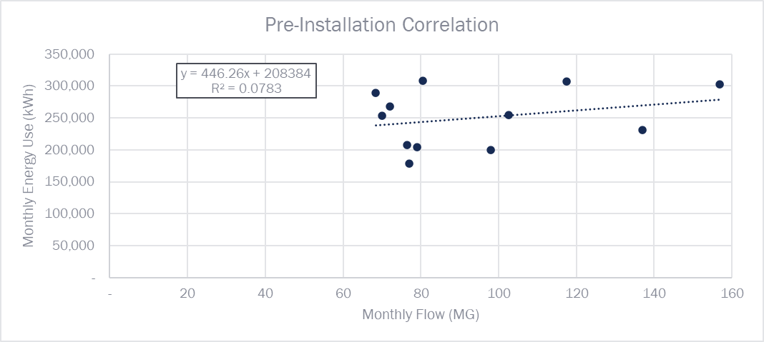
The evaluation team did not have access to additional pre-installation data. Therefore, we used the post-installation correlation with the 2023 data as the comparison. We understand that the daily average MGD for 2023 may be slightly lower than average annual flow at 3.11 MGD, but due to the poor correlation between pre-installation flow and energy use, we believe that the 2023 flow is a representative baseline. As mentioned previously, the reason for the lower realization rate for demand is because the evaluation team only used the difference in the average demand during the summer peak period, in contrast to the implementation team which utilized the entire year.
The results are shown below in Table 14.
Table 14. Verified Calculation Results
Month | Days in Month | 2023 Monthly Flow (MG) | Average Daily Flow (MG/day) | 2023 Monthly Energy (kWh) | 2023 Average Demand (kW/day) | Post-Installation Energy Normalized to 2023 Flow (kWh) | Post-Installation Demand Normalized to 2023 Flow (kW)
January | 31 | 117.5 | 3.79 | 307,200 |  | 211,752
February | 28 | 102.5 | 3.66 | 255,000 |  | 201,885
March | 31 | 156.8 | 5.06 | 303,300 |  | 237,605
April | 30 | 136.9 | 4.56 | 231,600 |  | 224,514
May | 31 | 98.0 | 3.16 | 199,500 |  | 198,925
June | 30 | 77.0 | 2.57 | 178,800 | 248.33 | 185,110 | 257.10
July | 31 | 79.1 | 2.55 | 204,000 | 274.19 | 186,492 | 250.66
August | 31 | 76.5 | 2.47 | 208,200 | 279.84 | 184,781 | 248.36
September | 30 | 70.0 | 2.33 | 254,100 |  | 180,505
October | 31 | 72.0 | 2.32 | 267,600 |  | 181,821
November | 30 | 68.4 | 2.28 | 289,800 |  | 179,453
December | 31 | 80.5 | 2.60 | 308,100 |  | 187,412
Total | 365 | 1,135 | 3.11 | 3,007,200 | 267.46 | 2,360,256 | 252.04
Verified Savings |  |  |  |  |  | 646,944 | 15.42

Project 2300006
Project ID#: | 2300006
Measure: | New Construction Efficiency Upgrades
Ex Ante Savings: | 196,948 kWh; 50.4 kW; -364 therms
Facility Type: | Community Athletic Center
End Use: | HVAC, Building Envelope, Domestic Hot Water, Lighting, Elevator
Sampled For: | Electric and Gas
Wave: | Wave 1

Measure Description
This project is a 32,000 sq ft, two-story, new-construction community athletic facility that began construction on 9/1/2022 and began occupancy on 2/1/2024. The scope of work includes upgrades from the initial design team plan consisting of upgrading the part load performance and cooling/heating efficiency of the mechanical system, wall and roof insulation as well as improved fenestration, lowered lighting power density, traction elevators, and efficient domestic hot water (DHW) heaters. The ally developed an energy model leveraging TMY3 weather data for the facility location and provided the savings results to the project team to influence their design decisions. The ally then updated the model based on the implementation team’s verification findings.

Key Findings
The ex ante calculations leveraged an energy simulation software, NEO, to estimate savings between an ASHRAE 90.1-2016 Appendix G baseline and an efficient ‘proposed’ scenario. The evaluation team took two of the most impactful measures from the energy model report, cooling efficiency and a decrease in lighting power density, and used the 2022 Illinois Technical Reference Manual V10.0 (TRM) to perform calculations to confirm the modeled measure results. The ex ante calculations were based on a total square footage of 37,068 square feet, later amended by the evaluation team to 32,000 square feet as advised by the current owner. The hours of operation listed in the final review matched the facility’s current operation schedule, so the listed value of 2,750 used in the ex ante calculations was also used in the TRM calculations. Several other parameters required for the TRM calculations, including cooling and heating capacity, were estimated using industry standards. The remaining parameters were pulled directly from the TRM. Our TRM calculations are estimates, while models are typically more accurate and include full interactive effects. Given that our estimates for the two largest measures exceed the ex-ante savings, we believe a realization rate of 100% is appropriate and that the model was accurately built.

The resulting project savings are shown in Table 15.
Table 15. Summary of Project 2300006 Savings
 | kW | kWh | Therms
Ex Ante | 50.4 | 196,948 | -364
Verified | 50.4 | 196,948 | -364
Realization Rate | 100% | 100% | 100%

Summary of the Ex Ante Calculations
The baseline for the model was based on ASHRAE 90.1-2016 Appendix G (Figure 21). The simulation software, NEO, is not available to the public, so we could not assess the modeling methods further than confirming the baseline and verified inputs. However, the annual and monthly usage breakdowns are available via the .sim file (Figure 22 through Figure 24) as well as a matrix of proposed and verified findings on a measure-by-measure basis (Figure 25 through Figure 27).
Figure 21. Baseline Parameters
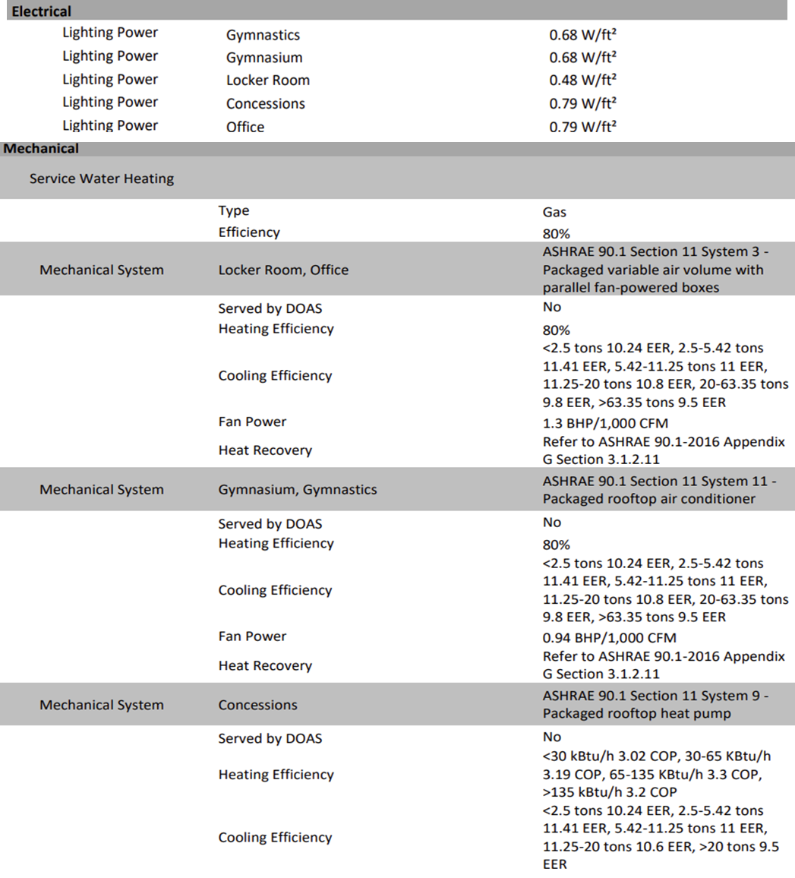
The selected mechanical system is VAV with gas heat and DX cooling with electric reheat for the facility. The gym and gymnastics area use an RTU with gas heat and DX cooling. The concession area uses a heat pump.
Figure 22. Baseline Annual Building Energy Usage
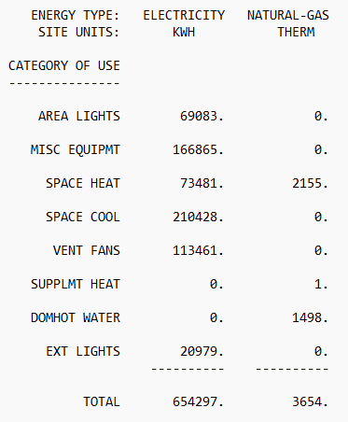
Figure 23. Proposed Annual Building Energy Usage
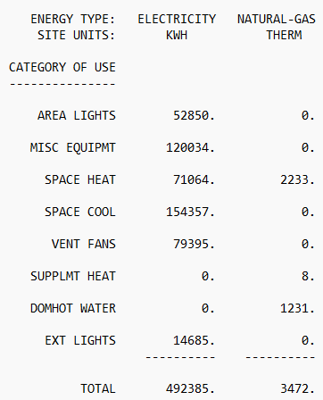
Figure 24. Proposed Monthly Building Energy Usage
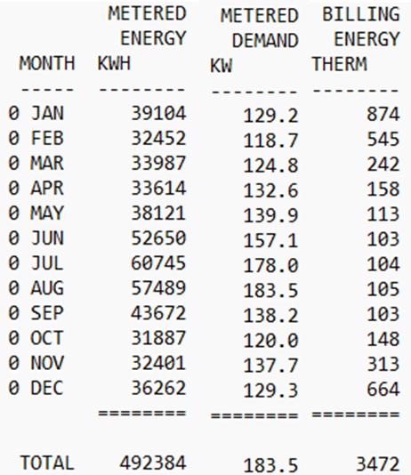
Figure 25. Mechanical Strategies and Verified Status
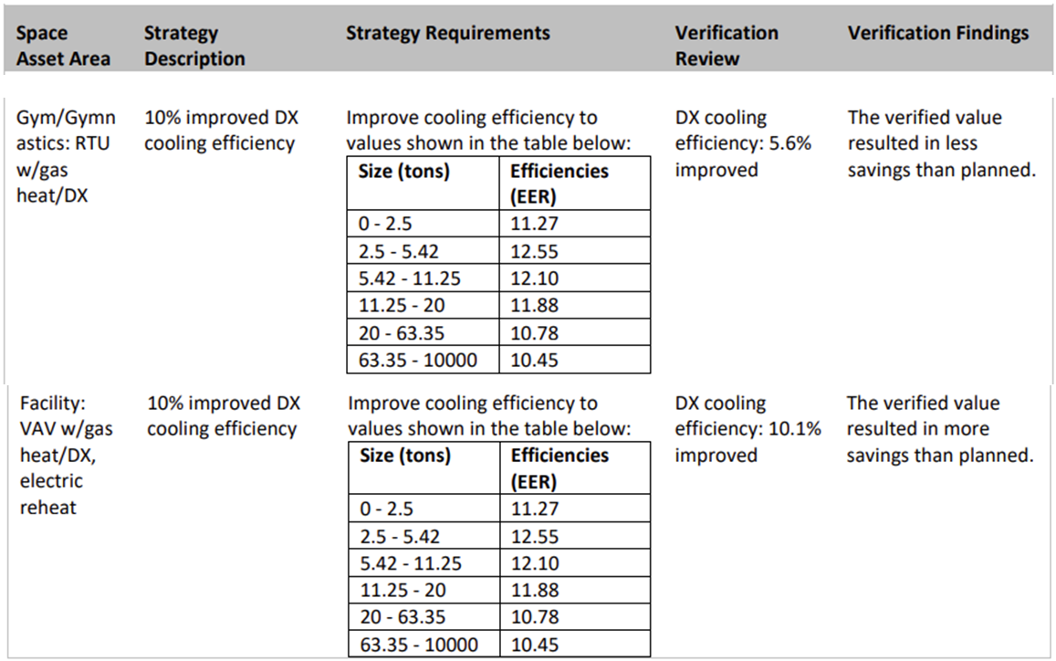
Figure 26. Lighting Strategies and Verified Status
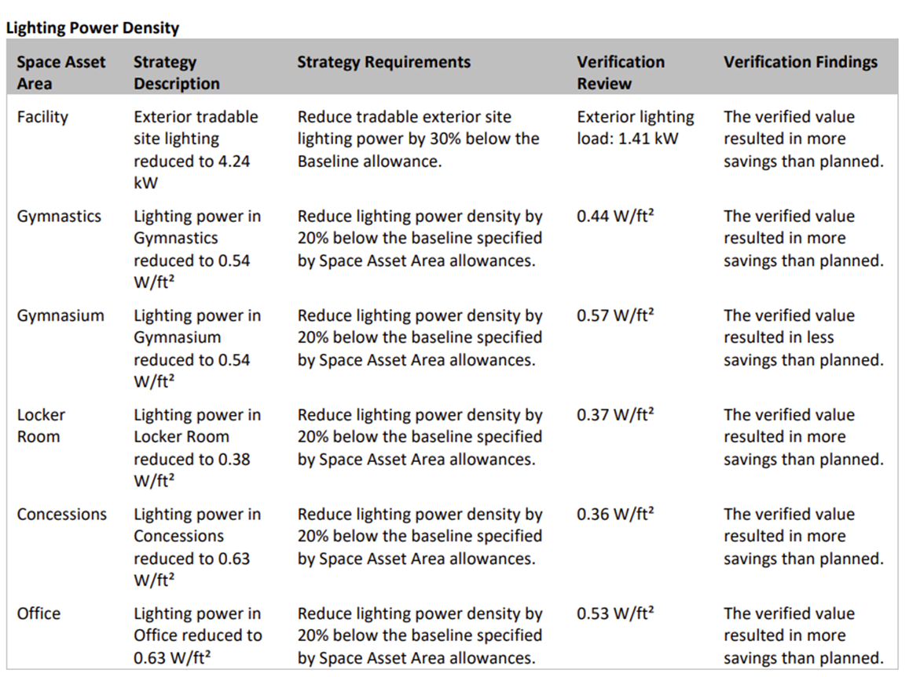
Figure 27. Verified Isolated Strategy Results – Most Impactful Measures
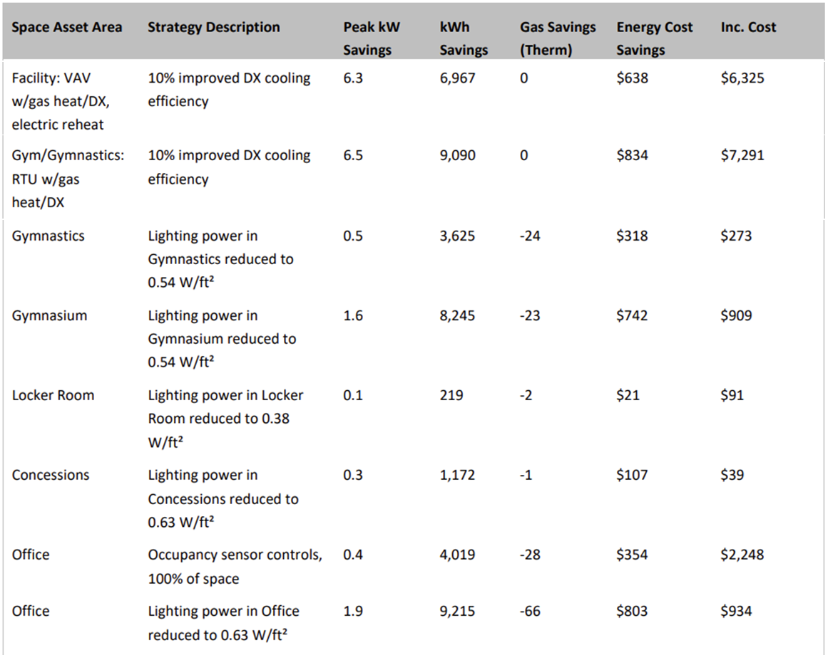

Measurement and Verification Plan
The implementation team took a different approach to verify the savings than the ex ante calculations. The ex ante calculations used an energy simulation software, NEO, to estimate savings between an ASHRAE 90.1-2016 Appendix G baseline, and the efficient ‘proposed’ scenario. The implementation team took two of the most impactful measures from the energy model report; cooling efficiency, and lighting power allowance improvements, and used IL-TRM V10.0 to perform parallel calculations to confirm the modeled measure results. The evaluation team interviewed the current owner regarding current conditions and operation, including heating and cooling capacity, as well as operating hours. Updated values for square footage were used in place of the ex ante assumptions.

Summary of the Verified Calculations
Table 16 compares the ex ante input assumptions with the values used in the verified analysis.
Table 16. Verified Model Inputs and Parameters for Project 2300006
Model | Input/Parameters | Ex Ante Assumption | Verified Assumption
Baseline | Hours of Operation | 2,750 | 2,750 (from interview)
 | Square Footage | 37,068 | 32,000 (from interview)
 | Heating / Cooling Capacity (SF/Ton) | Unknown | 500 / 400 (SF/Ton)
Efficient | Hours of Operation | 2,750 | 2,750 (from interview)
 | Square Footage | 37,068 | 32,000 (from interview)
 | Heating / Cooling Capacity (SF/Ton) | Unknown | 500 / 400 (SF/Ton)
Cooling efficiency savings calculation (IL-TRM V10.0):
$$∆kWh= \frac{({FLH}_{cool}*Capacity*\left(\frac{1}{({SEER}_{base}*(1-{DeratingCool}_{base})}-\frac{1}{({SEER}_{ee}*{SEER}_{adj}*(1-{DeratingCool}_{eff})}\right))}{1,000}$$
$${SEER}_{adj}=[(0.085*\left(\frac{{EER}_{ee}}{{SEER}_{ee}}\right)+0.367)]$$
Where FLH_{cool} equals the full load cooling hours, listed on page 217 of the IL-TRM to be 1,790 for a low rise office. This building type was used because no match was found for community centers. Capacity equals the capacity of the new equipment in Btu/hr – this value was not outlined in the TRM, so an industry standard of 400 square feet per ton of cooling required was applied to the conditioned area of the facility, (32,000 SF). SEER_{base} is equal to the seasonal energy efficiency ratio of the baseline unit (kBtu/kWh), listed on page 304 of the IL-TRM to be 13 SEER. SEER_{ee} is equivalent to the actual equipment efficiency ratio, which is estimated to be 15 SEER based on the information provided on page 7 of the final verification report. SEER_{adj} is equivalent to the adjustment percentage to account for in-situ performance of the unit. DeratingCool pertains to the quality installation of the unit – DeratingCool_{base} assumes a value of 0.1, and given it is not known if a quality installation was performed, DeratingCool_{eff} also assumes a value of 0.1.
$${SEER}_{adj}=[(0.085*\left(\frac{{EER}_{ee}}{{SEER}_{ee}}\right)+0.367)]$$
$${SEER}_{adj}=0.9573$$
$$∆kWh= \frac{(1,790*960,000*\left(\frac{1}{(13*(1-0.1)}-\frac{1}{(15*0.9573*(1-0.1)}\right))}{1,000}$$
$$∆kWh= 13,909.86$$
During and after the interview, an installed cooling capacity could not be discerned, so the capacity used in this calculation is estimated and may thus be different than the modeled savings (16,057 kWh).
$$Ex Ante ∆kWh= 16,057$$
Lighting power reduction savings calculation (IL-TRM V10.0):
$$∆kWh=(\frac{{Watts}_{base}-{Watts}_{ee}}{1000})*ISR*Hours*{WHF}_{e}$$
In order to calculate an accurate baseline and efficient scenario wattage, the lighting wattage was multiplied by the relevant square footage:
- Gymnastics: Base = 0.68 W/sf, Eff = 0.44, 4,500 SF
- Gymnasium: Base = 0.68 W/sf, Eff = 0.57, 12,000 SF
- Locker Room: Base = 0.48 W/sf, Eff = 0.37, 1,500 SF
- Concessions: Base = 0.79 W/sf, Eff = 0.36, 650 SF
- Office: Base = 0.79 W/sf, Eff = 0.53, 13,500 SF
$${Watts}_{base}=\left(4,500*0.68\right)+\left(12,000*0.68\right)+\left(1,500*0.48\right)+\left(650*0.79\right)+\left(13350*0.79\right)$$
$${Watts}_{base}=23,000$$
$${Watts}_{ee}=\left(4,500*0.44\right)+\left(12,000*0.57\right)+\left(1,500*0.37\right)+\left(650*0.36\right)+\left(13350*0.53\right)$$
$${Watts}_{ee}=16,684.5$$
The ISR parameter is listed on page 289 of the IL-TRM as the in service rate, the percentage of incentivized lamps that are actually in service. These fixtures were directly installed, thus a value of 100% was used. Hours refers to the average hours of use per year, the owner verified value of 2,750 hours was used. WHF_{e} refers to the waste heat factor for energy to account for cooling energy savings from efficient lighting. A value of 1.1 was used for low rise office.
$$∆kWh=(\frac{23,000-16,684.5}{1000})*0.945*2,750*1.1$$
$$∆kWh=19,104.39$$
During the interview, the facility square footage was reported to be 32,000 square feet versus the modeled square footage of 37,068 square feet. The results calculated via the TRM would thus be expected to fall short of the modeled savings (22,476 kWh).
$$Ex Ante ∆kWh= 22,476$$

Project 2300012
Project ID#: | 2300012
Measure: | Replace Absorption Chillers With VSD Electric Chillers
Ex Ante Savings: | 9,666,733 kWh
Facility Type: | Educational
End Use: | HVAC
Sampled For: | Fuel Switching
Wave: | FS

Measure Description
The customer replaced three water-cooled steam absorption chillers with three water-cooled centrifugal chillers. The chillers are part of a cooling system that serves three residence halls and two dining halls. Each of the existing chillers has a rated capacity of 625 tons, and the proposed efficient chillers matched that capacity (1,875 tons total). The cooling towers that previously served the absorption chillers was reused for the proposed centrifugal chillers, as were all existing chilled water pumps.
The project was completed in the Spring of 2024, and the implementer conducted a post-installation inspection on June 13, 2024.

Key Findings
The verified gas and site energy savings increased due to additional gas usage data being available to the evaluation team. The customer provided the team with trended chilled water, chiller power, and trended gas usage for the gas-fired boiler. A coal-fired boiler operated as a base-load while the natural gas boiler operated as the trim boiler. The evaluation team found that the gas usage attributed to the gas boiler for operating the absorption chillers was slightly higher than the ex ante estimate and therefore the gas savings increased. We were only able to establish a fair correlation between outside air conditions and the energy usage of the new chillers, but our result validated the ex ante estimate of the annual electrical energy usage of the new chillers.
The resulting project savings are shown in Table 17. Per guidance in IL-TRM V12.0, the evaluation team determined the verified savings for fuel switching projects by estimating the change in site MMBtu produced through the project. As such, we present an MMBtu realization rate for this project in Table 17, from which we allocated the MMBtu savings for this project across electric energy and gas savings for the purposes of counting savings towards goal attainment. The unallocated verified savings are presented in Table 18.
Table 17. Summary of Project 2300012 Savings
 | MMBtu | kW | kWh | Therms
Ex Ante | 32,983 | 0.0 | 9,666,733 | 0
Verified | 36,936 | -294.6 | 10,825,283 | 0
Realization Rate | 112% | N/A | 112% | N/A
Table 18. Project 2300012 Unallocated Verified Savings
 | MMBtu | kW | kWh | Therms
Unallocated Verified Savings | 36,936 | -294.6 | -1,210,296 | 410,654

Summary of the Ex Ante Calculations
The implementation team used historical natural gas usage and steam generation data to calculate steam generation efficiency. They then generated a regression model using monthly steam usage and heat rejection data from the cooling tower to model cooling load as a function of steam usage. The implementation team created another regression model to correlate wet-bulb temperature to the calculated cooling load. From there, the implementation team generated a weather model using 2012-2021 historical weather data. Finally, using cooling tower efficiency data extrapolated to the operating conditions of the chillers, and chiller efficiency curves from the manufacturer, the implementation team calculated chiller power at each weather bin to determine the proposed case electric chiller energy use.
To calculate the fuel switching savings, the implementation team converted baseline gas usage to equivalent kWh to compare the baseline steam absorption chiller usage to the proposed electric chiller usage. The team did not use post-installation data to verify chilled water system operation and cooling loads.

Measurement and Verification Plan
This project was selected for a virtual onsite inspection to verify verified savings. The evaluation team interviewed the facility representatives to verify typical operation of the new system. We did not witness real-time operation because the system is normally shut down from November through March. We requested the following trend data:
- Chiller status and output
- Chiller power
- Condenser water pump status and power
- Cooling tower status and operation, e.g. fan speeds
- Condenser water supply and return temperatures
- Chilled water supply and return temperatures
- Gas usage and steam generation for the gas boiler
The evaluation team also asked for additional information:
- Has the cooling load for the system changed since the chiller replacement?
- Has the CHWS temperature changed since completion?
- Does the system have CHW reset controls?
- Have there been any other modifications to the chilled water system that were not included in this project?
- Have there been any changes in occupancy or facility usage?
- Have there been any changes to the facility that would affect the cooling load, e.g. changes to spaces, other efficiency projects, etc.?
- Has cooling tower operation (temps, etc.) changed since project completion?

Early Review Notes
The evaluation team conducted an early review of this project prior to authorization. We noted that the regression-based analysis compiled by the customer was thorough and well-annotated. Our early review comments included the following:
- This project creates a fuel switching scenario, where previously the cooling had been natural-gas fueled but will now be electrically fueled. The implementation team initially converted gas to electricity using a site conversion ratio but struck out this conversion and left it for a later point in time. The evaluation team agrees that this is a critical piece to get right and recommends further discussion with us when the implementation team settles on a preferred approach.
  - The implementation team opted to allocate all site energy savings to electrical savings.
- The analysis does not include coincident peak demand impacts for the new electric chillers. Peak coincident demand should be calculated per the IL-TRM by averaging demand savings between 1-5pm on non-holiday weekdays, June – August.
  - The implementation team did not claim peak demand savings.
- The evaluation team recommends that the implementation team provide additional documentation in the final application on how the plant cooling load is derived from the evaporation rate at the cooling tower.
  - The team used a different approach using chiller curves.
- The evaluation team recommends collecting baseline metering/trending of the chilled water temperatures to validate the cooling load profile. Two weeks of data collected in June or July should be sufficient if wet-bulb temperatures exceed 70°F at least once during the monitoring period.
  - The team used a model developed by the customer to calculate savings, but it appears that post-case data was not used in the final savings calculations.
- Loading is based on current cooling tower data extrapolated to new chiller and existing cooling tower performance. The evaluation team recommends collecting post-installation metering/trend data of the new chillers, pumps, and cooling towers to validate or normalize operating conditions in the efficient case.
  - It appears that efficient-case condenser water power was not integrated into the savings calculations, which is a conservative approach. Project documents report de-rating the condenser water pump, but this work was not considered in the ex ante calculations.
- The evaluation team recommends the implementation team consider using TMY3 or TMYX weather data instead of 10-year average data to align more closely with industry-standard methodology.
  - The team used 10-year average weather conditions, with data from 2012 through 2021.
- Chilled-water power calculations assume a condenser water reset between 60°F and 82.4°F. The evaluation team notes that this range, while theoretically possible, may be limited during implementation efforts. Additionally, the calculation assumes that all chillers modulate in parallel (as opposed to a single trim chiller). The evaluation team recommends collecting post-installation condenser water temperatures and chiller sequencing to validate these assumptions or modify them as necessary.
  - The model used by the team maintained the water reset to 60°F. Increasing the minimum temperature has a relatively small effect on final savings.
- The calculations assume that all chilled water pumps, condenser water pumps, and cooling tower fans operate identically in the baseline and proposed cases. The evaluation team recommends collecting trend data before and after the project to verify these pieces of equipment have not changed. The evaluation team recommends including calculations for these pieces of equipment if the new chillers require more or less efficient part-loading operation.
  - The implementation team did not adjust savings to account for pump and cooling tower changes in energy usage, but this appears to be a conservative approach because the system heat rejection rate is lower with the electric chillers.

Summary of the Verified Calculations
The evaluation team collected monthly information from the customer dating from June 2016 to December 2024. The data included steam usage (in thousands of pounds per hour [pph]) and chiller electric power (kW) for the chiller plant, plus average outdoor dry bulb, wet bulb (WB), and dew point temperatures. We used the data to establish steam flow rates by the chillers at the plant as a function of WB outdoor air temperatures after removing outliers and flows during winter months, for which no steam flow was recorded. The correlation is shown in Figure 28.
Figure 28. Average Steam Usage vs. Average Wet Bulb Temperature
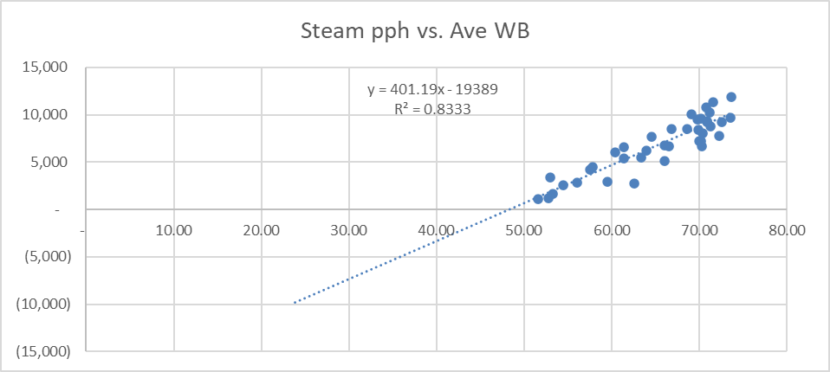
We used the results of this regression with the ex ante values for WB temperatures, which were based on average 2012-2021 historical weather data, in 2°F increments above 50°F WB, to establish annual steam usage for the absorption chillers using Equation 19, which was derived from the developed regression.
Equation 19. Annual Absorption Chiller Steam Usage
$$Steam Load \left(pph\right)=401.19*WB - 19389$$
The campus boiler plant has a coal-fired boiler that they use for base loads and a natural gas boiler to handle trim loads. The customer provided a correlation between natural gas input (in MBH) and steam output (in pph) as shown in Figure 29.
Figure 29. Boiler #4 NG (MBH) vs. Steam pph
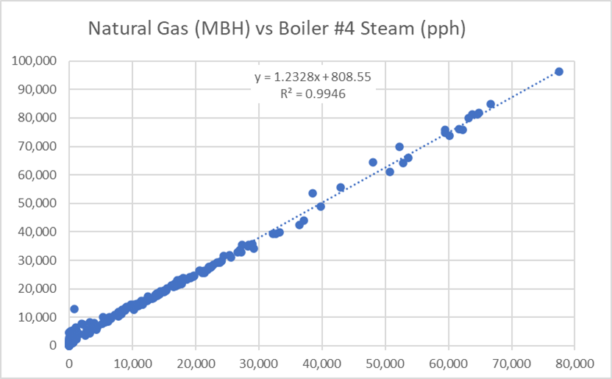
We used the slope of this correlation, 1.2328 MBH/pph, with the calculated steam load for each WB bin to establish therms used by the absorption chillers using Equation 20, where hours per year are bin hours from April through October.
Equation 20. Absorption Chiller Therm Usage
$NG Energy (therms)=Steam Load \left(pph\right)*1.2328 \left(\frac{MBH}{pph}\right)*\left(hours per year\right)÷100$
We investigated the correlation between new chiller energy usage (in kWh) and WB cooling degree days (50°F base temperature) yielding the linear regression equation shown in Figure 30.
Figure 30. Chiller kWh vs. CDD 50°F WB
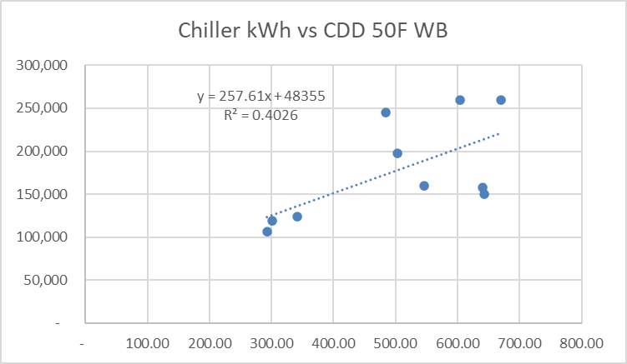
Although the coefficient of determination (R²) was poor, we used the correlation between chiller energy and wet bulb cooling degree days to produce a ballpark estimate of the new chiller usage, The result was 1,269,404 kWh, which reasonably validated the ex ante result of 1,210,296 kWh. We also found the water savings calculation to be reasonable and did not adjust the ex ante values.
The weather data used in the ex ante and verified calculations did not include hourly values, so the evaluation team used average WB temperatures for the summer months June through August (67°F WB), to establish electrical power for the chillers at that temperature. The result, 294.6 kW, represents the added power demand for the electric chillers.

Project 2300044
Project ID#: | 2300044
Measure: | Centrifugal air compressor & HOC dryer
Ex Ante Savings: | 1,038,169 kWh; 156.4 kW
Facility Type: | Manufacturing
End Use: | Process
Sampled For: | Electric
Wave: | 3

Measure Description
The customer installed a new 500 horsepower (hp) centrifugal air compressor and heat-of-compression dryer as part of an expansion project being completed at a manufacturing facility. The new compressor provides a base load of compressed air, while one existing variable frequency drive (VFD) compressor provides the trim load.

Key Findings
The evaluation team found the ex ante savings to be calculated using sound methodologies, and all key details used in the savings calculations were confirmed with the customer. The evaluation team found no necessary adjustments to the savings calculations, and as a result the verified savings are equal to the ex ante savings.
The resulting project savings are shown in Table 19.
Table 19. Summary of Project 2300044 Savings
 | kW | kWh
Ex Ante | 156.4 | 1,038,169
Verified | 156.4 | 1,038,169
Realization Rate | 100% | 100%

Summary of the Ex Ante Calculations
Factory test data for the proposed 500 hp centrifugal compressor was used to determine the annual energy use of the unit. The proposed compressor is expected to operate at 497 hp (394.3 kW input) for 6,640 hours per year, using 2,617,939 kWh. The assumed baseline compressor is specified as an oil-free rotary screw compressor, which the implementation team scaled up from its rated horsepower (1,842 CFM @ 400 hp, 338.5 kW) to match the compressed air capacity (2,602 CFM) of the proposed centrifugal compressor. The baseline compressor would have a demand of 478.2 kW to provide the same compressed air flow, and an annual energy consumption of 3,175,011 kWh. The resulting savings are 557,071 kWh.
For the compressed air dryer savings, the proposed heat-of-compression dryer is compared to a baseline heatless desiccant dryer with a similar capacity. The baseline dryer has a purge airflow of 437 actual CFM (ACFM), whereas the proposed dryer has a 60-CFM stripping cycle that operates 37.5% of the time and a 5-kW stripping heater that operates 12.5% of the time. Using the kW/CFM values for the baseline and proposed compressors, the annual energy use needed to provide the purge airflow of the baseline dryer is 511,588 kWh, and the annual energy use needed to provide the stripping cycle airflow and power the stripping heater amounts to 30,490 kWh; resulting in a savings of 481,098 kWh.

Measurement and Verification Plan
The evaluation team found the implementer’s approach to quantifying savings to be appropriate. The evaluation team will use the implementation team’s calculations and confirm inputs based on information from the customer.
The following information will be confirmed with the customer:
- Hours of operation
- Installation status of new equipment
- Project completion date
- Compressor model number
- System operating pressure
- Dryer model number
- Average system airflow rate
- Dryer purge cycle settings (duration & frequency)
- Dryer stripping heater settings (duration & frequency)
- During normal operating hours, does the compressed air demand of the facility ever drop enough that the new compressor shuts down or operates at partial loading? If so, how often does this happen?

Early Review Notes
We note that this project was subject to early review prior to authorization. Our early review comments included the following:
- The baseline compressor is specified as an oil-free rotary screw compressor. Based on the provided project documentation, the evaluation team believes that a more appropriate baseline compressor is an oil-injected rotary screw compressor, because oil-free compressors are more expensive and less efficient than oil-injected units. Moreover, oil-free compressors are typically only installed in systems where oil contamination is of utmost concern, such as in pharmaceuticals and food production. The evaluation team does not believe oil contamination is a large concern in this facility due to the fact that there are other oil-lubricated compressors already in the system. We recommend the implementation team adjust the baseline compressor to reflect an oil-injected rotary screw compressor.
  - The implementation team considered possible alternative baselines and ultimately decided to use the ally’s choice of actual baseline instead of a theoretical baseline. The actual baseline is also a conservative estimate of savings. The evaluation team accepts this justification.
- The evaluation team believes that the compressor efficiency values used in the dryer savings calculations are incorrect. The compressed air use of the dryers would impact the operation of the trim compressors in the system, not the operation of the baseline and proposed compressors for this project. This is because the base load compressor airflow load (CFM) will not change with a reduction in dryer purge volume, only the flow rate through the VFD trim compressor will decrease. This stems from the fact that a base load compressor, by definition, remains fully loaded at all times until the plant load falls low enough that it is the only compressor still required, at which point it begins to turn down. Given the information reviewed, this scenario is unlikely in this system. Therefore, the base load compressor will remain at a constant flow regardless of dryer purge volumes and all savings associated with a reduction in dryer purge volumes will occur at the trim compressor. Because of this, we recommend the savings calculations apply the trim compressor efficiency (kW/CFM) rather than the baseline and proposed compressors.
  - The implementation team agreed with the evaluation team and was able to use performance data from a previous study to adjust the compressor efficiency. The savings decreased by approximately 25,000 kWh.
- The evaluation team recommends that details be added to the Savings Summary document to show how the Purge Flow of the baseline compressed air dryer is converted from 398 SCFM to 437 ACFM. The details of the calculation are important because incorrect assumptions about plant air conditions can result in incorrect ACFM values, which will impact the energy savings calculations.
  - The implementation team added standard testing conditions and plant conditions to the Savings Summary document under the Energy Savings Calculation heading.
- The project summary indicates that the installation of the new compressor and dryer will cause the operation of an existing compressor and dryer at the facility to decrease from their current annual hours. It should be verified that the existing compressor and dryer were not involved in any past energy efficiency projects for which savings were claimed by utility programs, as it is important to ensure that savings are not being double-counted between projects by shifting compressed air loads between the existing and new equipment.
  - The implementation team provided details of projects at this site all the way back to PY18 and none create double-counted savings.

Summary of the Verified Calculations
The evaluation team contacted the customer and found that all of the information in the calculations were accurately reported and matched the ex ante calculations. No adjustments to the savings calculations were deemed necessary, so the verified savings are equal to the ex ante savings and this project achieves a realization rate of 100% for electric energy and demand savings.

Project 2200065
Project ID#: | 2200065
Measure: | Boiler Replacement
Ex Ante Savings: | 3,546,774 kWh; 422.2 kW; 1,577,311 Therms
Facility Type: | Manufacturing/Industrial
End Use: | Process Heat
Sampled For: | Electric, Gas
Wave: | Wave 3

Measure Description
This project includes installing a new boiler to produce process steam at 165 PSIG, which is the requirement for the facility processes. The new boiler is expected to operate at 83% efficiency. The existing system consists of two high pressure boilers (Boiler #1 and Boiler #3) that operate at 820 PSIG with an efficiency of 77%. The existing boilers were designed to run at 1,600 PSIG for power generation, but the generators have long been put out of service.
The existing Boiler #1 had a 600 hp forced draft (FD) fan and was fed by a 1,250 hp feedwater pump. The existing Boiler #3 had a 400 hp FD fan and was fed by a 125 hp feedwater pump. The new boiler has a 700 hp FD fan and is fed by two 125 hp feedwater pumps.
The project was completed in January 2024, with commissioning completed in February 2024.

Key Findings
There are two primary reasons that the verified gas savings are higher than the ex ante savings. First, the evaluation team was able to collect seven months of trend data from the customer while the ex ante verification was based on only two weeks of data. The average hourly gas usage over the seven-month period was lower than observed during the ex ante verification, and accounted for about 70% of the increased therm savings.
Second, the savings are also higher because of an adjustment to the new boiler’s hours of operation. The implementation team used data that accounted for down times for the baseline boiler, but they assumed that the new boiler would be operating for 8,760 hours per year. The evaluation team learned from the customer that the plant normally has an annual nine-day shutdown, so we reduced the hours of operation for the new boiler by 216 hours. This adjustment reduced the annual energy usage of the new boiler, resulting in higher gas savings.
The resulting project savings are shown in Table 20.
Table 20. Summary of Project 2200065 Savings
 | kW | kWh | Therms
Ex Ante | 422.2 | 3,546,774 | 1,577,311
Verified | 422.2 | 3,546,774 | 3,359,897
Realization Rate | 100% | 100% | 213%

Summary of the Ex Ante Calculations
The implementation team calculated electric savings for the existing and new forced draft (FD) fans and feedwater pumps. They considered the existing equipment to be the baseline, which included a 600 hp FD fan and a 1,250 hp feedwater pump on Boiler #1, plus a 400 hp FD fan and 125 hp feedwater pump on Boiler #3.
The customer provided trend data for the existing boilers that included boiler steam flows and Boiler #3 feedwater pump amperage. Average daily data was reported for the period from March 7, 2020 through December 31, 2021, but data for the period from October 3, 2020 through May 10, 2021, was not included. They provided trend data for the new boiler that included daily average motor amps for the FD fan and feedwater pumps for a three-week period from June 1, 2024 through June 20, 2024.
The implementation team calculated existing Boiler #1 FD fan power and feedwater pump power using nameplate amps and an assumed 4,000 Volts and 55% load factor. Existing Boiler #3 FD fan power was calculated using nameplate amps and an assumed 480 volts and 55% load factor. Boiler #3 feedwater pump power was calculated using trended amperage at 480 volts. They calculated FD fan and feedwater pump power for the new boiler using trended amperage with the FD fan at 4,160 volts and the feedwater pumps at 480 volts. A 0.9 power factor was assumed for all motors. They assumed that the motors would run at those power levels for 8,400 hours per year. The results are summarized in Table 21.
Table 21. Summary of Electric Calculations
Description | Boiler #1 | Boiler #3 | New Boiler LP | Savings
FD fans kW | 276.1 | 175.9 | 451.4 | 0.6
Feedwater pumps kW | 535.0 | 42.4 | 155.7 | 421.6
Total kW | 811.1 | 218.3 | 607.1 | 422.2
Hours of operation | 8,400 | 8,400 | 8,400 | N/A
Total kWh | 6,812,966 | 1,833,786 | 5,099,979 | 3,546,744
The implementation team used 2021 billed usage data to establish annual gas input for the baseline boiler, which appeared to represent the only significant gas demand on the gas meter. They established average hourly gas usage for the new boiler using data collected from June 1, 2024, through June 20, 2024. They multiplied the average usage by 8,760 hours to establish annual gas usage for the new boiler and calculated savings of 1,577,311 therms by taking the difference between the baseline and new usage.
The implementation team used an Energy Efficiency and Renewable Energy (EERE) boiler calculator to validate the savings. The calculator uses inputs for average steam pressure and temperature, combustion efficiency, blowdown rate, and other factors to calculate fuel energy input at average operating conditions. They used the calculated gas input rates to establish annual baseline and new therms usage, assuming 350 days per year of operation. The result based on the calculator was 1,982,142 therms per year in savings, indicating that the quantified savings from the billed usage data was a conservative estimate.

Measurement and Verification Plan
This project was selected for a virtual onsite inspection for electric and gas savings verification. The evaluation team interviewed the customer and requested screen sharing to review setpoints and asked the customer to provide additional trend data for the new boiler. We also asked the following:
- Have there been any changes in production since the completion of the project?
- How many hours has the process operated in the past year?
- What other equipment is on the same gas meter as the boilers?
- Is the period from June through December typical for production throughout the other 5 months of the year?
- Are there any seasonal/weather dependent factors affecting gas usage?
- Is the plant shut down for holidays, maintenance, etc.? If so, how many days per year?
- Can you provide additional trend data from after the completion of the project?

Summary of the Verified Calculations
The evaluation team collected trend data from the customer covering the period from June 20, 2024, through January 28, 2025 for the new boiler that included the following parameters:
- Feedwater pump current (Amps) and pressure
- Natural gas flow
- Combustion air fan motor current (Amps)
- Boiler drum pressure
- Steam flow
We updated the inputs for the new boiler for forced draft fan current (Amps), feedwater pump current (Amps), and gas usage based on the collected data. We found that average gas consumption for the post period was lower than estimated in the ex ante analysis. The ex ante analysis based annual baseline gas usage on monthly billing data, which accounted for plant shutdowns and maintenance, so we did not adjust baseline gas usage in the verified analysis.
The evaluation team reduced the hours of operation by 216 hours for the new boiler to account for an expected nine days of scheduled plant shutdown. We calculated the average steam output for the new boiler in thousand pounds per hour and found that it was about 8% lower than during the baseline period. The site representative reported that production was abnormally low during part of the efficient period due to market demand and natural gas prices. We normalized pre- and post-case gas usage to the average steam production over the baseline and efficient periods.
The evaluation team found that electric energy savings without normalizing were greater than the ex ante results but lower when normalized for steam flow. The team is not confident that a simple proportional normalization for the motors involved is sufficiently accurate, so we concluded that the ex ante electric energy savings are reasonable.



Tyler Sellner
Principal Consultant
tsellner@opiniondynamics.com
Contact:
Zach Ross
Director
zross@opiniondynamics.com

U.S. Department of Energy Motor Challenge Factsheet – Determining Electric Motor Load and Efficiency, https://www.energy.gov/eere/amo/articles/determining-electric-motor-load-and-efficiency accessed 1/24/2025. Motor curves in this report come from Figure 2 of this publication.
Version 10.0 of the IL-TRM was in effect at the time of construction, so it was referenced for the verified savings analysis.
Ibid.

